Software DESIGN DESCRIPTION

DOCUMENT

JAM-003

JOB APPLICATION MANAGEMENT SYSTEM

By

Group 10

BAHRİ TÜREL
CELAL ÇIĞIR
MÜCAHİD KUTLU
ÖMER FARUK UZAR

May 5th, 2008
Bilkent University - Ankara

March 14th, 2008
Bilkent University - Ankara

UNCLASSIFIED

UNCLASSIFIED

Revision History

Date | Version | Description | Author
May 5, 2008 | 1.0 | Software Design Description Document. | Bahri Türel, Celal Çığır, Mücahid Kutlu, Ömer Faruk Uzar

TABLE OF CONTENTS
Revision History 2
List of Figures 4
1. INTRODUCTION 6
1.1 Purpose 6
1.2 Scope 6
1.3 Definitions, Acronyms and Abbreviations 6
1.4 Overview 7
2. REFERENCES 7
3. DECOMPOSITION DESCRIPTION 7
3.1 Module Decomposition 9
3.1.1 AllAccounts Entity 10
3.1.2 WarningList Entity 10
3.1.3 AccountList Entity 10
3.1.4 UserAccountList Entity 10
3.1.5 InterviewList Entity 10
3.1.6 CommentList Entity 10
3.2 Concurrent Process Decomposition 11
3.2.1 Controller Entity 11
3.2.2 Security Entity 11
3.3 Data Decomposition 11
3.3.1 OpenPosition Entity 11
3.3.2 Warning Entity 11
3.3.3 User Entity 11
3.3.4 JobQualification Entity 11
3.3.5 ApplicantAccount Entity 11
3.3.6 ApplicantProxy Entity 11
3.3.7 Comment Entity 12
4. DEPENDENCY DESCRIPTION 12
4.1 Intermodule Dependencies 12
4.2 Data Dependencies 12
5. INTERFACE DESCRIPTION 13
5.1 Login to System 13
5.2 General Applicant List 14
5.3 Open a New Position 15
5.4 Open Position 16
5.5 Register New Applicant 17
5.6 Applicant Information 19
5.7 First Interview Window 21
5.8 Second Interview Window 22
5.9 Search Result 23
6. DETAILED DESIGN 25
6.1 Module Detailed Design 25
6.1.1 AllAccounts Detail 25
6.1.2 WarningList Detail 26
6.1.3 AccountList Detail 26
6.1.4 UserAcccountList Detail 27
6.1.5 InterviewList Detail 28
6.1.6 CommentList Detail 29
6.1.7 Controller Detail 30
6.1.8 Security Detail 30
6.2 Data Detailed Design 31
6.2.1 Open Position Entity Detail 31
6.2.2 Warning Entity Detail 32
6.2.3 User Entity Detail 32
6.2.4 JobQualification Entity Detail 33
6.2.5 ApplicantAccount Entity Detail 33
6.2.6 ApplicantProxy Entity Detail 35
6.2.7 Comment Entity Detail 36
6.3 Logical Architecture 37
6.4 UML INTERACTION DIAGRAMS 38
6.4.1 Create Open Position 38
6.4.2 Register New Applicant 39
6.4.3 Determine Applicants for First Interview: 43
6.4.4 Add comment for a particular applicant 44
6.4.5 Log Into System 45

List of Figures

Figure 1. Overall Design Diagram 7
Figure 2. Modules of the JAM System 8
Figure 3. E/R Diagram of the JAM 11
Figure 4. Login to System Screen 12
Figure 5. General Application Screen 13
Figure 6. Open a new Position Screen 14
Figure 7. Open Position Information Screen 15
Figure 8. Register new Applicant Screen 1 16
Figure 9. Register new Applicant Screen 2 17
Figure 10. Applicant Information Screen 1 18
Figure 11. Applicant Information Screen 2 19
Figure 12. First Interview Screen 20
Figure 13. Second Interview Screen 21
Figure 14. Search Screen 22
Figure 15. Result of Search Screen 23
Figure 16. Diagram for user interface & module relation. 36

INTRODUCTION

Purpose
The Software Design Description (SDD) document describes all of the essential components of the system to satisfy the requirements given by the client. This report is used especially during implementation of the system.

Scope
Traditional job application tracing systems are difficult to use and do not satisfy the company requirements. This leads to problems in timely employing process. Taking more time in employing the qualified people process also entirely slow downs the project and therefore costumers are not satisfied. This causes big problems such as costumers do not want to work with this company. Companies should determine what to do in a short time. Most applicants apply for a job to more than one company. The company that gives respond quicker can work with that applicant. Otherwise, he/she may want to work in another company because of having no response. Moreover, more problems occur such as increase in project completion timing, planning process of projects and accounting. This affects project managers, department manager, projects members and corporate management. Therefore, the purpose of the project is to automate the job application process in order to do better elimination of candidates and fasten the process. Scope of the project is determined via various facilities. These facilities are web interface for applicant and department and project managers. Users are able to create open position, register new applicant, determine applicants for first interview, add comment for a particular applicant, log into system, enter first interview results, add new user to system, change password, search, close open position, approve and disapprove procedure, enter or update personal information. As it is mentioned above objectives of this project is to automate the job application process and make it easier for both companies and for applicants. This project enables more reliable applications since people do not have to wait more than needed.

Definitions, Acronyms and Abbreviations
JAM: Job Application Management System.
SSD: Software Specification Document
SRS: Software Requirements Specification
SDD : Software Design Description
SPMP: Software Project Management Plan
UR: User Requirement
DB: Database
I: Implementation
DP: Deployment
UML: Unified Modelling Language
OMT: Object Modelling Technique
TUBITAK: The Scientific and Technological Research Council of Turkey (Türkiye Bilimsel ve Teknolojik Araştırma Kurumu)

Overview
Up to this document, Project Description Document, Software Project Management Plan (SPMP) and Software Requirements Specification (SRS) have been released. In this document, detailed design of the system with user interfaces will be described. In section 3; Decomposition of the system with module decomposition, concurrent process decomposition and data decomposition is given, in section 4; Dependency Description is given, in section 5; User Interface Description can be found and finally in section 6 Detailed Design of the system is provided.

REFERENCES
- Project Description Document of Job Application Management.
- Software Project Management Plan for Job Application Management
- Software Requirements Specification for Job Application Management
- Declan Delaney and Stephan Brown, “Documentation Templates for Student Projects in Software Engineering”, Department of Computer Science, National University of Ireland, 2002.
- Software Engineering Standards Committee of the IEEE Computer Society, “IEEE Recommended Practice for Software Design Descriptions”, IEEE Std 1016-1998.
- Cagatay Undeger, “Sample Work Breakdown Structure”, Department of Computer Engineering, Bilkent University, 2008.
- Software Engineering Standards Committee of the IEEE Computer Society, “IEEE Standards for Software Project Management Plans”, IEEE Std 1058-1998.

DECOMPOSITION DESCRIPTION
This part includes a hierarchical structure of entities. Each entity is determined and briefly mentioned in this section. For each entity a detailed description will be provided in the sixth section. It can be seen entity diagram of overall system in Figure 1.

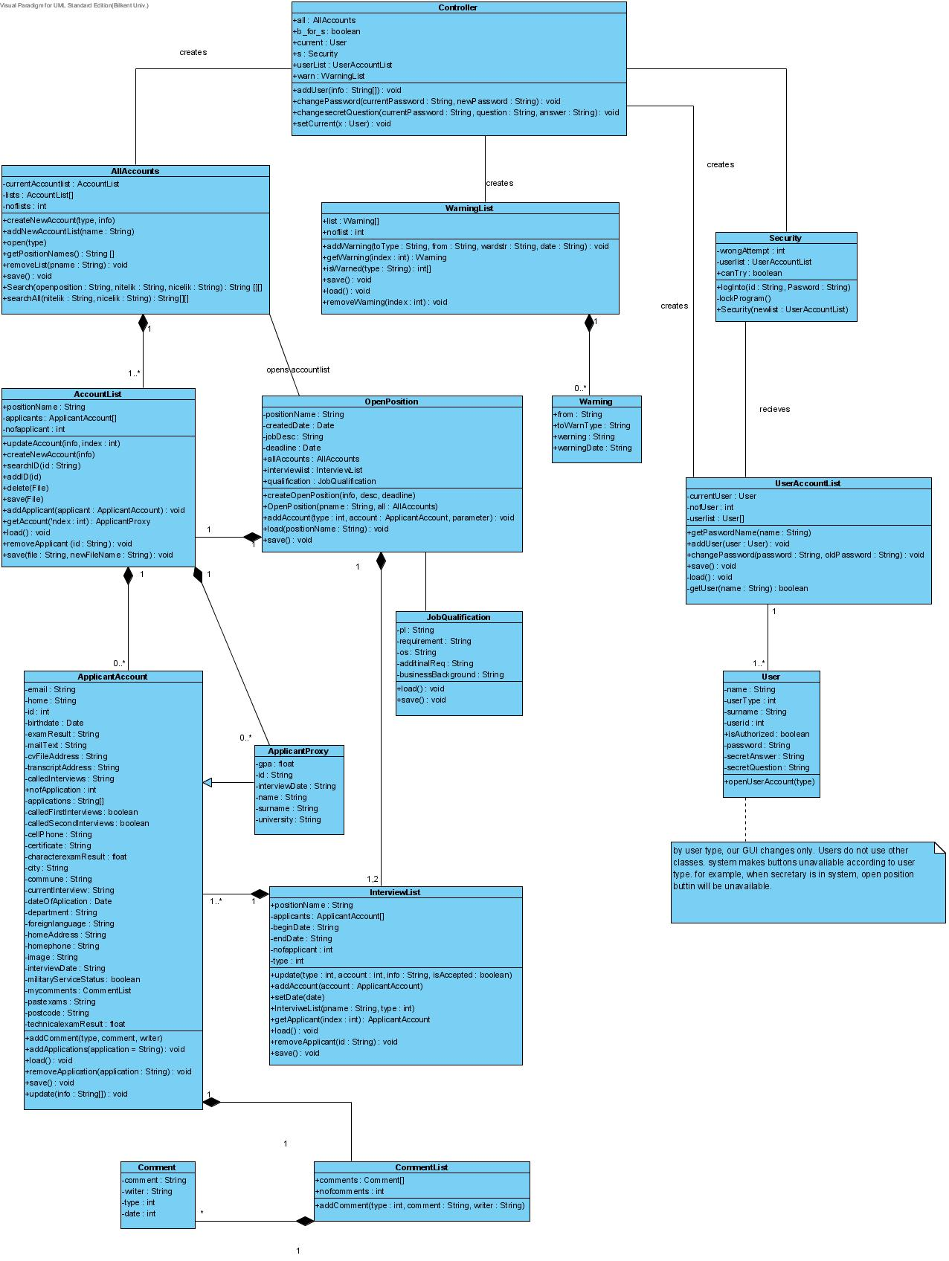
Figure 1. Overall Design Diagram
Here we will describe each entity. However we divide the entities into three groups which are module entities, concurrent process entities and data entities.

Module Decomposition
JAM has 4 different components each has different responsibilities inside the system. They are shown in Figure 2.

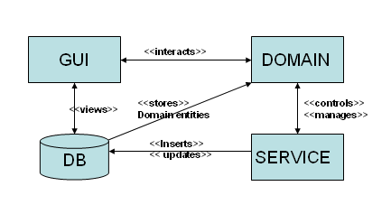
Figure 2. Modules of the JAM System

- GUI: Graphical User Interface that views the database and interacts with Domain and Service components. It is an essential and important part of the system since user interacts with the system via user interface. This component is divided into two parts;

  - Windows GUI: This GUI part is for the users of system such as secretary, project manager and department manager. They are able to use the system via this interface. An internet access is not needed for this purpose since program is only used in the company building (by requirements). So in order to make it more secure we have chosen it to be windows-based.

  - WEB GUI: This GUI part is used by applicants only. They can apply any job via web by following the positions announced by company. Open positions are entered to the web page by database administrator that is responsible in the company. All the applications are stored immediately to database when they are submitted so that company workers can access them without any problem.
Detailed GUI design will be given in 5.Interface Description.

- DOMAIN: This component includes the entities that represents the domain objects like open position, user, applicant account etc. In other words, any fundamental object of our system will find a place to itself in this component. Besides this, domain component has a connection with database and GUI. Views of each domain object is represented in GUI component and stored in database.
This component includes OpenPosition, Comment, Warning, User, JobQualification, ApplicantAccount and ApplicantProxy classes.
- SERVICE: This component includes the entities that are responsible for business logic. For example, security service that controls the login operations and controller entity that is generally controls the flow of action between several other entities are elements of this component. All the work that is related to business logic is done by the entities of this component.
This component includes Controller and Security classes.

- DATABASE (DB): Database component is an external component of JAM which stores all the data necessary for system such as user accounts, applicant account, open positions etc. Each domain object is stored in the database securely and retrieved when necessary.

AllAccounts Entity
This entity simply holds all the applicants applied to a particular position in the company. For each position, such as applicant list is also held in this class. A detailed description will be given in section 6.

WarningList Entity
This entity is used to hold all of the warnings in the system. A detailed description will be given in section 6.

AccountList Entity
This is simply an entity consisting of open position name and list of applicants applied for the position. A detailed description will be given in section 6.

UserAccountList Entity
This is the list of users that are able to use the system actively such as secretary, project manager etc. A detailed description will be given in section 6.

InterviewList Entity
This is the list of all interviews for a specific position. Begin and end dates of interview periods are held in this entity. A detailed description will be given in section 6.

CommentList Entity
This is the entity that represents the list of comments for a particular applicant. This holds all comments made by different people. A detailed description will be given in section 6.

Concurrent Process Decomposition

Controller Entity
This entity is used to create most of the entities which are AllAccounts, UserAccountList and WarningList. This entity works like a general controller of the system. A detailed description will be given in section 6.

Security Entity
This class with the help of the user list determines if a person trying to login to the system is already registered one or not. If not, number of wrong trials prevents him to do indefinite number of attempts. A detailed description will be given in section 6.

Data Decomposition

OpenPosition Entity
This is an entity representing the open position for a job. It holds all the required properties for the job such as name, due date, all the applicants etc. A detailed description will be given in section 6.

Warning Entity
This entity is simply a warning object. A detailed description will be given in section 6.

User Entity
This entity represents simply a user of JAM. A detailed description will be given in section 6.

JobQualification Entity
This entity holds the qualifications for an open position such as programming languages, requirement and operating system etc. A detailed description will be given in section 6.

ApplicantAccount Entity
This is detailed account of an applicant including position he applied, exam and interview results etc. A detailed description will be given in section 6.

ApplicantProxy Entity
Most general information of an applicant, like GPA, name and surname, is represented by this entity. A detailed description will be given in section 6.

Comment Entity
This entity represents the comments made by a specific person to a specific applicant. A detailed description will be given in section 6.

DEPENDENCY DESCRIPTION

Intermodule Dependencies
Both Domain and Service modules saves,updates or deletes the database module entries. GUI module interacts with Domain module. Service module controls and manages Domain module objects. Behind this, GUI modules views the Database module entries.

Data Dependencies
The dependencies between the data will be fully presented in E/R diagram that can be seen in Figure 3.

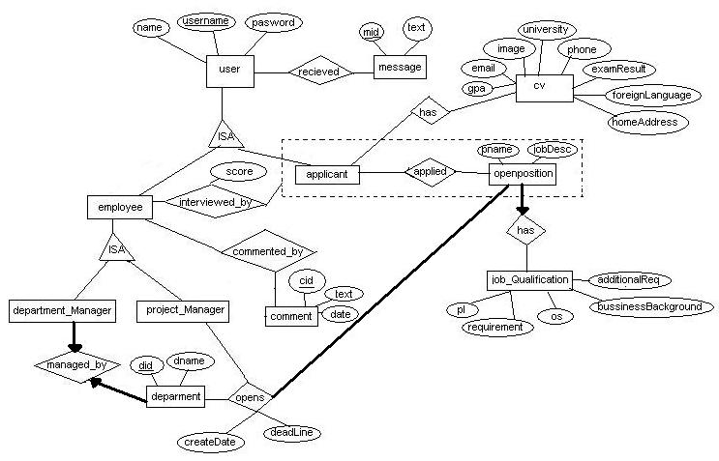
Figure 3. E/R Diagram of the JAM

INTERFACE DESCRIPTION
In this section, each user interface is explained along with some screenshots.

Login to System
Login screen will be available for all workers of TUBITAK. At this screen, users enter their ID and their password to be able to use JAM. This page is to provide the security of the system. Therefore, in wrong password entries system shall warn the user with pop-up window. In addition, users shall be able to reach “Şifremi Unuttum” service through this page. General view of this screen can be seen in Figure 4.

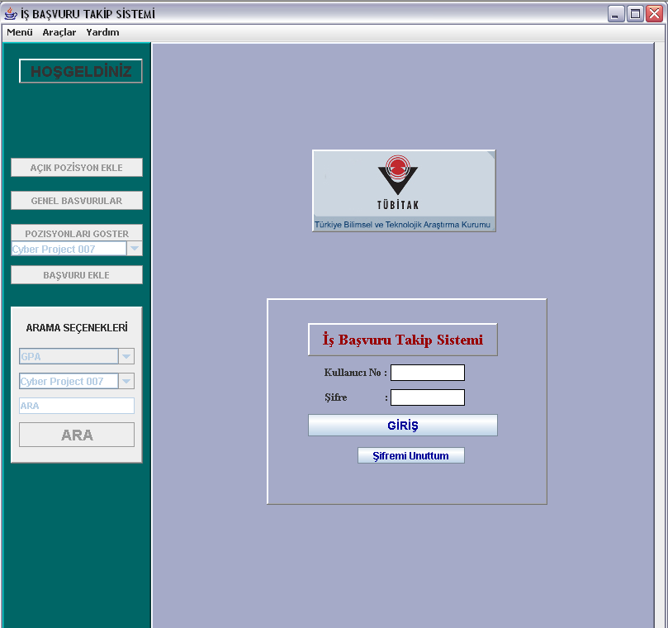
User enters the ‘userID’ into “Kullanıcı No” field and password into ‘Şifre’ field.
Then s/he presses “GİRİŞ” button in order to log into system
If the password and userID are correct, program activates the disabled buttons, “AÇIK POZİSYOM EKLE”, GENEL BAŞVURANLAR POZİSYONLARI GOSTER BAŞVURU EKLE and ARA. Besides this, “Menü” “Araçlar” and “Yardım” menu group will be activated after user log into system successfully. Otherwise and they are deactivated.
When user want to exit, user uses this button. A pop up window will be appear to ask user whether s/he is sure or not to exit from system.
Figure 4. Login to System Screen

General Applicant List
This screen will be available for all authorized users such as secretary, project manager etc. Whole applicants who have applied TUBITAK shall be listed at this page. User shall be able to select an applicant and go to Applicant Information Page that is filled by selected applicant.

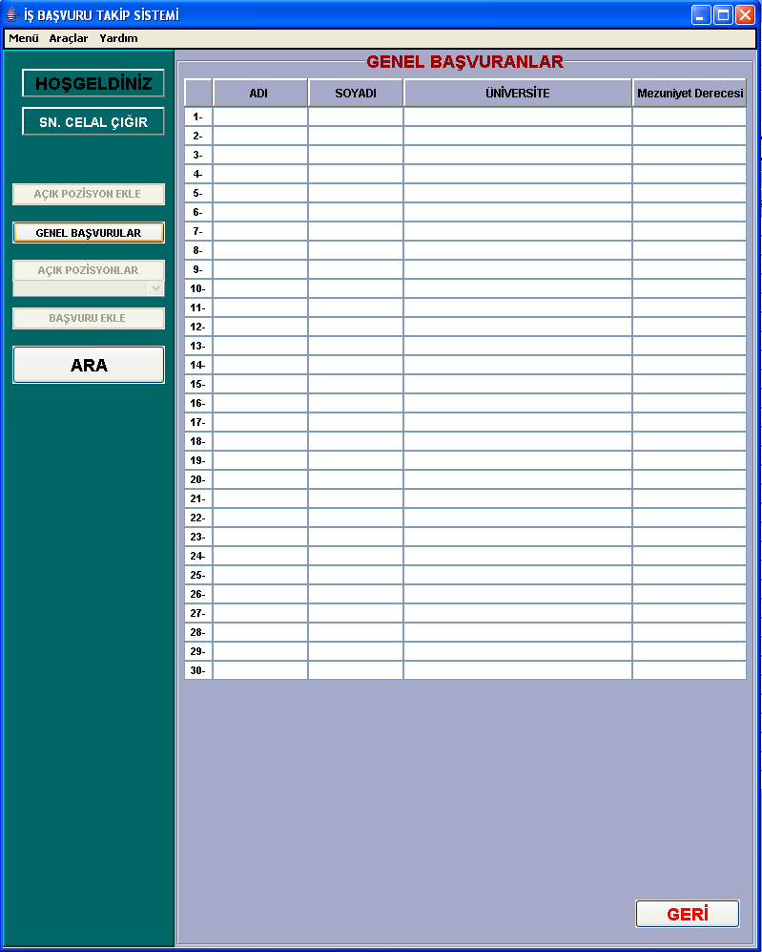
When user presses one of these buttons, list will be sorted alphabetically with respect to it.
When user double clicks one of these applicants, the “Applicant Information” window will appear as you can see in part 5.6 Applicant Information.
User will be able to search the applicant
Also there will be “welcome” message and “user name” displayed here
Figure 5. General Application Screen

Open a New Position
When the “AÇIK POZİSYON EKLE” button is pressed, this screen will appear. In this screen, user (Department Manager or Project Managers) creates new Open Position by entering and selecting the desired qualifications.

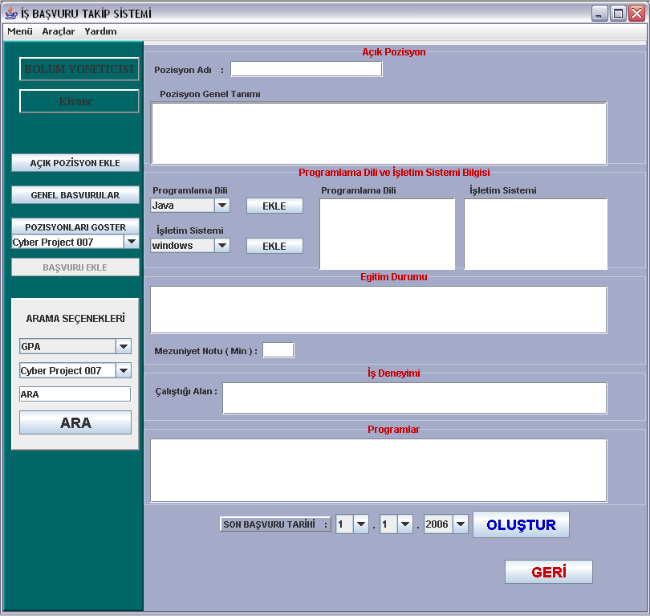
Figure 6. Open a new Position Screen
If user presses this button, and if s/he changed something above, pop up window will appear to ask user whether s/he want to save or create open position or not.

This text field is for Tool Environment that user wants applicants to be familiar such as Borland JBuilder, Photoshop etc.
After entering desired qualifications, user presses “OLUSTUR” button to create the Open Position.

Open Position
This screen will be available for all authorized users of JAM. At this page, users shall be able to see details and specification of an open position and applicants who have applied for that particular position. In addition they shall be close the position at this page or see the list of applicants who are accepted for first interview which is at First Interview Page or list of applicants who are accepted for second interview which is at Second Interview Page or see the info of any particular applicant.

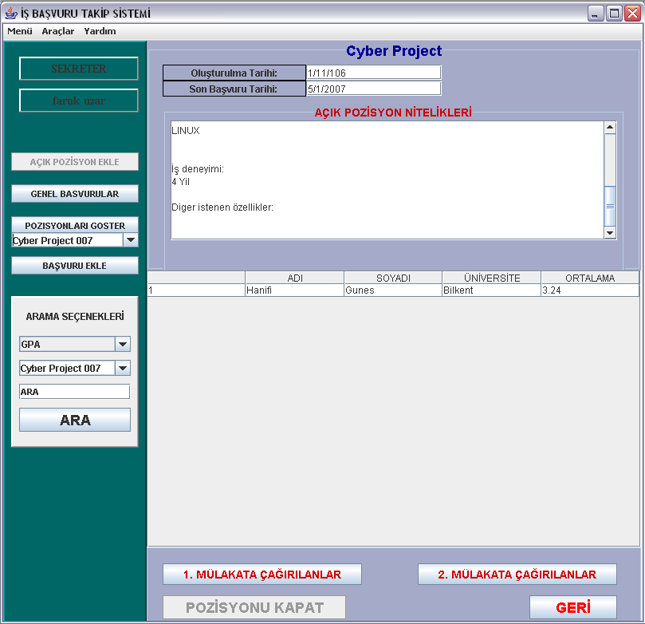
When user clicks left and then right one of these applicants, the “Applicant Information” window will appear as you can see in part 5.6.Applicant Information. Then s/he can add comment if s/he have a permission
Figure 7. Open Position Information Screen
If user presses this button, Second Interview List of this Open Position will appear as you can see in “5.8. Second Interview Window”.
This is for closing open position. Project Manager that creates this Open Position or Department Manager can use, Secretary is not. Of course, it will be disabled under Secretary Account.
If user presses this button, First Interview List of this Open Position will appear as you can see in “5.7. First Interview Window”.

Register New Applicant
This screen shall be designed one for secretary and one for applicants who will apply via internet web cite. All people shall be use web cite. They shall enter their CV or references and specify open that they will apply. On the other hand, secretary shall do the same things for applicants who have applied by sending documents of him via e-mail or giving hard-copy.

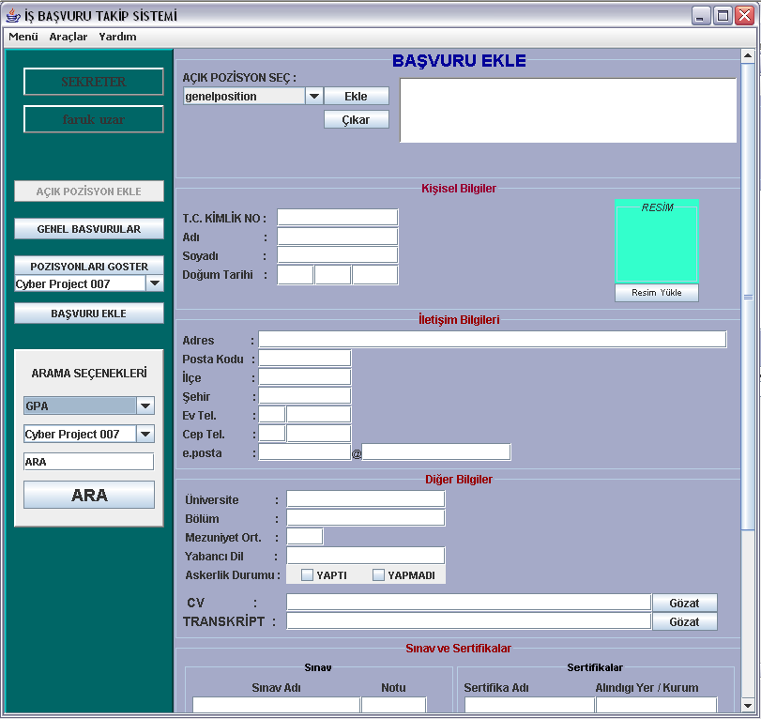
Firstly, Secretary selects the open position that applicant applied. Since applicant may apply more than one open position, secretary can select more than one open position
Secretary enters the applicant information into the appropriate fields here.
Secretary uploads the CV and Transcript of applicant by using this field.
Figure 8. Register new Applicant Screen 1

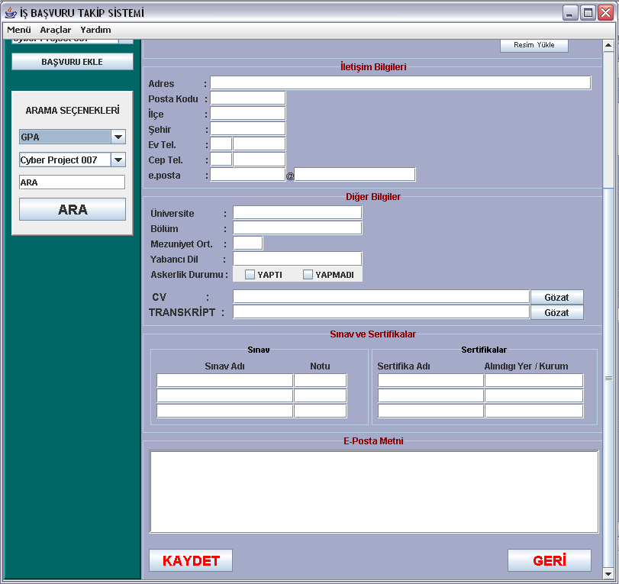
Figure 9. Register new Applicant Screen 2

When Secretary enters the whole information, s/he presses “KAYDET” button to save the applicant information in the system.

Applicant Information
This screen will be available for all authorized users of JAM. Users shall be able to
- see info of a particular applicant
- add comment about him/her
- add him/her to the first or second interview list
- print information of that applicant
- Update info of applicant ( only secretary will do this. )
via this screen.

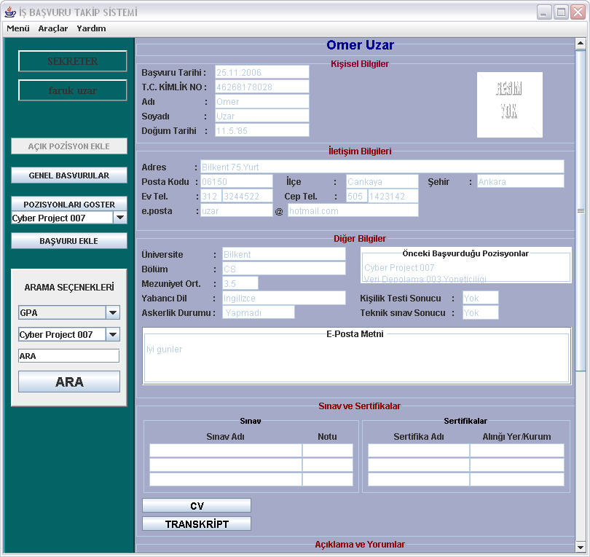
Figure 10. Applicant Information Screen 1

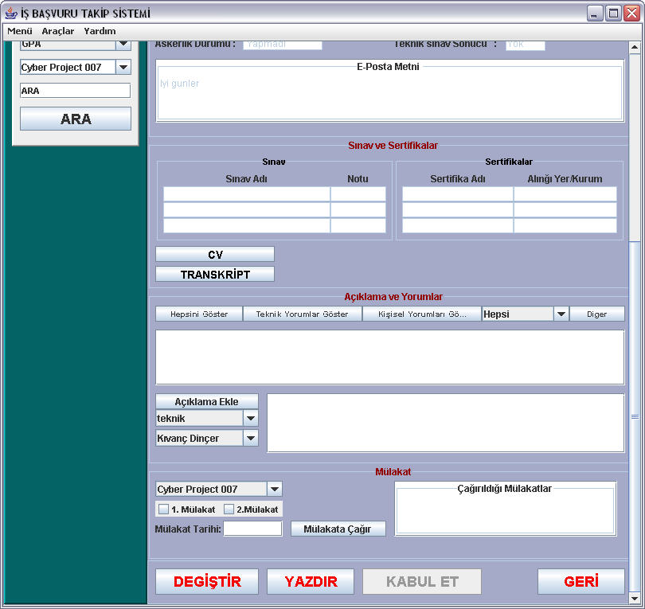
Figure 11. Applicant Information Screen 2

First Interview Window
This screen will be available for all authorized users of JAM. Users shall be able to
- See list of applicants who are accepted for first interview.
- See info of any particular applicant’s info in that list.
At this page, project or department manager shall be able to deselect an applicant for first interview while secretary cannot. Therefore, this page will differ according to user type.
This is the first interview window of particular Open Position that contains the applicants who applied this open position and called for first interview. If user wants to delete one applicant from this interview list, he selects the applicant and presses the “ÇIKART” button and pop up screen appears to ensure that user is sure or not.

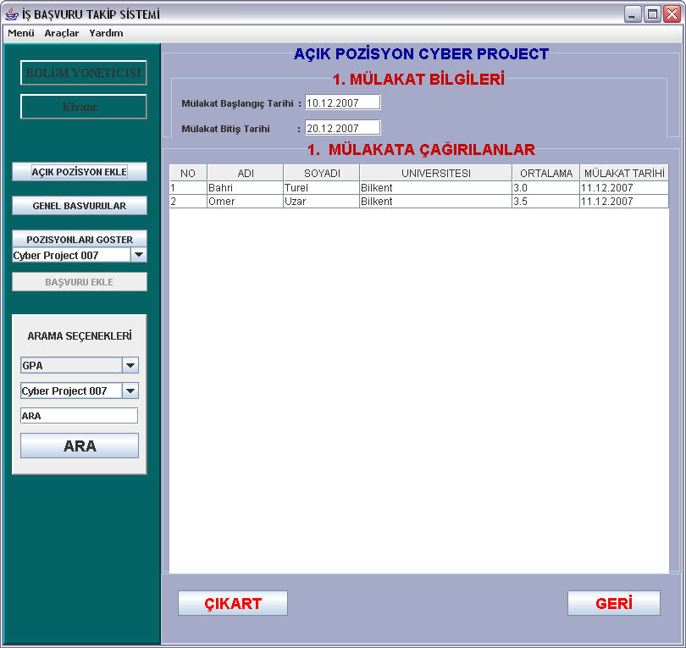
Figure 12. First Interview Screen

Second Interview Window
This screen will be available for all authorized users of JAM. Users shall be able to
- See list of applicants who are accepted for second interview.
- See info of any particular applicant’s info in that list.
At this page, project or department manager shall be able to deselect an applicant for second interview while secretary cannot. Therefore, this page will differ according to user type.
This is the second interview window of particular Open Position that contains the applicants who applied this open position and called second interview. If user wants to delete one applicant from this interview list, he selects the applicant and presses the “ÇIKART” button and pop up screen appears to ensure that user is sure or not.

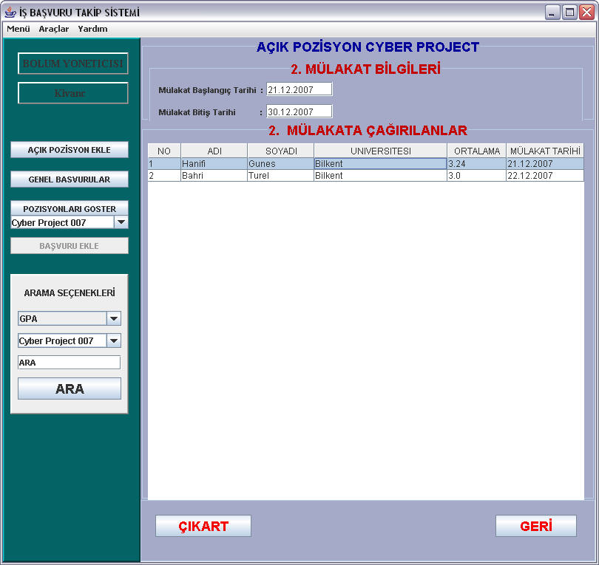
Figure 13. Second Interview Screen

Search Result
This page will be available for all authorized users of JAM. Users shall be able to
- See list if applicants that satisfies conditions of search criteria
- Go to applicant information page by selecting an applicant in that list.

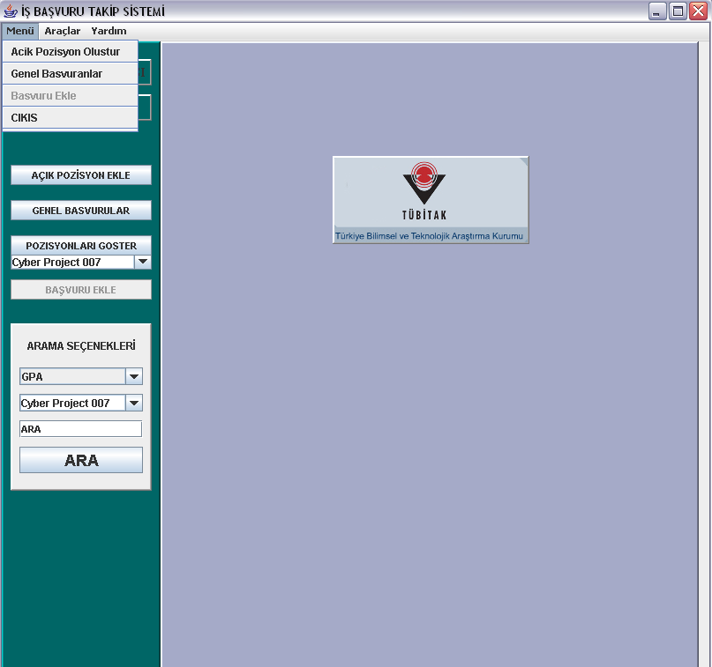
Figure 14. Search Screen

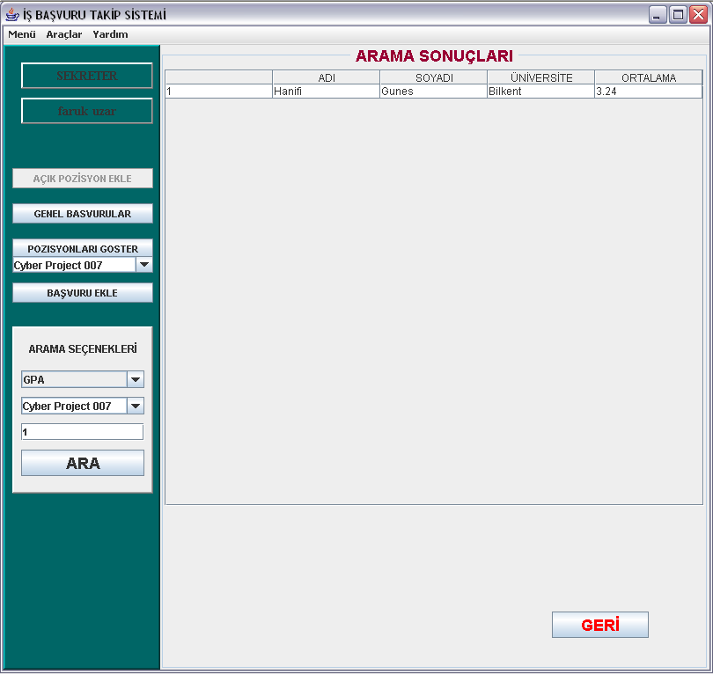
Figure 15. Result of Search Screen

DETAILED DESIGN

Module Detailed Design

AllAccounts Detail
AllAccounts is a module by which we hold the data of all applicants and retrieve them or make a search between all applicants. Its purpose to be generated is we are able to reach all info of all applicants via single module and having this property makes easy to search or update our database. It has three attributes which are shown below.
- currentAccountlist : This is an AccountList object which user makes operation on it. By this attribute, we do not forget accounlist to do operation during passing from one window to another window.
- lists : This is an array of Accountlist which holds all Accountlist data of our system. We are able to reach all data by this array.
- nofLists : This attribute holds the size of the list, that is, number of open positions.

There are functions that we can do by this module below:
- creatingNewAccount ( type, info ) : This function is used to add new account to ths system by giving its type and information including its name,surname, CV, etc.
- addNewAccountList ( name ) : This function is used to add new accountlist by its name for opening new position.
- getPositionNames : This function is used to get all position names.
- removeList ( name ) : This function is used to remove an account list when we want to close a position.
- save : This function is used to save after updating our database.
- search ( opepnposition, property, amount ) :This function is used to make search by giving criteria for search and openposition name.
- search( property, amount ) : :This function is used to make search by giving criteria for search at all positions.

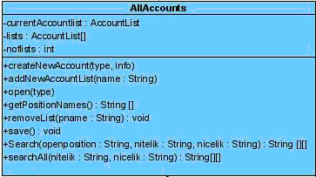

WarningList Detail
Warning list is module which we use for controlling and performing our warning system. Generally, whenever there is an update or event which has to be known by others, this module sends messages to users that are related to that event. It has two attributes which are shown below:
- list : This is an array of warning objects that holds all warning that are in action.
- noflist : This attribute holds number of warnings.

There are functions that we can do by this module below.
- addWarning ( to, from, message, date ) : This function is used to add new warning by giving its message, person to be warned, person who sends the message and date. This property of this module is activated whenever a new position is opened or closed or an interview is set.
- getWarning ( index ) : This function is used to get warnings and showing themt to the related person.
- save : This function is used to save in case a new warning is added or removed from system.
- load : This function is used to load the warning for our user interface in order to show the warning to the user.
- removeWarning ( index ) : This function is used to remove specific warning by giving its position in the array.

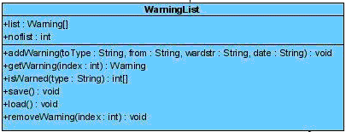

AccountList Detail
AccountList is a module which holds all applicants for a specific open position. Its purpose is to make easier operations such as search applicant or adding/removing applicants for a specific open position. It has three attributes which are shown below:
- position Name : It is the name of the open position.
- aplicants : This attribute is an array of applicant who are applied for that position.
- nofApplicant : This attribute holds the number of applicants who are applied for that position.

There are functions that we can do by this module below.
- updateAccount(info, index) : We can update any info of applicant by giving info to be updated and index number of that applicant in the array.
- addNewAccount( info ) : We can add new account to the system by giving its info.
- searchID( id ) : we can perform searches between all applicants by giving its ID.
- delete ( file ) : when we want to delete a records of applicant, we delete its info by giving its file pathname to delete his/her CV, transcript etc.
- save ( file ) : When we want to add new applicant to the system, by giving its filename to save his/her CV, transkript etc.
- addApplicant ( applicant ) : we can add new applicant for the position by giving applicant object as a parameter.
- getAccount ( index ) : We can retrieve applicants info by giving its index number in array to show in the info of applicants in list. Not to retrieve all data that we will not use in list, we get proxy of applicant that has smaller amount of applicant info.
- load() : we load the info of position in order to show it in our interface.
- removeApplicant ( id ) : We can remove any applicant from the position.
- save ( filepath , fileName ) : We can save any record by giving its path and its special name.

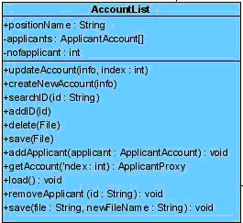

UserAcccountList Detail

UserAccountList module is a module that holds the data of users of JAM and does some changes on them. Purpose of this module is to hold the current user of the system and manage the security easier. This module has three attributes that are shown below.
- currentUser : This attribute holds the user who are using JAM at that time.
- userlist : This attribute is an array of users that holds all users of JAM.
- nofUser : This attribute holds the number of users of JAM.

There are functions that we can do by this module below:
- getPasswordName( name ) : This function is used in logging part in order to do provide security of JAM.
- addUser ( user ) : This functiın is used to add new user for JAM.
- changePassword ( newPassword, oldPassword ) : This function is used in order to change password of current user.
- save() : This function is used to save the changes of the system
- load() : This function is used to initialize the user info of system at the beginning of JAM.
- getUser ( name ) : This function is used to get the specified user in order to use at other functions.
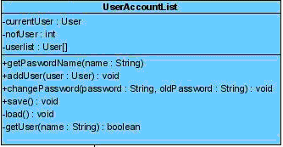

InterviewList Detail

InterviewList module is a module that holds the required data for any interview. The purpose of this module is to make easy operation about interviews since there can be many interviews for each position. This module prevents the possible confusion in retrieving data or changing it. This module has six attributes that are shown below.
- positionName : This attribute holds the name of the position that current interview list belongs to.
- applicants : This attribute is an array of applicants that are called for an interview.
- beginDate : This attribute holds the beginning date of interview.
- endDate : This attribute holds the last date of interview.
- nofApplciant : This attribute holds the number of applicants of that interviewList.
- type : This attribute holds data type of the interview. It can be one or two since there are two interviews for a position.

There are functions that we can do by this module below.
- update ( type, account, info, isAccepted) : This function is used to do operation on our database. We give type of interview ( first or second), index and info of account and result of interview ( accepted or not ) and do the necessary change on our database.
- addAccount( account ) : This function is used to add new account for that position’s interview list.
- setDate(date): This function is used to set date of interview.
- interviewList(name, type): This function is used to get any type interivew of any position and current interviewList position name is set to name of this method.
- getApplicant (index): This function is used to select applicant by giving its index. This index is determined by row number of table that applicant is shown at user interface of JAM.
- load(): This function is used to initialize data of user interface part of JAM like filling table.
- removeApplicant(id): This function is used to remove applicant from current list. This function is used when an applicant is rejected.
- save (): This function is used to save changes in our database.

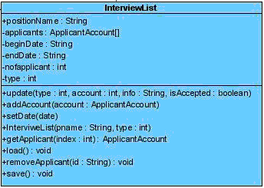

CommentList Detail

CommentList module is a module that holds the comments of all users and manages them. By having this module, we are able to retrieve comments easier and it prevents possible confusion. This module has two attributes that are shown below.
- comments: This attribute holds all the comments in JAM.
- nofComments: This attribute holds the number of comments in JAM.
There are functions that we can do by this module below:
- addComment( type,comment,writer ): This function is used to add new comment for to an applicant by giving comment, writer and type as a parameter.

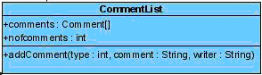

Controller Detail
Controller is a module which we use to manage JAM. Its purpose is to prevent confusion and manage easily. This module initializes all object at start of JAM. This module has five attributes that are shown below.
- all : This attribute holds AllAccounts object.
- current : This attribute holds current user who is using JAM at that time.
- userList : This attribute holds UserAccountList which is used for security.
- warn : This attribute holds WarningList for warning usecase.
- s : This attribute holds Security object.
There are functions that we can do by this module below:
- addUser( String [] ) : This function is used add new user to JAM.
- changePassword( currentPassword, newPassword ) : This function is used to change password of current user.
- changeSecretQuestion ( currentPassword, question, answer ) : This function is used to change secret question of current user.
- setCurrent ( user ) : This function is used to change current user.

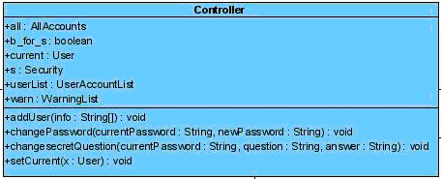

Security Detail
Security module provides security of JAM. This module has three attributes that are shown below.
- wrongAttempt : This attribute holds number of wrong Attempt of user.
- userlist : This attribute holds all users info for security.
- canTry : This attribute holds the data whether user can try or not.
There are functions that we can do by this module below:
- logInto ( id, password) : This function is used for logging process.
- lockProgram() : This function is used to lock program when user performs wrong attempts for three times.
- Security ( userAccountList ) : This function is used to provide security process.

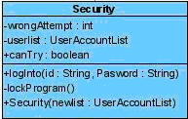

Data Detailed Design

Open Position Entity Detail
This entity is used to represent the open position. When a new position is opened an instance of this class is created. Being a general purpose data holding instance, this entity is a base entity in our system decomposition. It holds following properties and has some functionality.
- positionName: A string representing the name of position like software engineer
- createdDate: Date of creation of this position.
- jobDesc: A string describing the job itself.
- deadline: This is the due date to apply this open position.
- allAccounts: This is another entity. This holds all the accounts currently available in the system. This entity is required here in order to make a search between different applicants who did not apply this open position. It might be useful for other positions to consider other applicants.
- interviewList: This is another entity that holds the list of interviews for this position.
- qualification: Qualification of the position opened is hold in the entity by this property.
- createPosition(info, desc, deadline): This function is used to open a new position.
- addAccount(type, account, parameter): This method adds an applicant to the current position
- load(positionName): Brings all the information related to the position with supplied name from database.
- save(): Saves the changes into position if any.

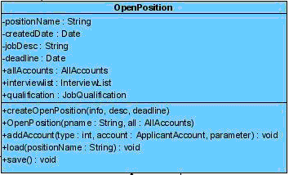

Warning Entity Detail
This entity is used to realize warning mechanisms in our system. Warnings are used to communicate between company employees during application evaluation. For instance, when an applicant is accepted to a job, secretary is warned by the team leader to call the applicant for good news. This entity has the following properties:
- from: This is of type string and represents the sender of the warning.
- toWarnType: This is of type string and represents the receiver of warning.
- warning: This property is text of warning. In other words, this is the body of warning.
- warningDate: This is of type date and represents the date when the warning is sent.
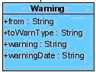

User Entity Detail
This entity is used to represent the users registered to our system, JAM, like secretary, project manager etc. This is one of the most base entities of our design. System can be used by only the registered users. Properties and functions of this entity are the following:
- name: Name of the user is hold within this property.
- surname: Last name of the user is held in this property.
- userType: This is of type integer and represents the type of user. Available types are secretary(1), project manager(2) and department manager(3).
- userid: Id of the user that is held in database.
- isAutherized: This is a Boolean which represents if a user is authorized. This is set to true when registration of a user is approved.
- password: Login password of the user.
- secretQuestion: This is a string which holds the secret question that is asked when the user looses his/her password.
- secretAnswer: This string holds the answer of the secret question.
- openUserAccount(type): Any user can open a new user account by supplying its type.
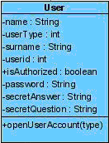

JobQualification Entity Detail
This property is used to represent the general qualifications of an open position. These can be in different areas like programming languages known, operating systems, experience etc.
- pl: This property is used to determine which languages are preferred for an open position.
- requirement: Being a string this property holds the specific requirements for job. For instance at least 5 year of experience in web-based technologies.
- os: Operating systems that the applicant should know is held under this property.
- additionalReq: This property is filled with any additional requirements if any.
- businessBackground: Work experience and the companies worked before is listed in this property.
- load(): loads a job qualification from database.
- save(): saves the qualification if any change exists.

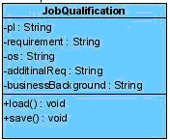

ApplicantAccount Entity Detail
This is an applicant information for a position. Besides the personnel information of the applicant, this entity includes the application process information like exam results, interview results and so on. These are the properties and the functions of the entity.
- email: E-mail address of the applicant to communicate.
- id: id of the applicant which is stored in the database.
- birthdate: Date of birth of the applicant.
- calledInterviews: Interviews that the applicant was called is held as string.
- noOfApplication: number of applications that user applied in the company.
- calledFirstInterview/ calledsecondInterview: Boolean representing if the applicant is called to first/second interview.
- cellPhone: Cell phone number of the user.
- characterExamResut: Result of character examination which is float.
- technicalExamResult: Result of technical examination which is float.
- city: City where the applicant applies.
- dateOfApplication: Date of application when the applicant applied.
- homeAddress: Home address of the applicant.
- foreignLanguages: Languages known by the applicant.
- militaryServiceStatus: IS the military service is done or not.
- applications: string array of application made before.
- addComment(type, comment, writer): Adds a comment to the applicant for the current application.
- addApplications(application): adds application to the application list of this applicant account.
- load(id): loads the applicant account with id supplied as parameter from database.
- removeApplication(application): Removes the application when it is determined and concluded.
- save(id): saves the application account with d supplied as parameter.
- update(info): updates the information of the application.

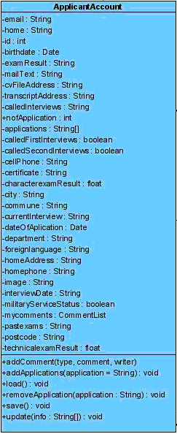

ApplicantProxy Entity Detail
This entity is used to represent the applicant. When a applicant make an application to an Open position, the main personal information of applicant is in this entity.
- name: A string representing the name of the applicant.
- surname: A string representing the surname of the applicant
- id: ID of the applicant
- interviewDate: The interview date of the applicant.
- gpa: GPA of the applicant.
- university: University of the applicant.
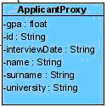

Comment Entity Detail
This entity is used to represent the comments made for the applicant. When an applicant makes an application to an open position, project manager or department manager makes a comment to the applicant. So the department manager can use these comments to decide to choose the applicant.
- writer: A string representing the name of the writer of the comment.
- type: describes the type of the writer (Department or Project manager).
- date: This is the date of comment written.
- comment: Comment it self.

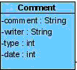

Logical Architecture
There is diagram that shows the relationship between modules and user interface at Figure 16.

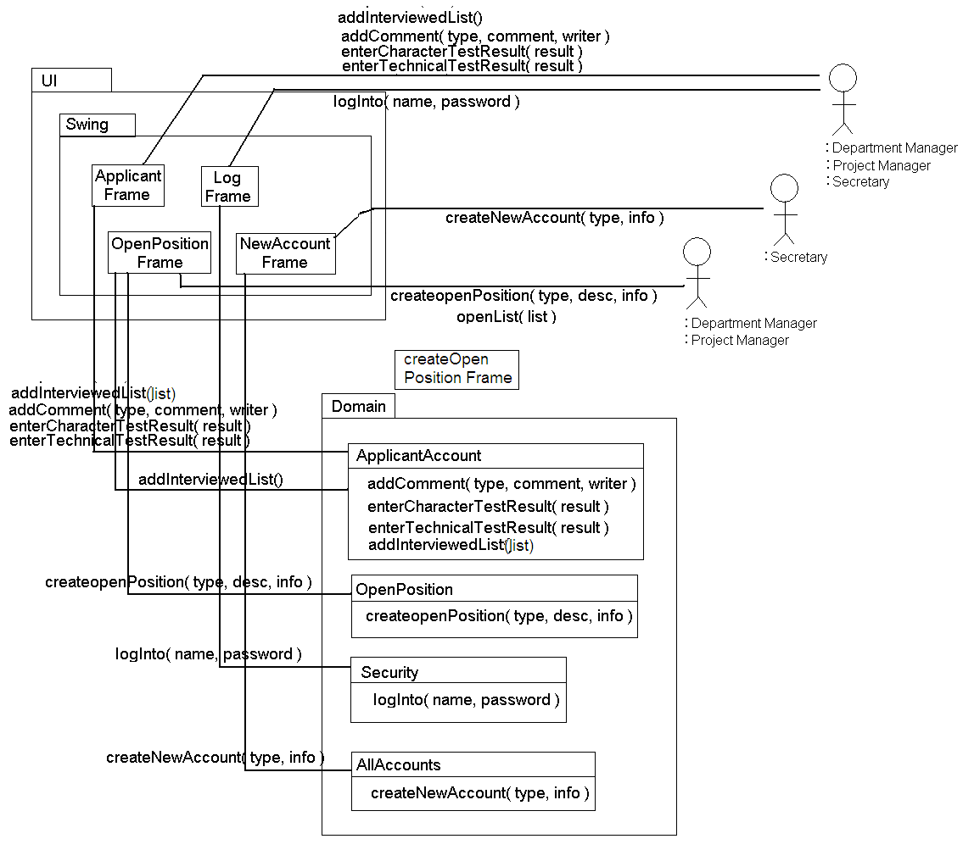
Figure 16. Diagram for user interface & module relation.

UML INTERACTION DIAGRAMS

Create Open Position

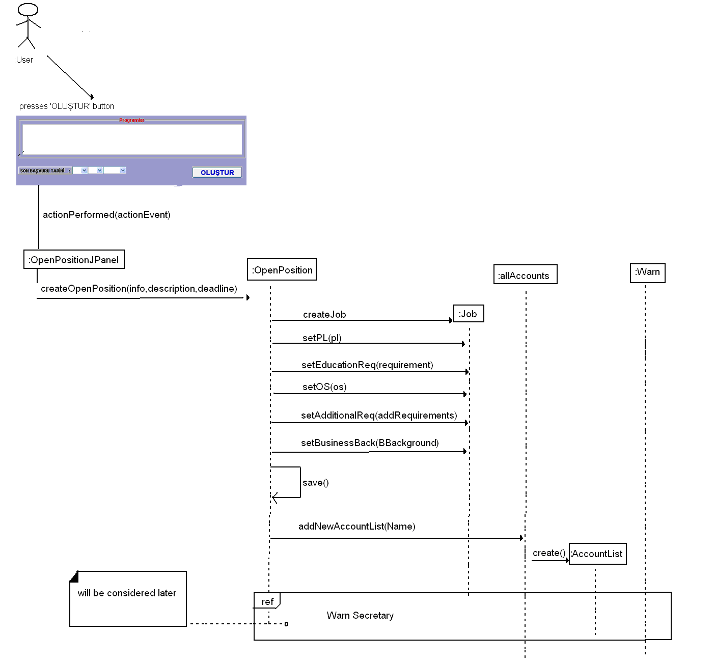

Register New Applicant

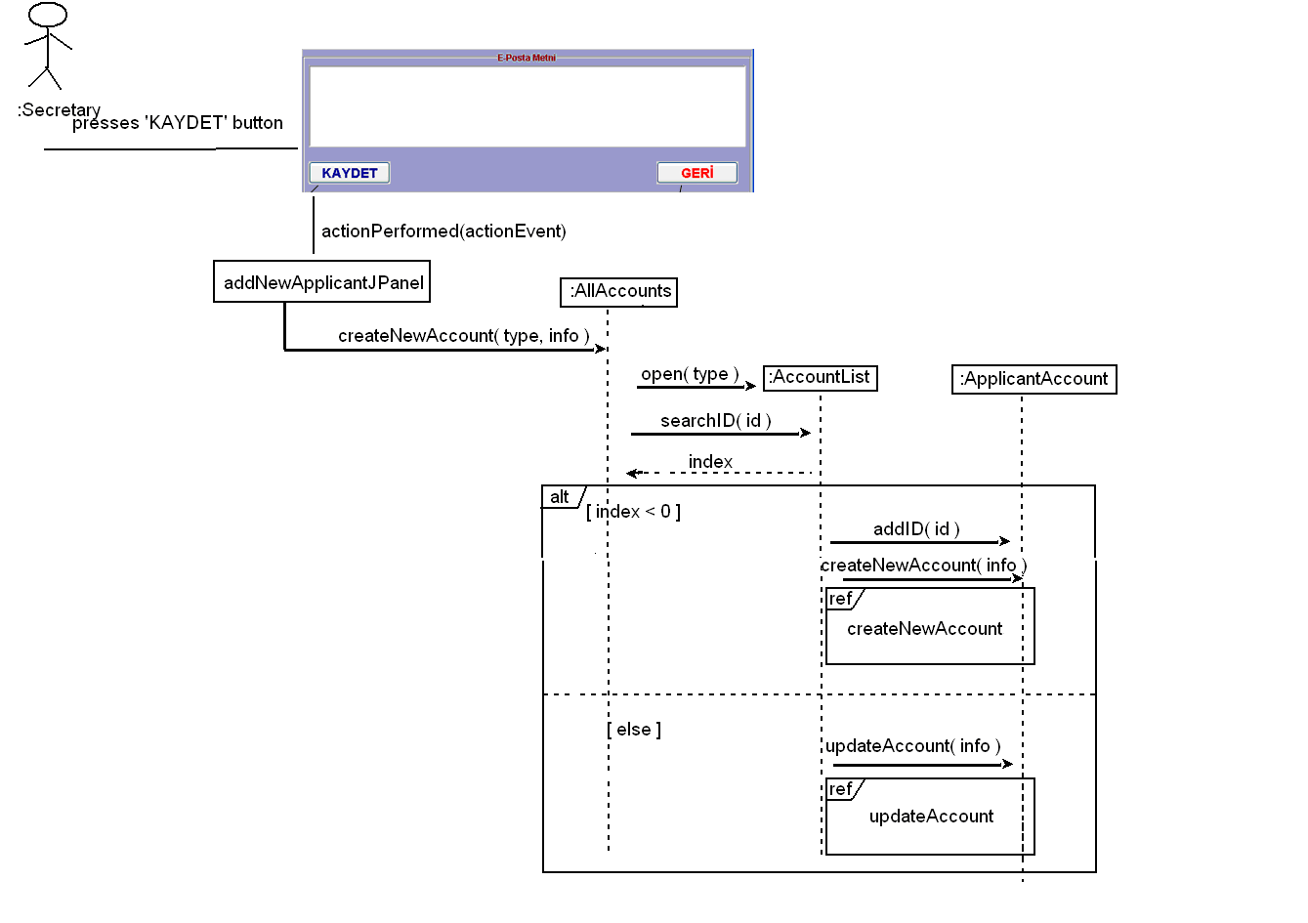

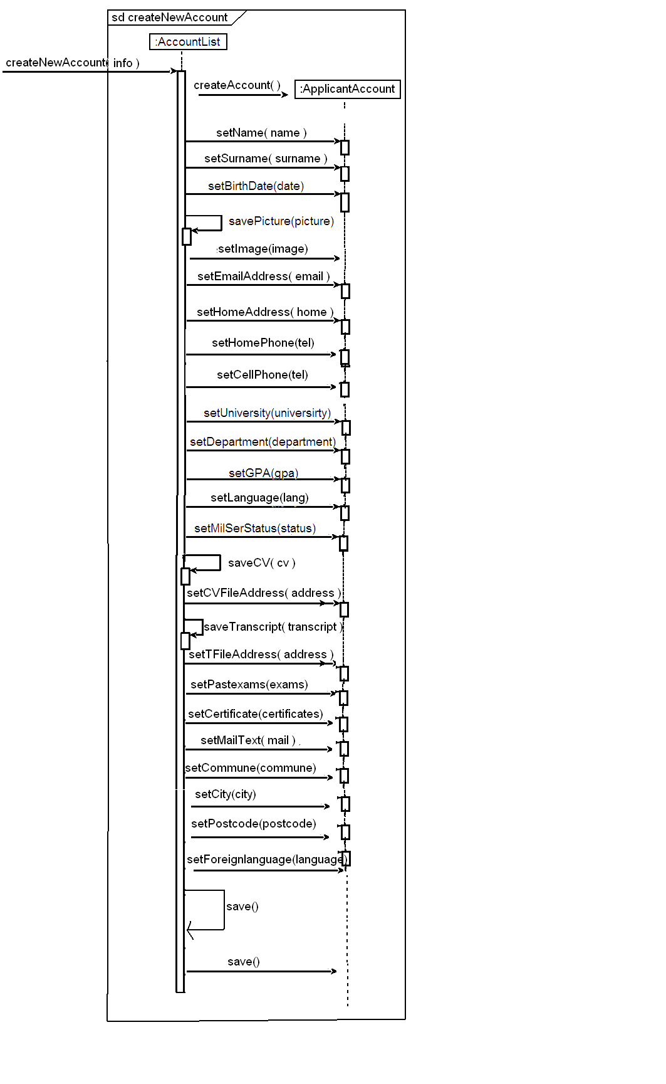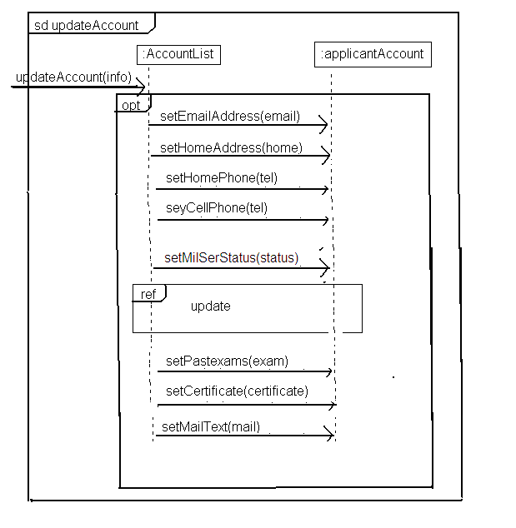

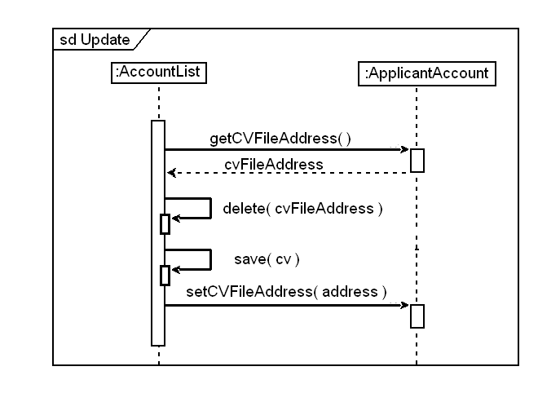

Determine Applicants for First Interview:

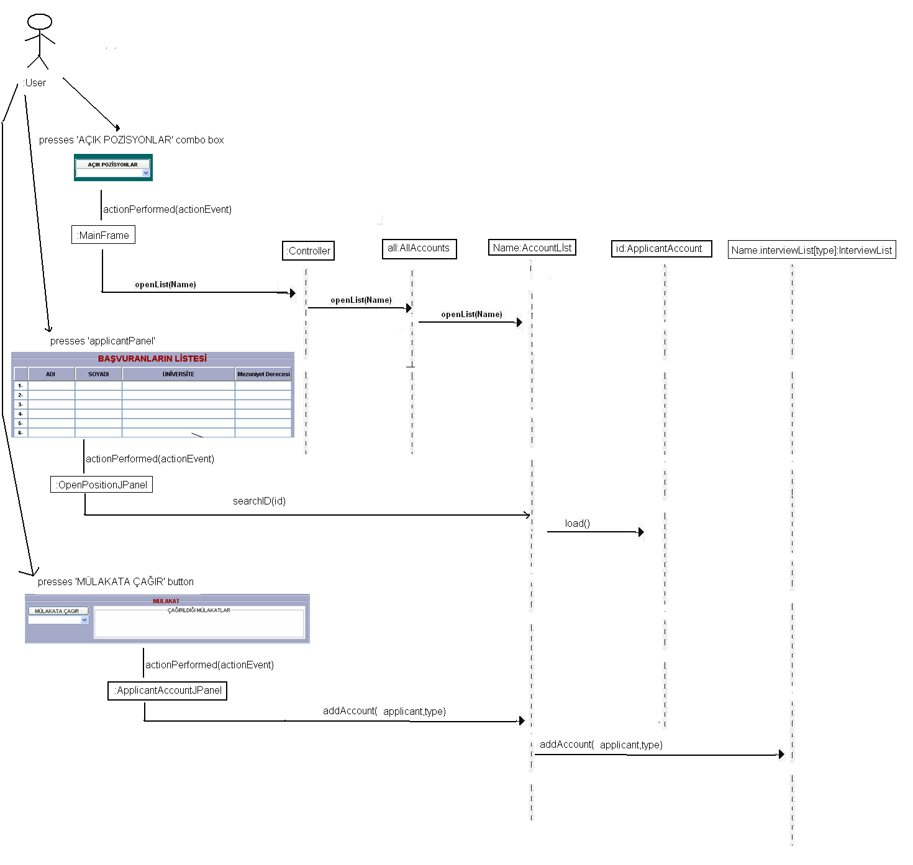

Add comment for a particular applicant
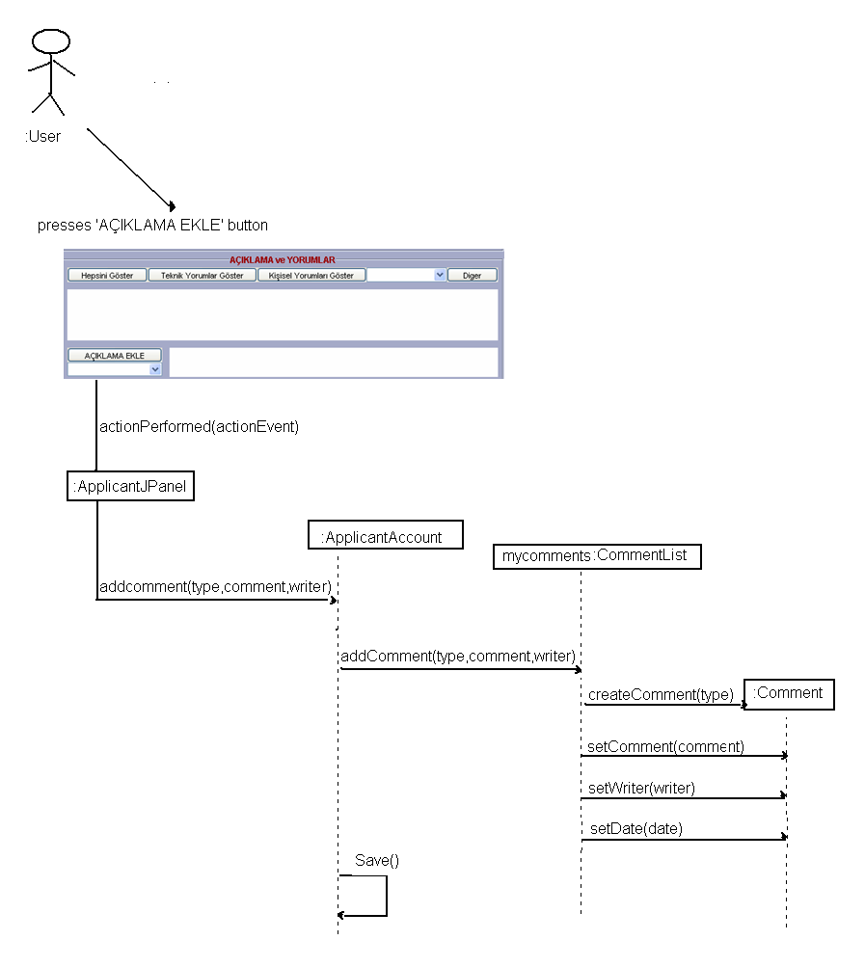

Log Into System
