TWO DIMENTIONAL ARRAYS

It’s an array of arrays.

1
2
3 ROWS
4
5
6 1 2 3 4 5 6 7 8 9 10 11 12
Columns

Example 1:
int[][] table=new int[5][10];

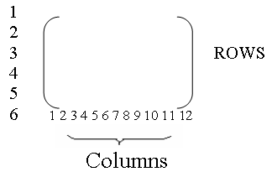
table[5][12]
for(int row=0; row<table.length; row++)
for(int coloumn=0; coloumn<table[row].length; coloumn++)
table[row][coloumn]=100*row+coloumn;
System.out.println(table[row][coloumn]);

for(int row=0; row<table.length; row++)
{
for(int coloumn=0; coloumn<table[row].length; coloumn++)
{
System.out.println(table[row][coloumn]+ “\t”)
}
System.out.println();
}
Example 2;
import java.text.DecimalFormat;
int[] array={1,2,3};
int[][] matrix={{1,2,3,4},{5,6,7,8,10},{0,0,0,0}};

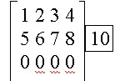
final int nRows=matrix.length();
final int nCols=matrix[0].length();

int[] rowSum=new int [nRows];
int[] colSum= new int [nCols];

for(int i=0; i<nRows; i++)
rowSum[i]=0;

for(int row=0; row<nRows; row++)
for(int col=0; col<nCols; col++)
{
rowSum[row]+=matrix[row][col];
colSum[col]+=matrix[row][col];
}
DecimalFormat fmt=new DecimalFormat(“0,#”);
System.out.println(“averages”);
for(int row=0; row<nRows;row++)
System.out.println(“row#” +(row+1)+”:”+fmt.format((float)rowSum[row]/nCols);

Call By Value:
public int f(int a, int b)
{
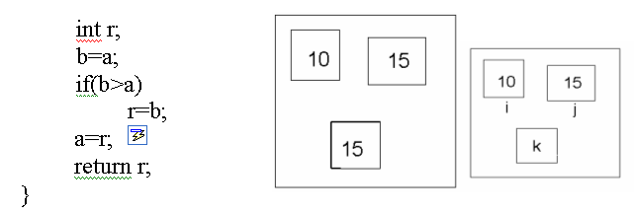

Array is used Called By Reference
public int f1(int[] a)
{
int r=0;
for(int I=0; i<a.length(); i++){
r+=a[i];
a[i]=i;
}
return r;
}

Main
int[] array={10,20,30};
int k=f1[array];
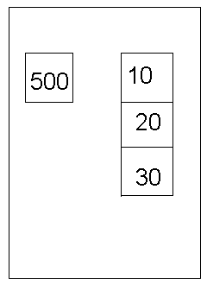

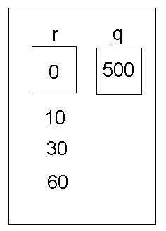

public int f2(int x)
{
int r;
r=10+x;
x=r;
return r;
}
Main
int[] arrya={10,20,30}
int k;
k=f2(arrya[0]);
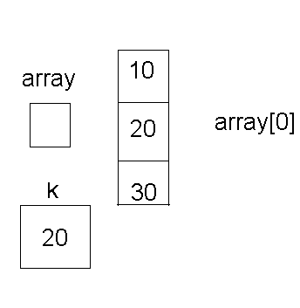

public class MT
{
public int x;
public int y;

public MT (int a, int b)
{
a=b ;
}
public void swap() ;
int temp=x;
x=y;
y=temp ;
}
public String toString()
{return “(“+x” “+y”)”;
}
public MT copy()
{
MT result=new MT (x,y);
return result;
}
Main
int a,b,c;
a=new MT(1,2);
b=new MT(3,4);
c=a;
c.swap;
System.out.println(a+b+c);

A+b;
B=c;
b.x=42;
System.out.println(a+b+c);

QUESTIONS:
1) What’s method Overloading?
Ans:
Using two methods with same names but for different purposes.
2) What’s alias?
Ans:
Java use addresses of the objects instead of the objects themselves. These references are called alias.
3)What will the fallowing program print?
int[ ] [ ] x = {{1,2,3}, {0,0,0},{9}}
int [ ] [ ] y={{0,0,0},{1,1,1},{2}}
x=y;
x[0][0]=99;
x[0][1]=99;
x[0] [2]=99;
System.out.println(”y[0][0]= ” +y[0][0])

Ans: 99
4)What to do if you want to make two equal two dimensional arrays but don’t want the changes you make to one to affect the other?
Ans:
Instead of “array1=array2;”
Do the following;
for(int rows=0; rows<array1.length( ); rows++)
for(int cols=0;cols<array1[rows].length( );cols++)
array1[rows][cols]=array2[rows][cols];
5)Write a program so that it will print out a three dimensional array.
Ans:
for(int 1D=0; 1D<array.length( ); 1D++)
for(int 2D=0; 2D<array[1D].length( ) ; 2D++)
for(int 3D=0; 3D<array[1D][2D].length( ); 3D++)
System.out.println(array[1D][2D][3D]);

