INTRODUCTION TO JAVA

Variables & Constants

Concept Of Algorithm: An algorithm defines the steps used to solve a problem. (It shows the steps of producing the desired outputs using the inputs.)

INPUT(S)
ALGORITHM
OUTPUT (S)

a=$\sqrt{b}$
- An algorithm must have an input(s) & output(s).

- It must be correct.

- It must stop.

- It must be unambiguous (clear).

b a
$$\sqrt{b}$$

9 3

4 2

a= max (x, y)
a= max (x, y)
x
a
y
x y a
5 10 10
2 0 2
BLACK BOX

Problem:

Find the maximum of two numbers. Algorithm in the form of a flowchart.

First of all let’s see the shapes that used in a flowchart.

START, END
INPUT
OUTPUT
COMPUTATION & ASSIGNMENT
DECISION MAKING
CONNECTOR
CONTINUOUS PURPOSES

And here is an example for a simple flowchart & the solution of our problem.
START
READ X, Y
X>Y?
NO (FALSE)
YES (TRUE)
A=Y
A=X
DISPLAY A
STOP
This was a simple flowchart. And now time to trace our flowchart.

x y a
5 10 10
2 0 2

PSEUDO CODE

Start

Read x, y
If (x>y) then

a=x

Else

a=y

End if
ELSE
THEN

A=Y
A=X

X>Y?

Display a

End

Let’s pass to another problem.

Problem:

a= | b |

In this problem first we can draw a “Black Box” to understand it. Then we can draw our flowchart

BLACK BOX PRESENTATION

Black Box

b a
a= | b |

START
READ b
b>0?
a = - b
a = b
DISPLAY a
STOP
FALSE
TRUE

Questions

1- Trace the algorithm $a=\sqrt{x^{2}+y^{2}}$ for the given x , y values . ( 12 , 5 ) , ( 4 , 3 ) , ( 8 , 15 )

2- Draw a flowchart which calculates sgn (A) =$\begin{aligned}\left\{1,A>0 | \right.\left\{0,A=0 | \right.\end{aligned}$ and trace it for the given values. –3, 21, 0

3- Trace the algorithm “a” is the minumum of the three numbers for given numbers (2,7,4) , (7,9,1) , (4,2,8)

4- Draw a flowcart for the problem; if “x>y” draw a star (*), else draw a dot(.).

5- Draw a Black Box equation for a=|x| * |y|

Answers

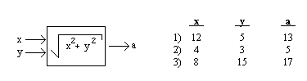1-

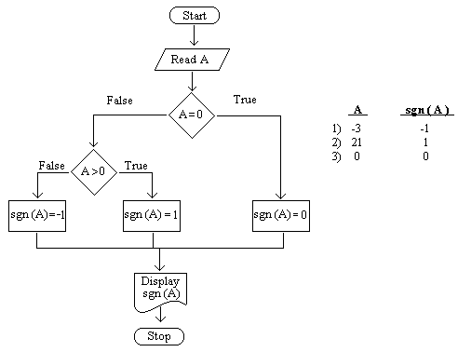2-
3- x y z a 2 7 4 2
7 9 1 1
4 2 8 2
a= min (x,y,z)
x
y a

z

5-

A = |x| * |y|

x a
y

4-
START
READ X, Y
X>Y?
NO (FALSE)
YES (TRUE)
Draw a “.”
Draw a “*”
DISPLAY THE RESULT
STOP

