SUMMARY OF JAVA LECTURE WEEK 1

Prepared by Kerem Sabri MENTEŞ and Kaya DEMİR

A computer system is made up of software and hardware.

1- Hardware: They are the physical components of a computer. We can classify as,

CPU: Central processing unit

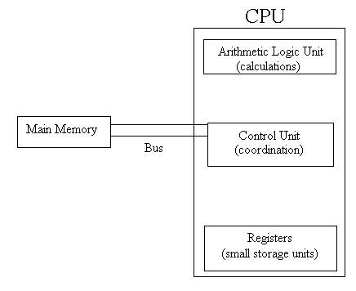

Main Memory: RAM (random access memory, sd rams, rd rams, ddr rams)
Secondary Memory: Permanent storage for data, hard disks, floppy disks.
We can also see Rom in memory mentality.(read only memory)
Input/output devices: They allow human beings to interact with computers.
Input: Keyboard, mouse, scanners. Output: Monitors, speakers, goggles, printers.

2-Software: Includes instructions for hardware execution.
Operating systems (windows, unix, dos)
Application programs (word, frontpage, excel)

Paging
Programs are executed easily by using the method called paging. It means the transferring of only the part of the program that will be used from hard disk to main memory.

Instruction Execution

- Fetch (bring the instruction from memory to instruction register.
- Decode (understand the purpose of the instruction
- Perform (execute)

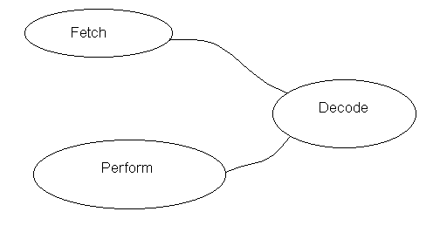

How to store information in memory?

Byte=8 bits bit: binary digit(0,1)

1 Kbyte=1024bytes=2¹⁰ bytes
1 Mbyte=1024.1024=2²⁰bytes
1 Gbyte=1024.1024.1024=2³⁰bytes
1 Tbyte=1024.1024.1024.1024=2⁴⁰bytes

byte=xxxx xxxx
0100 1100_{2 (the base is 2)}
Decimal Number System : Base 10 digits 0,1,2,3,4,5,6,7,8,9
Binary Number System : Base 2 digits 0,1
Hexadecimal Number System : Base 16 digits 0,1,2,3,4,5,6,7,8,9,A,B,C,D,E,F

15.65=1.10¹+5.10⁰+6.10⁻¹ + 5. 10⁻²

11.01= 1.2¹+ 1.2⁰+ 0. 2⁻¹ + 1. 2⁻²

HEX. BIN.
- 0000
- 0001

- 0101
- 0110
- 0111
- 1000

A 1010
B 1011
C 1100
D 1101
E 1110
F 1111

001 1011₂ : 1B₁₆ (Group them from right to left by 4 bits)

Data represantation:
Both data and programmes are stored by using binary numbers

Types of Data:
  - Numeric Data( integer, real)
  - Character Data(ASCII 1 byte/ character EBCOIC :Used by IBM main frame)

Character ASCII
- 30

A 41
B 42

P 50

a 61
b 62

z 7A

In memory, stored in binary form
Hexadecimal used for easy interpreting

Robo

Robo is a sweet robot with a pen who helps us draw pictures buy using simple commands.
Robo will teach us the principles of programming step by step.

f : forward r : turn right l: turn left x : repeat d : do the procedure
f(250) r(90) l(90) x 3 circle d circle(name of the method)

Questions:
1. Can you find the ASCII represantation of the letter F if the represantation of A is 41 in hexadecimal system?
2. Consider that the representation of a is 61 in hexadecimal system. Then, can you write how the word, Computer, is stored in memory?
3. Can you convert this number, 1101001001001011,from binary to hexidecimal system?(Hint: Group them four by four if you know the reason for that.)
4. Can you give an example of ROM that we can change the information on it ?(Flash Rom)
5. What is the aim of the instruction register?

