How to Write and Execute a Program?

Problem

- Sub problems ( Divide and conquer the problem into sub problems)
Java Program
Java Translator

(compiler)
Bytecode
(equivalent of object code )
Source
Program
Compiler
(Translator)
object
Memory

Executable
Program
Library filc in machine
language

Linker
and loader

Written by the programmer

Robo :

F(x):move x units forward
R(x):turn x degrees to the right
L(x):turn x degrees to the right
P:pen up and pen down
r(30)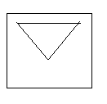
f(200)
r(120)
f(200)
r(120)
f(200)

PROBLEM SOLVING& PROGRAMMING

- The purpose of writing a program is to solve a problem. Problem solving consists of multiple steps:

- Understand the problem.
- Dissect the problem into manageable pieces.
- Design a solution.
- Consider alternatives to the solution and refine it.
- Implement the solution.
- Test the solution and fix any problems that exist.

Key Idea:Divide&Conquer!!

Problems

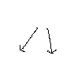
Sub Problems Sub Problems

- ALGORITHM: It is the step by step definition of the solution of a problem. In other words, we can say that it is the step-by-step process for solving a problem. For you to understand it clearly some examples for algorithms are stated below:
- A recipe,
- Travel directions,
- Operating a machine, etc.

!!!REMARK: Every program implements an algorithm. So every software developer should spend time thinking about the algorithm before writing any code.

An algorithm must:
- Have more than one input,
- Have at least one output,
- Be clear,have unambigious steps,
- Stop, come to an end,
- Be correct!!

- An algorithm can either be described by a flowchart or by using pseudo code.

FLOWCHART SYMBOLS:

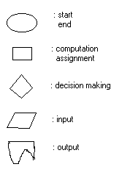

Example: Find the maximum of x and y, assign it to A.

ALGORITHM
START

READ
X, Y

X>Y

A=Y
A=X

DISPLAY
A

STOP

X
A=
Maximum(X,Y)
A
Y

Black Box: We know what it does for us but we do not know how.

- PSEUDO CODE: It is a mixture of code statements and English phrases, writing the solution in natural language.

- // Find the maximum of x, y and assign it to A

read x,y

if x>y then

A=x

else

A=y

(end if)

display A

stop

Example: Find maximum of X,Y,Z and assign it to A

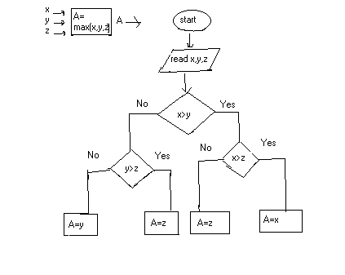

Trace : X/1 Y/5 Z/10 A/10

