Zero to Java in Internet Time

David Davenport
Computer Engineering Dept.,
Bilkent University, 06533 Ankara - Turkey
email: david@bilkent.edu.tr

Abstract: First year engineering students often start with zero computer experience and must rapidly assimilate not only basic computer and Internet literacy skills, but also the programming of object-oriented systems and event-driven graphical user-interfaces. In order to make this experience worthwhile and relevant to all students, we organised our first year programming classes to focus more on fundamental engineering skills and use programming merely as a means to promote these values, not as an end unto itself. This paper describes our course and the rationale behind it, as well as some of the tools we have developed to support it. These tools, Robo & JRobo, provide simplified environments which help introduce basic programming, software engineering, and object-oriented design and programming concepts, in a very concrete way. This provides the foundation for semester-long design projects in which student groups produce real-world applications in Java. Java's support for OOP and Internet standards make it relatively easy to incorporate network and database components, and thus encourages students to tackle larger, more sophisticated projects than has been possible in the past. Tapping student enthusiasm in this way provides increased opportunities for vital engineering skills to be practised and learnt.

Introduction
Today's students have to cope with a vastly more complex and rapidly changing world than their predecessors and nowhere is this more apparent than in the programming classes taken by freshmen engineering students. In addition to learning basic programming and computer literacy skills, students are now confronted with the Internet and the added complexities of programming object-oriented systems and event-driven graphical user interfaces.

Programming classes are often mandatory for all first year engineering students -in our case CS, EE, IE & even some science students too. The task is to take such freshmen students, who frequently have zero computer programming experience and get them up-to-speed as quickly as possible. By focusing on fundamental engineering skills and concepts, rather than mere programming and syntax, we hope to make the course manageable, interesting and relevant, and hence able to justify its place in an already overcrowded curriculum. This paper details our approach and experience in teaching this course, and presents the tools we have developed to help us in this endeavour.

What to Teach and Why?
To be successful, engineers today must be not only technically competent, but must be able to work together in teams and be able to communicate clearly and concisely in written and oral form. They should have confidence in their ability to locate and apply knowledge, and be motivated to follow technology and continue learning throughout their careers. However, while they should certainly be computer and Internet literate, except for prospective software engineers, they do not necessarily need to be able to write programs. A programming class in the first year engineering curriculum thus seems justifiable only if it helps meet these more general objectives. Surprisingly, perhaps, such a class can be an excellent vehicle for this; programming, after all, is a form of communication, one that, if it is not clear and precise enough, neither the computer nor other people will understand. Software engineering is about designing such communications. It frequently involves very complex systems and so is usually done by teams of people. Such characteristics thus make it an ideal training ground for prospective engineers. Our task, as educators, is to take advantage of this, and of the natural curiosity and affinity that students often have for computers, and meld it to our own ends.

Engineering relies on methodologies and techniques which, when correctly understood and applied, should pretty much guarantee success in any size project. Unfortunately, the need for such techniques only become apparent when sufficiently large problems are undertaken and so beginning programmers are rarely exposed to such difficulties. The current wisdom is to teach object-oriented design/programming right from the beginning, avoiding the need for students to switch paradigms which can allegedly take experienced programmers 18 months or so [1]. Taking advantage of the information hiding inherent in OO systems provides opportunities to work with complex systems, however, students do need to have acquired certain basic skills before they can make much use of objects at all. Moreover, the procedural top-down structured approach is widely applicable outside programming (for example, in essay writing, project planning, etc.) making it a generally useful technique for all engineering students to learn. There is also a huge amount of such old-style software still in the field and in need of maintenance, so it would seem advantageous for computer students, at least, to have some experience of structured programming. For these reasons, we elected to continue to teach basic procedural programming and structured design first, albeit at a significantly reduced level. Doing this seems to provide a reasonably smooth transition into both functional design and the mechanics of OOP.

Many factors, particularly historical ones, influence the choice of language. While CS students would probably have to learn C++ sooner or later, it was not considered particularly appropriate as a first language, thus, when the course was first implemented, our Pascal background made Delphi the natural choice. Several years later, when Java appeared, this decision was reviewed and in common with many other schools, it was decided to switch to Java. Its close association with the Internet, plus its relatively clean and consistent OOP syntax, the fact that it is free, platform independent and (nowadays) powerful enough to build real-world networked applications, seem to make this a logical choice. Pedagogically, however, Java is not particularly friendly and even writing a simple program that will read in and add two numbers, can be something of a challenge! This can easily result in students (and faculty) concentrating on syntactic details, at the expense of more important things.

Based on these observations we reorganised our course so as to use Java and to concentrate on the broader engineering goals rather than just programming per se. Several tools have been implemented which help hide messy syntactic details and give students a taste of "large" problems in the hope that they will consequently achieve better understanding and appreciation of the overall engineering mentality.

Course Organisation
In order to smooth the transition from school to university, we decided that our first semester classes retain a relatively conventional lecture-based approach, supplemented by weekly laboratory assignments. This also helps ensure that all students gain the necessary background skills and understanding (initial labs, for example, cover using Windows98 computers, using the web, email, and word processing -especially styles and outlines.) We have developed two teaching tools that introduce fundamental programming concepts. The first, Robo, tackles basic procedural programming and software engineering issues, while the second, JRobo, extends this to object-oriented programming (the next section has a detailed description of Robo & JRobo.) Both tools are designed to provide a simplified environment in which the main concepts can be developed quickly and in a very concrete fashion, avoiding too much cognitive overhead. In this way, students get to see all of the ideas compressed in a very short space of time and, hopefully, come to appreciate the rationale behind them. Having thus established the "big picture," the remainder of the time is devoted to filling-in the details, mainly syntax, and in becoming proficient in their application. By the end of the semester, students should be familiar with top-down design, basic documentation, constructs for sequence, decision, repetition, simple input/output and assignment, methods, creating and using objects of existing classes, and creating and using their own classes. They will also have been introduced to arrays and object-oriented design and object inheritance and polymorphism, although they may not be particularly familiar with them. This may seem a rather leisurely pace, especially given that it is all done in a text-based (non-GUI) environment. However, the difficulty and time required to acquire even minimal programming expertise should not be underestimated. Time spent establishing a solid foundation, prepares the way for the complex structures that must be built atop them and is thus surely time well spent.

The second semester is a combination of project and lectures (with occasional laboratory assignments.) The lectures begin with a review of OOP (especially inheritance, polymorphism & interfaces) and then concentrate on event-driven GUI programming and more conventional topics, such as recursion and simple data structures (stacks, queues, lists, and trees.) The real focus of this second course, however, is the semester-long projects. These are undertaken in groups of approximately six and are organised into four stages: requirements, user-interface, detailed design and implementation. At each stage, except the last, groups are required to prepare a written report and present it orally. Feedback is provided verbally during the presentation, and in written form afterwards (by the instructor and a peer group.) Reports are then revised and the next stage begins. Groups are required to put their reports and programs on a course webserver that also provides facilities for them to use Java applets, servlets, databases and, now, Java Server Pages (JSP.)

Students are allowed to select their own projects, provided that they are considered challenging enough. Projects should require students to go beyond what is explicitly taught in the course, thus challenging them to find out how to use such things as databases and network resources for themselves. Projects are also expected to be reasonably substantial, thus requiring students to share out the work and co-operate, if they are to succeed. The project is viewed primarily as a design exercise, so creativity, clarity and completeness are the most important considerations. We thus stress that fully working and tested implementations are not required, although they should attempt to do as much as possible within the time available. What is imperative, however, is that the basis of a complete implementation has been properly laid. If the program could be completed by someone else, without them having to start again from scratch, then it is judged acceptable. In fact, most groups do actually succeed in producing reasonable working demonstrations of their projects, an indication, perhaps, of the enthusiasm and effort students put into their work. Students are encouraged to use sophisticated IDE's (Integrated Development Environments, such as Visual Cafe & JBuilder) in order to reduce the programming effort required. This also has the advantage of getting students familiar with such complex programs.

A project open-day/competition is held early in the second semester each year (as the current class are just starting their projects.) This enables students to see what their predecessors did and, hopefully, encourages them to work harder. It also provides an incentive (in the form of prizes) for students to continue to polish their projects after the course finishes, ready for the following year's contest.

This year, we are also starting an informal, extra-curricular group of students and faculty, interested in both technical and social issues related to the Internet. It is hoped that this group will provide further encouragement and, by sharing knowledge, enable everyone (including faculty) to keep up with the rapidly changing world.

Tools
To introduce basic programming concepts and, at the same time, demonstrate the rationale for them, two tools, Robo and JRobo, are employed.

Robo is a much-simplified version of Logo's turtle graphics. It provides a very simple, concrete means by which to get students programming within minutes and facing obvious and serious difficulties of scale within the hour. Robo is a little robot that has to be instructed to move around his world such that the trail it leaves behind forms a given picture/pattern. Students are introduced to Robo's four basic commands, (f(x) - move forward x units, r(x) & l(x) - turn right/left x degrees, and p - alternatively pick up/put down the pen to toggle between leaving a trail or not) and then walked through a set of simple examples. This generates a lot of interaction and usually gets the class off to a good start! When they are feeling confident, a longer Robo program is given and they learn to trace and debug. This proves relatively difficult and, after a homework which results in an even longer program, students are asked to imagine that they now have to earn a living by the production of extremely large Robo programs and to reflect on the difficulties of the task. This sets the scene for the improvements, in the form of comments and meaningfully named methods. Using these we then talk about top-down design and the notion of pre and post conditions. Clearly, programmer productivity would be enhanced through reuse of previous solutions and this leads naturally to generalising methods through the use of parameters and to the idea of maintaining a library of useful modules that can be incorporated into new designs. It also demonstrates the need for improved documentation. Mechanical repetition is also introduced at this stage.

Having talked about all of these ideas "on paper" students are then given several exercises to solve in the laboratory. They are challenged to produce designs that work correctly the first time they are implemented. A computer environment, also called Robo, allows them to test their programs (see Figure 1.) A key feature of this environment is that programs/methods cannot be longer than 20 lines, thus forcing students to break their problem into pieces (although this doesn't guarantee good structure.) Students are also asked to make changes to each other's programs, simulating the maintenance phase of software development and, hopefully, reinforcing the importance of good design and documentation. The Robo program and teaching package are freely available [2]. Further details can be found in [3].

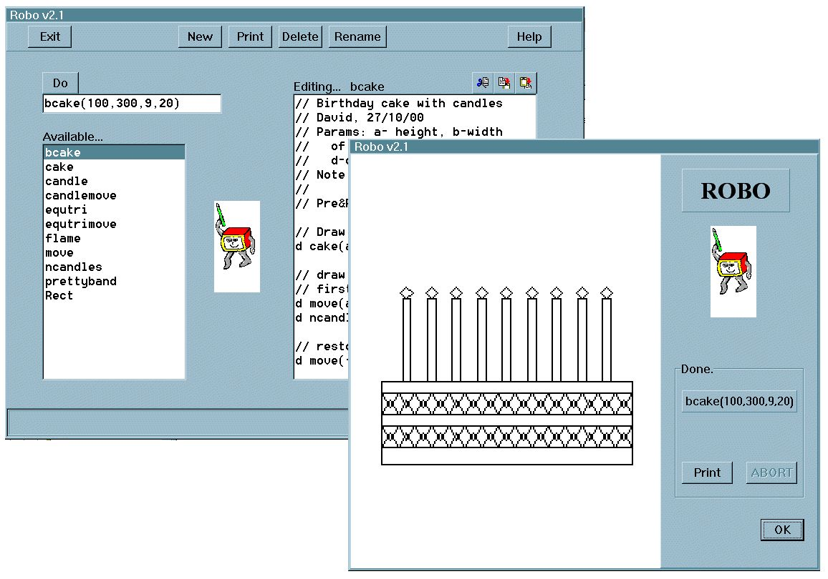

Figure 1. Robo screenshots

Following on from Robo, we talk about top-down algorithm development in pseudocode, first in terms of everyday tasks and then for more restricted computational-type problems. This leads naturally to the question of how information can be represented, to the development of a model for a computing device and to a discussion of the von Neumann architecture. Finally, the notions of compilation, byte-code, applets, etc., can be meaningfully introduced. At this point, students are usually introduced to a Java IDE and to Java syntax, and are given a sequence of programming exercises to practice on. Once they have mastered these we move on to Jrobo.

JRobo builds on Robo's procedural programming base by helping to demonstrate the concepts of, and the rationale for, object-oriented programs. OOP is introduced as (a) being a very natural way to view/describe the world, and (b) facilitating greater reuse of software. Students (particularly those with previous programming experience) are often surprised to see how easy and natural it can be to describe the world in terms of classes of objects, each having specific properties (state/attributes) and behaviour (functionality.) Since these correspond to data and methods, with which they are now familiar, students can quickly grasp these basic ideas. Mechanisms such as inheritance, polymorphism, etc., can also be appreciated very easily by showing how they facilitate software reuse. Since new problems are rarely exactly the same as old ones, existing library code may not be exactly suitable for the new problem, even though it does most of the job. OOP constructs, however, allow any code to be tweaked (added to and/or modified) as necessary, so that it can be easily incorporated into new software products, without breaking existing products that use it or even having the source code for them.

JRobo provides a neat way to demonstrate these ideas. After examining the characteristics of everyday objects such as cars, people and books, discussion should easily produce the properties and behaviours required for Robo. A Java class that implements the four basic Robo commands (f, r, l, p) is shown, and the syntax for creating a new JRobo and instructing it to execute its methods is demonstrated. The ease with which multiple JRobo's can be created and used is also shown. Next, the various ways in which JRobo can be modified are explained. Adding a method (to draw rectangles, for example), can be done either by writing a method which takes a JRobo as a parameter, or by modifying the JRobo class itself, or by creating a new class that extends the existing JRobo class. Additional properties can also be added by editing JRobo or using inheritance. More impressive is the ability to modify the behaviour of existing code. This is demonstrated by overriding the f method in the sub-class so as to produce JRobo's that draw in different colours and using different scales. Collections of these different JRobo's can be created and used to demonstrate polymorphism, as shown in Figure 2. Other classes, representing, for example, Wallets and CellPhones, allow composition to be shown and lead naturally to a "message-passing" metaphor.

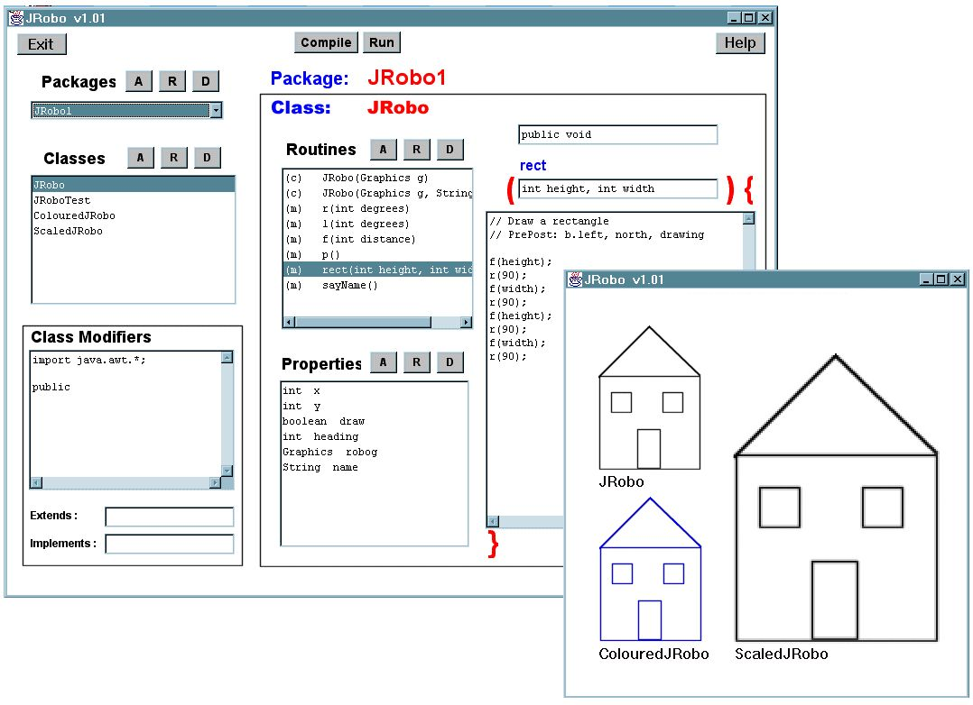

Figure 2. JRobo screenshots

The JRobo environment is actually a full Java IDE that allows students to be exposed to Java, albeit in a controlled fashion. Many of the syntactic complexities can be hidden from view initially so that students can attend to the "big-picture." Later, as they gain understanding, the environment can be slowly opened up to expose all the facilities Java has to offer. In the meantime, students can take the examples we show them and easily extend and modify them, to further enhance their understanding. In this way, the mechanics of OOP become concrete and usable.

The JRobo examples, teaching package and IDE are available online [4]. In the future, we intent to extend the IDE in order to help enforce good programming practice (in terms of comments, layout, naming conventions, etc.) and to offer a number of design examples to build upon.

Concluding Remarks
The course, which currently enrols around 400 students annually, has been running in the form described for several years now. Originally taught in Pascal/Delphi (see [5]), it has survived the early switch to Java and is now revelling in the new opportunities offered by Java2 and the Internet. Not only are students very enthusiastic about undertaking Internet-based projects, but the additional motivation and openness offered by making their work (reports and programs) publicly accessible, seems particularly effective. Obviously, the Internet is an incredible resource and students use it extensively while researching their projects and solving whatever programming problems happen to crop up. The course also makes use of the web for course management (announcements, assignment distribution, sample solutions, grade notification, etc.) and communication (for answering individual student questions and, increasingly, for peer interactions between students.)

Recent Java projects have included a Napster clone, various chat and instant messaging programs, a simple html editor, physics and optical workbenches, several multi-user internet-based games, a paint program for kids, an online shop, and an online dating service. Most projects look good and work well from the user's perspective. Internally, however, while the better ones are models of OOP design, some are a total disaster. Undoubtedly, a major reason for this is our failure to show many really good examples of OO programming and design (itself, due, in part, to our inexperience with the topic.) It is evident that we need to place more emphasis on appropriate program design and structure in the future. On the other hand, while the quality of the projects may vary considerably, the sheer energy, enthusiasm and work that has gone into them are clearly evident. Students may be very tired by the end of the semester, but they are also generally very proud of what they have achieved.

Running a project-based course does take considerable extra time and effort. Not surprisingly, scores on standard examinations remain largely unchanged, but it is hoped that the long term effects, as regards student interest, motivation, interaction, confidence, the ability to solve new problems, to communicate, and to work together in a team, more than compensate for this and make it all worthwhile.

Acknowledgements: The author wishes to express his thanks to CS student Murat Yesildal who implemented the first version of JRobo. Thanks also go to the assistants and teaching faculty of CS101 & CS102 over the years, and, of course, to the thousands of students who have managed to learn a few neat programming tricks despite all this.

References
[1] Joseph Bergin, Why Procedural is the Wrong First Paradigm if OOP is the Goal, http://csis.pace.edu/~bergin/papers/Whynotproceduralfirst.html
[2] Robo webpage, http://www.cs.bilkent.edu.tr/~david/robo.htm
[3] Davenport, D., Robo: A Programming System for Teaching Introductory Software Engineering Concepts, Proc. ISCIS-V (Int. Symposium on Computers & Information Systems), Cappadocia, Turkey, Oct.30-Nov.2 1990, pp953-962.
[4] JRobo webpage, http://www.cs.bilkent.edu.tr/~david/JRobo
[5] Davenport, D., Experience using a Project-based Approach to Teaching an Introductory Programming Course, IEEE Trans. on Education, (to appear November 2000.)

Roughly 10% of our students have absolutely no experience of computers (down from nearly 90% five years ago now that computers are finding their way into homes and schools.) About 10% have some programming experience (usually in Basic), but the vast majority have used computers only for playing games or, of late, surfing and chatting on the net.
We also encourage groups to link up to real "customers" (such as the local Ministry of Education who need special software for school use.) This can provide additional motivation to students.
The contest, Software Quest, is actually open to all students from all classes and universities across the country. Students, parents, faculty and representatives from the software industry are invited to examine the projects, and prizes are awarded in various categories. First year student projects usually do very well.
In the future we intend to use JRobo for these introductory Java programming exercises too. Indeed, the intention is that JRobo will ultimately displace the separate Robo environment as well, thus taking students rapidly from zero to full OOP in Java.
The programs students could produce using Java 1.0 proved very crude compared to those done previously with Delphi due to language restrictions and the lack of a good easy to use IDE. Combined with our lack of experience and of a good textbook, the first year of Java use proved somewhat traumatic. Luckily things have improved since then.

