Purpose of the Assignment
This assignment introduces you to PowerPoint; one of the four major applications in the Professional version of Microsoft Office (Microsoft Word, Microsoft Excel, Microsoft Access are the other three). PowerPoint enables you to create a professional presentation in a variety of ways. You can show the presentation on the computer, overhead transparencies, via slides, or on the World Wide Web.

Objectives
After this assignment you will be able to do:

- Describe the common user interface; give several examples of how PowerPoint follows the same conventions as other Office applications.
- Start PowerPoint; open, modify, and view an existing presentation.
- Describe the different ways to print a presentation.
- List the different views in PowerPoint; describe the unique features of each view.
- Use the outline view to create and edit a presentation; display and hide text within the outline view.
- Add a new slide to a presentation; explain how to change the layout of the objects on an existing slide.
- Use the Microsoft Clip Gallery to add and/or change the clip art on a slide.
- Apply a design template to a new presentation; change the template in an existing presentation.
- Add transition effects to the slides in a presentation; apply build effects to the bullets and graphical objects in a specific slide.

- PowerPoint is easy to learn because it is a Windows application and follows the conventions associated with the common user interface. Thus, if you already know one Winadows application, it is much easier to learn PowerPoint because you can apply what you know that are common to all Microsoft Office applications (Word, Excel...)
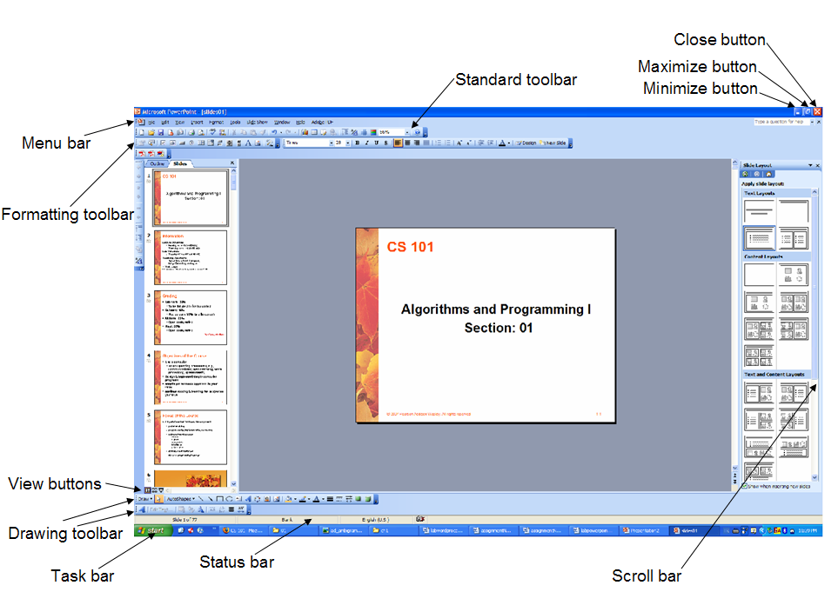
Figure 1. Introduction to Power Point.
The above figure illustrates the following:

- The Title bar indicates the application as well as the name of the presentation on which you are working.
- The menu bar provides access to the pull-down menus within the application.
- The Standard toolbar contains the buttons for the most basic commands in PowerPoint such as opening, saving, and printing the presentation.
- The Formatting toolbar provides access to formatting operations such as boldface, italics, and uderlining.
- The Status bar indicates the slide that you are working on and the language (ex: Slides 1 of 77, you are working on slide 1 and Engligh (US)).
- The View buttons are used to switch between the different views of the presentation.
- Drawing toolbar contains the additional tools for working on the slide (adding shapes, textbox, arcs, colouring...)
- The task bar appears at the bottom of the screen and shows you the open applications.

Six Different Views
PowerPoint offers six different views in which to create, modify, and/or show a presentation. You can access these different views and can switch back and forth between the views by clicking the appropriate view from view menu via the menu bar or directly from view bar at the bottom of the screen.
- Slide view displays one slide at a time and enables all operations for that slide.
- Slide sorter view displays multiple slides on the screen and lets you see the overall floe of the presentation.
- Outline view shows the presentation in outline form.
- Notes Page view lets you create the presenter’s notes for some or all of the slides in a presentation. These notes do not appear when you show the presentation, but can be printed for use during the presentation to help you remember the key points about each slide.
- Normal View displays the Slide, Outline, Notes Page view in a single window, with each view in its own pane.
- Slide Show view displays the slides one at a time as an electronic presentation on the computer.The show may be presented manually where you click the mouse to move from one slide to other or can be shown automatically, where each slide stays on the screen for a predefined amount of time, after which the next slide appears automatically.
Assignment:
- Exercise on an existing presentation:

- You can download an existing power point slide. Start the internet explorer, go to the course web page and download chapter1’s slides.
- Click Start → Programs→ and find and click the PowerPoint application to star the program.
- Click File → Open → and find the path of the chapter1’s slides that you have saved on your computer, select the document and click the open button to begin the exercise.
- Change the title slide and click File → Save as → and save the modified document with a different name.
- Change the font of the text on title slide (font size, font type, colour...)
- Work and understand the different capabilities of each view styles of the slides.
- Change places of the objects on the slide.
- You can display the Office assistant by pressing F1 key or press Microsoft Office PowerPoint Help or press Show Office Assistant from Help menu on menu bar. Exercise how to use the office assistant. (ex: type “How do I show a presentation?”) and apply the directions that are offered to you.
- Click Slide Show button above the status bar or pull down the view menu and click Slide Show or press F5 key. Click the mouse to move to the next slide. You can print Esc key at any time to cancel the show.
- Exercie the ways of printing. Pull down the File menu, click Print to display the Print dialog box. Exercise the “Print what” and “Print range” parts.
- Pull down the File menu, click Close to close the presentation.

- Create your own presentation:
(Assume that your are introducing yourself)
- Pull down the File menu, click New and click blank presentation.
- You should automatically see the title slide as the first slide.
- Add the title “Introduction to PowerPoint” as title, your name as the subtitle.
- For each slide also add your notes (comments) about each slide by switching between Notes Page view and Slide View or directly use Normal view.
- Click the Outline view, click after your name, press enter, and press Shift-Tab. New slide will be added. You can also change the content of the slide within the outline view. New slides can be added by using Slide view, right click on a slide where you want to add the slide, and click New Slide. Exercise the properties that you can use from the right click pop-up menu.
- Also for each slide, you can change the slide layout. Click Format → Slide Layout and choose the appropriate layout that suits best with the content of the current slide.
- The second slide usually displays the overciew of the presentation.
- Create 5-10 slides powerpoint presentation that describes yourself. ( Hints: 1. birthdate, sex, bithplace, address, tell no, 2. family members and their personal informations (job, age) 3. hobbies, 4. graduated schools, 5. future plans....).
- Click Tools → Spell Checker to check the presentation for spelling. Misspelled a word in your presentation and use spell checker.
- Save the powerpoint presentation in your account H:/ drive.
- Pull down the Format menu and click the Slide Design. Slide Design window will be opened. Choose a template from the list and apply the template. Do not forget to save the presentation!.

- Optional:

- add clip art objects
- learn transition effects
- add animation effects

