CS464 Introduction to Machine Learning

Fall 2010
Questions 2 – Decision Tree Learning

Q1) Give decision trees to represent the following boolean functions:
- A ∧ ¬B

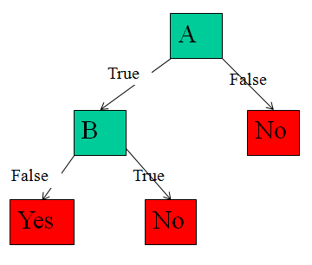

- A ∨ [B ∧ C]

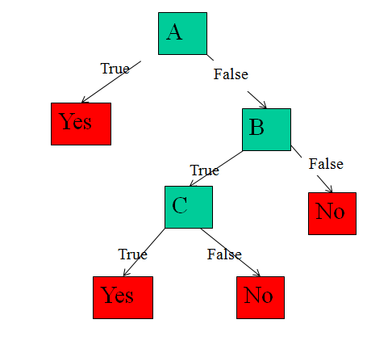

- A XOR B

A1 means A, and A2 means B
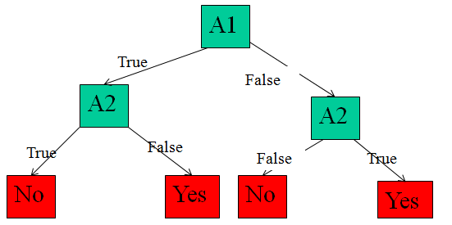

- [A ∧ B] ∨ [C ∧ D]

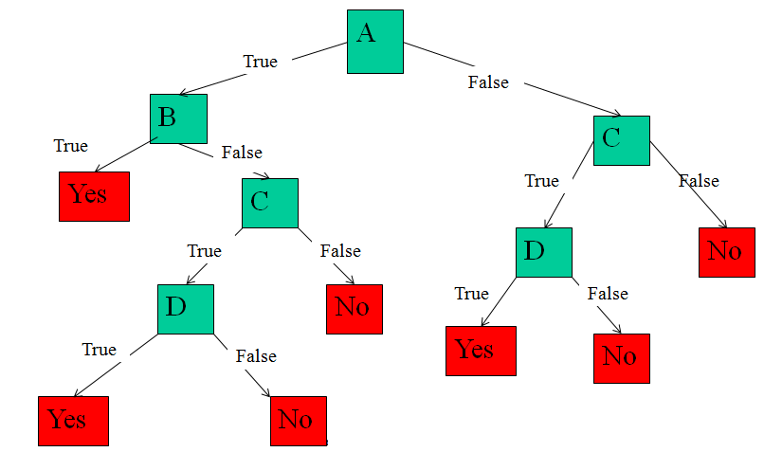

Q2) Consider the following set of training examples:

- What is the entropy of this collection of training examples with respect to the target function classification?

Entropy = -3/6(log3/6) – 3/6(log3/6) = 1

- What is the information gain of a2 relative to these training examples?

E(a2 =T) = -2/4log(2/4) – 2/4log(2/4) = 1
E(a2 =F) = -1/2log(1/2) – 1/2log(1/2) = 1

Gain of a2 = E(S) – 4/6E(a2 =T) – 2/3E(a2 =F)
= 1- 4/6 – 2/6 = 0

- Create the decision tree for these training examples using ID3.

Gain(S,a1) > Gain(S,a2)
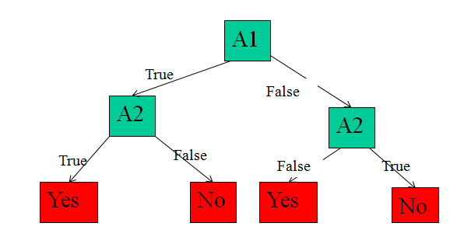

Q3) Consider the following set of training examples:

Instance | Classification | Attrb1 | Attrb2 | Attrb3
1 | c1 | a | T | a
2 | c1 | a | T | b
3 | c2 | b | F | c
4 | c1 | c | T | d
5 | c3 | a | F | a
6 | c3 | b | T | b
7 | c2 | c | F | c
8 | c2 | b | T | c
9 | c1 | a | T | a
10 | c1 | b | F | b

- What is the entropy of this collection of training examples with respect to the target function classification?

Entropy = -5/10log(5/10) – 2/10log(2/10) – 3/10log(3/10) = 1.48

- What is the information gain of Attrb1 relative to these training examples?

E(Attrb1 = a) = -3/4log(3/4) – 1/4log(1/4) = = 0.811
E(Attrb1 = b) = -2/4log(2/4) – 1/4log(1/4) – 1/4log(1/4) = 1.5
E(Attrb1 = c) = -1/2log(1/2) – 1/2log(1/2) = 1

Gain of Attrb1 = E – 4/10E(Attrb1 = a) – 4/10 E(Attrb1 = b) – 2/10E(Attrb1 = c)
= 0.36

- Create the decision tree for these training examples using ID3.

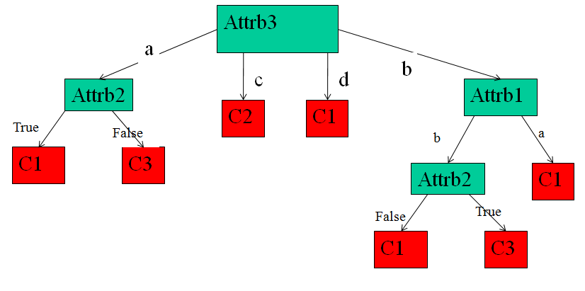

d) Convert the decision tree into the rules.

If (Attrb3 = a) ∧ (Attrb2 = T) Then Classification = c1
If (Attrb3 = a) ∧ (Attrb2 = F) Then Classification = c3
If (Attrb3 = b) ∧ (Attrb1 = a) Then Classification = c1
If (Attrb3 = b) ∧ (Attrb1 = b) ∧ (Attrb2 = T) Then Classification = c3
If (Attrb3 = b) ∧ (Attrb1 = b) ∧ (Attrb2 = F) Then Classification = c1
If (Attrb3 = c) Then Classification = c2
If (Attrb3 = d) Then Classification = c1
Q4) Consider the following set of training examples:

Instance | Classification | Attrb1 | Attrb2
1 | T | 4 | F
2 | T | 10 | T
3 | F | 20 | F
4 | F | 34 | T
5 | F | 50 | F
6 | F | 70 | F
7 | T | 76 | F
8 | T | 80 | T
9 | F | 90 | T
10 | F | 92 | T

- Create the decision tree for these training examples using ID3. Note that Attrb1 is a continuous-valued attribute.

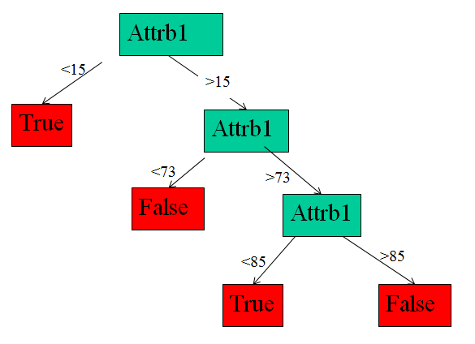

- Convert the decision tree into the rules.

If (Attrb15 < 15) Then Classification = True
If (Attrb15 > 15) ∧ (Attrb73 < 73) Then Classification = False
If (Attrb15 > 15) ∧ (Attrb73 > 73) ∧ (Attrb85 < T) Then Classification = True
If (Attrb3 = b) ∧ (Attrb1 = b) ∧ (Attrb85 > T) Then Classification = False

