Questions 3 Solutions

Q1)

a) w0 = -0.1 , w1 = -0.3 , w2 = 0.3 => 0.3A – 0.3B – 0.1 > 0

b)
Row no: | x₁ | x₂ | t_{d} | o | Δw₁ | w₁ | Δw₂ | w₂ | Δw₀ | w₀
0 | - | - | - | - | - | 0.1 | - | 0.1 | - | 0.1
1 | 0 | 0 | 0 | 1 | 0 | 0.1 | 0 | 0.1 | -0.2 | -0.1
2 | 0 | 1 | 0 | 1 | 0 | 0.1 | -0.2 | -0.1 | -0.2 | -0.3
3 | 1 | 0 | 1 | 0 | 0.2 | 0.3 | 0 | -0.1 | 0.2 | -0.1
4 | 1 | 1 | 0 | 1 | -0.2 | 0.1 | -0.2 | -0.3 | -0.2 | -0.3
5 | 0 | 0 | 0 | 0 | 0 | 0.1 | 0 | -0.3 | 0 | -0.3
6 | 0 | 1 | 0 | 0 | 0 | 0.1 | 0 | -0.3 | 0 | -0.3
7 | 1 | 0 | 1 | 0 | 0.2 | 0.3 | 0 | -0.3 | 0.2 | -0.1
8 | 1 | 1 | 0 | 0 | 0 | 0.3 | 0 | -0.3 | 0 | -0.1
9 | 0 | 0 | 0 | 0 | 0 | 0.3 | 0 | -0.3 | 0 | -0.1
10 | 0 | 1 | 0 | 0 | 0 | 0.3 | 0 | -0.3 | 0 | -0.1
11 | 1 | 0 | 1 | 1 | 0 | 0.3 | 0 | -0.3 | 0 | -0.1
12 | 1 | 1 | 0 | 0 | 0 | 0.3 | 0 | -0.3 | 0 | -0.1

Q2)

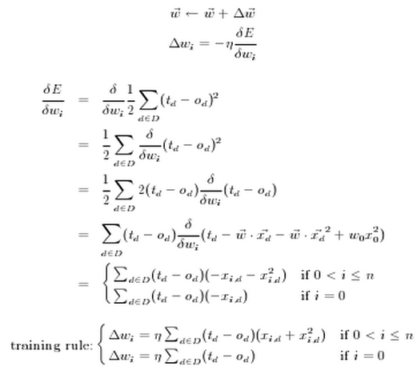

Q3)

Learning Rate |  |  |  |  | 0,3
Momentum |  |  |  |  | 0,9
Ex | a | b | d | outc | outd | δc | δd | Δwca | Δwcb | Δwc0 | Δwdc | Δwd0 | wca | wcb | wc0 | wdc | wd0
 |  |  |  |  |  |  |  | 0 | 0 | 0 | 0 | 0 | 0,1 | 0,1 | 0,1 | 0,1 | 0,1
1 | 1 | 0 | 1 | 0,550 | 0,539 | 0,003 | 0,115 | 0,001 | 0,000 | 0,001 | 0,019 | 0,034 | 0,101 | 0,100 | 0,101 | 0,119 | 0,134
2 | 0 | 1 | 0 | 0,550 | 0,550 | -0,004 | -0,136 | 0,001 | -0,001 | 0,000 | -0,005 | -0,010 | 0,102 | 0,099 | 0,100 | 0,113 | 0,125
1 | 1 | 0 | 1 | 0,550 | 0,547 | 0,003 | 0,112 | 0,002 | -0,001 | 0,001 | 0,014 | 0,025 | 0,103 | 0,098 | 0,101 | 0,127 | 0,149
2 | 0 | 1 | 0 | 0,550 | 0,555 | -0,004 | -0,137 | 0,001 | -0,002 | -0,001 | -0,010 | -0,019 | 0,105 | 0,095 | 0,100 | 0,117 | 0,131

