CS464 Introduction to Machine Learning
Practice Questions 4 -- Solutions
1 –
- P(Classification=c1) = 5 / 10 = 0.5
P(Classification=c2) = 3 / 10 = 0.3
P(Classification=c3) = 2 / 10 = 0.2
- The conditional probabilities of attribute values for given classification values are
P(Attrb1=a | c1) = 3/5
P(Attrb1=b | c1) = 1/5
P(Attrb1=c | c1) = 1/5
P(Attrb1=a | c2) = 0/3
P(Attrb1=b | c2) = 2/3
P(Attrb1=c | c2) = 1/3
P(Attrb1=a | c3) = 1/2
P(Attrb1=b | c3) = 1/2
P(Attrb1=c | c3) = 0/2

P(Attrb2=T | c1) = 4/5
P(Attrb2=F | c1) = 1/5
P(Attrb2=T | c2) = 1/3
P(Attrb2=F | c2) = 2/3
P(Attrb2=T | c3) = 1/2
P(Attrb2=F | c3) = 1/2

P(Attrb3=a | c1) = 2/5
P(Attrb3=b | c1) = 2/5
P(Attrb3=c | c1) = 0/5
P(Attrb3=d | c1) = 1/5
P(Attrb3=a | c2) = 0/3
P(Attrb3=b | c2) = 0/3
P(Attrb3=c | c2) = 3/3
P(Attrb3=d | c2) = 0/3
P(Attrb3=a | c3) = 1/2
P(Attrb3=b | c3) = 1/2
P(Attrb3=c | c3) = 0/2
P(Attrb3=d | c3) = 0/2

<Attrb1=c,Attrb2=T,attrb3=a>
v = P(c1) * P(Attrb1=c/c1) * P(Attrb2=T/c1) * P(attrb3=a/c1) = 1/2 * 1/5 * 4/5 * 2/5 = 4/125
v = P(c2) * P(Attrb1=c/c2) * P(Attrb2=T/c2) * P(attrb3=a/c2) = 3/10 * 1/3 * 1/3 * 0 = 0
v = P(c3) * P(Attrb1=c/c3) * P(Attrb2=T/c3) * P(attrb3= a/c3) = 2/10 * 0 * 1/2 * 1/2 = 0
Therefore, the target value is c1 for the instance.

2-

2.69
1.13 (3. nearest)
0.28 (1. nearest)
0.64 (2. nearest)
1.56
2.97

f(xq) = (3.0 + 5.0 + 6.0) / 3 = 4.66

Using distance weighted 3-nearest neighbor algorithm, find the function value for the instance <Attrb1=3.0,Attrb2=1.8>.
w1 = 1 / 2.69^2 = 0.138 w2 = 1/ 1.13^2 = 0.781 w3 = 1/ 0.28^2 = 12.5
w4 = 1/ 0.64^2 = 2.439 w5 = 1/ 1.56^2 = 0.409 w6 = 1/ 2.97^2 = 0.11
f(xq) = (0.781 x 3 + 12.5 x 5 + 2.439 x 6 ) / (0.781 + 12.5 + 2.439 ) = 5.055
3-

The following training set of examples are given in two-dimensional space:
positive examples: (0,1) (1,2)
negative examples: (3,0) (3,1)
- The linear SVM (the maximum margin linear classifier) for this training set can drawn as follows:

y = 2x – 2.5
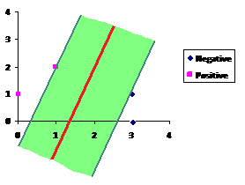
Instances which are nearest to SVM line are on support vectors. These are positive instance (1,2) and negative instance (3,1).

- Length of the margin is square root of 5 = 2.24

4-

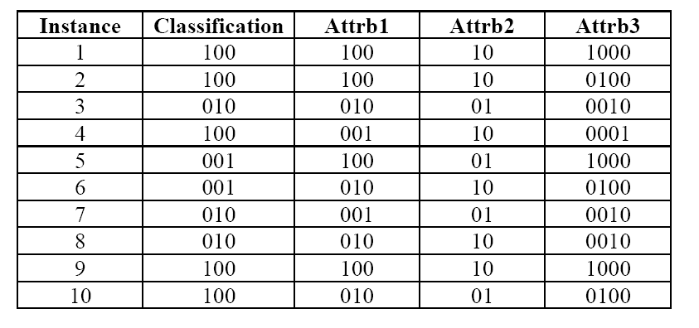

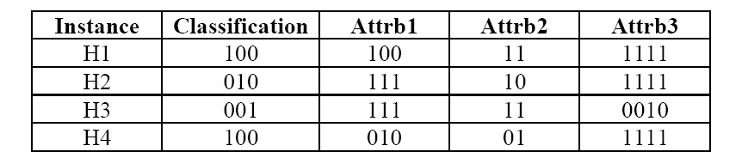

Fitness values: (“-” means wrong classification, “+” means right classification)
H1: <+,+,?,?,-,?,?,?,+,?> = ¾
H2: <-,-,?,-,?,-,?,+,-,?> = 1/6
H3: <?,?,-,?,?,?,-,-,?,?> =0
H4: <?,?,-,?,?,?,?,?,?,+> = ½
