Deliverable 11.4

Report on progress
with respect to partial solutions on
Human detection algorithms,
human activity analysis METHODs, and
Multimedia Databases

Prepared by

- Enis Cetin

Bilkent University

Ankara, Turkey

Summary:

This report consists of two parts. The first part of the project describes the partial solutions developed by the members of WP-11 on human activity detection and understanding systems in video in the last eighteen months. In these systems features extracted from video and associated audio are processed by Hidden Markov Models (HMMs), Neural Networks (NN), Dynamic Programming (DP), and eigenspace methods to extract meaningful information. In this report, the following methods are described:
- Human face detection in video using DP,
- human body detection using classification of moving regions in video,
- moving object classification by eigenanalysis of periodic motion,
- detection of falling persons in video using both audio and video track data.
- detection of fire in video, and
- detection of moving tree leaves in video.

In the second part of the report, our research on multimedia databases and the partial solutions to the following problems are described:

- Natural language interfaces for interaction with multimedia databases,
- gesture-based interaction with multimedia databases, and
- text recognition in video.

Finally gaps in know-how and recommended future directions are discussed.

- Human Face Detection in Video

Our current research is based on the idea that a face can be recognized by its edges. In fact, a caricaturist draws a face image in a few strokes by drawing the major edges of the face. Most wavelet domain image classification methods are also based on this fact because wavelet coefficients are closely related with edges, see e.g., [Garcia 1999].

The first step of the algorithm is to find possible face regions in a typical image or video. This can be determined by detecting regions with possible human skin colors. In these regions edges are estimated by using a standard edge detector. Edges can be estimated by summing the absolute values of high-low, low-high and high-high wavelet sub-images of the two-dimensional wavelet transform. Wavelet coefficients of the low-high (high-low) sub-image correspond to horizontal (vertical) edges of the image region.

After computing the edges in skin coloured region, their horizontal and vertical projections of edge images are computed. The horizontal (vertical) projection is simply computed by summing the pixel values in a row (column) in the edge image. Typical face-edge projection plots are shown in Figure 1. One can also obtain similar plots from frontal face drawings or caricatures. Horizontal and vertical projections are good features to represent a face image because they are robust to pose angle. Another advantage of the projections is that they can be normalized to a fixed size and this provides robustness against scale changes.

Horizontal and vertical projections are used as features in region classification which can be carried out using dynamic programming or a standard neural network or support vector machines. Dynamic Programming was used in finite vocabulary speech recognition and various communication theory applications (e.g., the Viterbi algorithm) but it is not widely used in pattern analysis and image processing.

Figure 1: Face edge projections of two face images. Black (red) coloured plots are the horizontal (vertical) projections. In red plots, the first peak corresponds to the left
eyes, the second peak corresponds to nose and mouth and the third peak corresponds to the right eye, respectively.

The main reason that we want to use dynamic programming is that it produces better results than neural networks and HMM in small vocabulary speech recognition.

The dynamic programming is used to compare the projection plots of a region with typical face templates. Three template couples corresponding to frontal, 45 and 90 degrees are used in the current face recognition system.

The recognition performance of the dynamic programming will be compared to neural networks and support vector machines. Also, the projection based face detection method using dynamic programming will be also compared to the currently available face detection methods.

The face detection algorithm is implemented in C++ and will be available in the MUSCLE WP-11 web-page in September 2005.

2. Human body detection using silhouette classification

Object classification based on contours of moving regions were studied by many authors, see e.g., the report by [Collins1999, Collins2000]. In this approach the moving regions in video is extracted by background subtraction and moving blobs in video are estimated. Once the object contour is determined a one-dimensional function is estimated from the boundary as shown in Figure 2. The distance of the contour from the center of mass of the object idea is computed in a clockwise direction. This distance function is used in object classification.

An example silhoutte and its distance function is shown in Figures 2 and 3, respectively.

Neural networks are used to classify objects according to object boundary but dynamic programming has not been studied in object classification. The problem is essentially a finite vocabulary classification problem and dynamic programming may outperform other methods as in finite vocabulary speech recognition. We will study this problem in detain in the next three months.

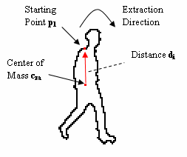

Figure 2: A moving blob in video and the construction of a one-dimensional function to represent the moving blob.

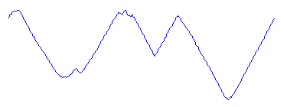

------------------------------------------------------------------------> (degree)

0 angle → 360

Figure 3: The distance function representing the moving blob in Figure 2.

- Moving object classification by eigenanalysis of periodic motion

The method described above is a static method and it does not take advantage of the motion of moving blobs for classification. MUSCLE partners Technion and Sztaki developed a motion based moving object classification method [Goldenberg 2005], [Havasi 2005].

The first step of the [Goldenberg 2005] algorithm is also object contour estimation. In this method, the boundary contour of the moving object is first computed efficiently and accurately. After normalization, the implicit representation of a sequence of silhouette contours given by their corresponding binary images, is used for generating eigenshapes for the given motion. Singular value decomposition produces these eigenshapes that are then used to analyze the sequence. It is also shown that the method can be used not only for object classification but also behavior classification based on the eigen-decomposition of the binary silhouette sequence.

The problem of detection and characterization of periodic activities was addressed by several research groups and the prevailing technique for periodicity detection and measurements is the analysis of the changing 1-D intensity signals along spatio-temporal curves associated with a moving object or the curvature analysis of feature point trajectories, see e.g., [Tsai 1994]. Technion group estimated global characteristics of motion such as moving object contour deformations and the trajectory of the center of mass.

In Figure 4, the motion characteristics of a walking person is shown. It is experimentally observed that a walking cat or a dog exhibit entirely different periodic motion in video and this fact can be used in object classification.

In the last stage of the algorithm principle component analysis (PCA) is used for object classification.

The periodic behaviour of a walking person is also used by Bilkent group to distinguish falling persons from walking persons in [Toreyin 2005,1]. This method is described in detail in Section 4.

It is our belief that a robust human detection method can be developed by combining the methods described in Sections 3 and 4. Such a method will take advantage of both temporal and spatial nature of the problem.

4. Falling Person Detection Using Both Audio and Video

Automatic detection of a falling person in video is an important problem with applications in security and safety areas including supportive home environments and CCTV surveillance systems. Intelligent homes will have the capability of monitoring activities of their occupants and automatically provide assistance to elderly people and young children using a multitude of sensors including surveillance cameras in the near future [Barnes 1998, Bonner 1997, McKenna 2003]. Human motion in video is modeled using Hidden Markov Models (HMM) in this study. In addition, the audio track of the video is also used to distinguish a person simply sitting on a floor from a person stumbling and falling. Most video recording systems have the capability of recording audio as well and the impact sound of a falling person is also available as an additional clue. Audio channel data based decision is also reached using HMMs and fused with results of HMMs modeling the video data to reach a final decision.

Video analysis algorithm starts with moving region detection in the current image. Bounding box of the moving region is determined and parameters describing the bounding box are estimated. In this way, a time-series signal describing the motion of a person in video is extracted. The wavelet transform of this signal is computed and used in Hidden Markov Models (HMMs) which were trained according to possible human being motions. It is observed that the wavelet transform domain signal provides better results than the time-domain signal because wavelets capture sudden changes in the signal and ignore stationary parts of the signal.

Audio analysis algorithm also uses the wavelet domain data. HMMs describing the regular motion of a person and a falling person were used to reach a decision and fused with results of HMMs modeling the video data to reach a final decision.

4.1 Analysis of Video Track Data

In the first step of the proposed method moving object boundaries are estimated. The method does not require very accurate boundaries of moving regions. After a post-processing stage comprising of connecting the pixels, moving regions are encapsulated with their minimum bounding rectangles as shown in Fig. 5. Next, the aspect ratio, ρ, for each moving object is calculated. The aspect ratio of the ith moving object is defined as:

where H_{i}(n) and W_{i}(n) are the height and the width of the minimum bounding box of the i^{th} object at image frame n, respectively, We then calculate the corresponding wavelet coefficients for ρ. Wavelet coefficients, w_{i}’s, are obtained by high-pass filtering followed by decimation.
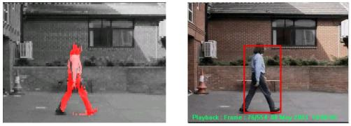

(a) (b)

Fig. 5 (a) Moving pixels in video, and (b) their minimum bounding box.

The wavelet transform of the one-dimensional aspect ratio signal is used as a feature signal in HMM based classification in our scheme. It is experimentally observed that the aspect ratio based feature signal exhibits different behaviour for the cases of walking and falling (or sitting) persons. A quasi-periodic behaviour is obviously apparent for a walking person in both ρ(n) and its corresponding wavelet signal as shown in Fig. 6. On the other hand, the periodic behaviour abruptly ends and ρ(n) decays to zero for a falling person or a person sitting down. This decrease and the later stationary characteristic for fall is also apparent in the corresponding wavelet subband signal (cf. Fig. 2.4).

Using wavelet coefficients, w, instead of aspect ratios, ρ, to characterize moving regions has two major advantages. The primary advantage is that, wavelet signals can easily reveal the aperiodic characteristic which is intrinsic in the falling case. After the fall, the aspect ratio does not change or changes slowly. Since, wavelet signals are high-pass filtered signals [Kim 1992], slow variations in the original signal lead to zero-mean wavelet signals. Hence it is easier to set thresholds in the wavelet domain which are robust to variations of posture sizes and aspect ratios for different people.
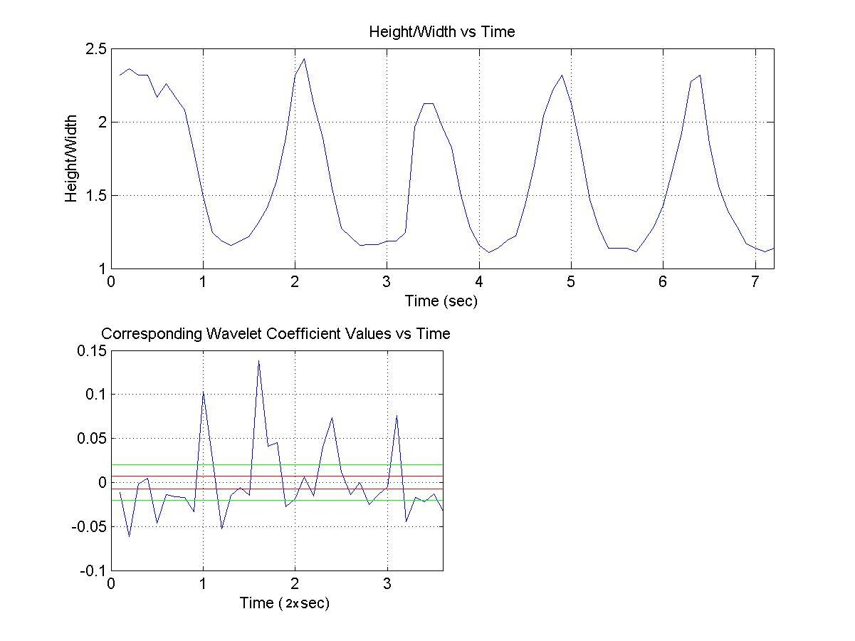

T2

T1

Fig. 6. Quasi-periodic behaviour in ρ vs. time (top), and the corresponding wavelet coefficients w vs. time for a walking person (sampling period is half of the original rate in the wavelet plot). Thresholds T1 and T2 introduced in the wavelet domain are robust to variations in posture sizes and aspect ratios of different people.

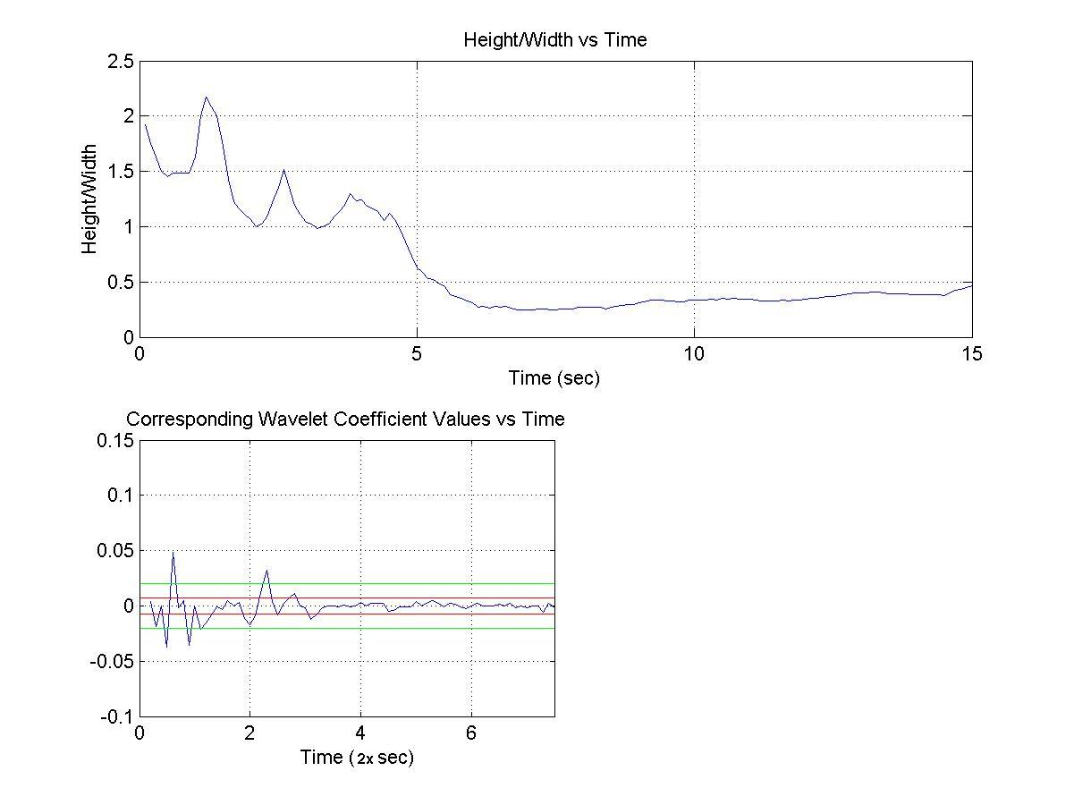

Fig. 7. Aspect ratio ρ vs. time (top), and the corresponding wavelet coefficients w vs. time for a falling person (sampling period is half of the original rate in the wavelet plot)

HMM Based Classification: Two three-state Markov models are used to classify the motion of a person in this study. The first Markov model corresponds to a walking person and characterizes the quasi-periodic motion shown in Fig. 6. The second Markov model corresponds to a falling (or sitting) person and characterizes the motion shown in Fig. 7.

The two Markov models are shown in Figure 8. At time n, if |w_{i}(n)| < T1, the state is in S1; if T1 < |w_{i}(n)| < T2, the state is S2; else if |w_{i}(n)| > T2, the state S3 is attained. During the training phase of the HMMs transition probabilities a_{uv} and b_{uv}, u,v = 1, 2, 3, for walking and falling models are estimated off-line, from a set of training videos.

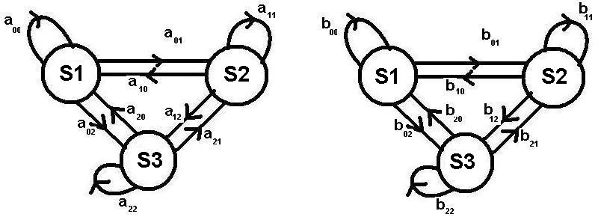

Fig. 8. Three state Markov models for (a) walking, and (b) falling (or sitting down).

For a walking person, since the motion is quasi-periodic, we expect similar transition probabilities between the states. Therefore the values of a’s are close to each other. However, when the person falls down, the wavelet signal starts to take values around zero. Hence we expect a higher probability value for b₀₀ than any other b value in the falling model, which corresponds to higher probability of being in S1. The state S2 provides hysteresis and it prevents sudden transitions from S1 to S3 or vice versa.

During the recognition phase the state history of length 20 image frames are determined for the moving object detected in the viewing range of the camera. This state sequence is fed to the walking and falling models. The model yielding higher probability is determined as the result of the analysis for video track data. However, this is not enough to reach a final decision of a fall. Similar w vs. time characteristics is observed for both falling and ordinary sitting down cases. A person may simply sit down and stay stationary for a while. To differentiate between the two cases, we incorporate the analysis of the audio track data to the decision process.

4. 2 Analysis of Audio Track

In our scheme, audio signals are used to discriminate between falling and sitting down cases. A typical stumble and fall produces high amplitude sounds as shown in Fig. 9-a, whereas the ordinary actions of bending or sitting down has no distinguishable sound from the background (cf. Fig. 9.b). The wavelet coefficients of a fall sound are also different from bending or sitting down as shown in Fig. 9. Similar to the motivation in the analysis of video track data for using wavelet coefficients, we base our audio analysis on wavelet domain signals. Our previous experience in speech recognition indicates that wavelet domain feature extraction produces more robust results than Fourier domain feature extraction [Jabloun 1999]. Our audio analysis algorithm also consists of three steps: i) computation of the wavelet signal, ii) feature extraction of the wavelet signal, and iii) HMM based classification using wavelet domain features.

In audio analysis, three three-state Markov models are used to classify the walking, talking and falling sounds. During the classification phase a state history signal corresponding to 20 image frames are estimated from the sound track of the video. This state sequence is fed to the walking, talking, and falling models in running windows. The model yielding highest probability is determined as the result of the analysis for audio track data.

In the final decision stage, we combine the audio result with the result of the video track analysis step using the logical “and” operation. Therefore, a “falling person detected” alarm is issued only when both video and audio track data yield the highest probability in their “fall” models.

The proposed algorithm is implemented in C++ and it works in real-time on an AMD AthlonXP 2000+ 1.66GHz processor. As described above HMMs are trained from falling, walking, and walking and talking video clips. A total of 64 video clips having 15,823 image frames are used. Some image frames from the video clips are shown in Fig. 10. In all of the clips, only one moving object exists in the scene. Details of experimental studies can be found in [Toreyin 2005,1].

There is no way to distinguish a person intentionally sitting down on the floor from a falling person, if only video track data is used. When both modalities are utilized, they can be distinguished and we do not get any false positive alarms for the videos having a person sitting down.

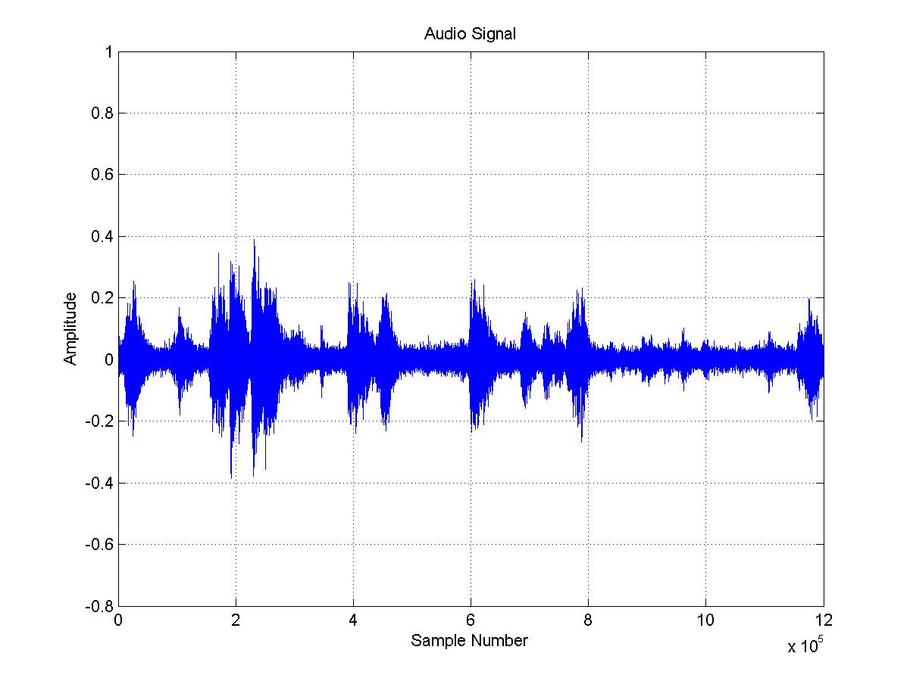
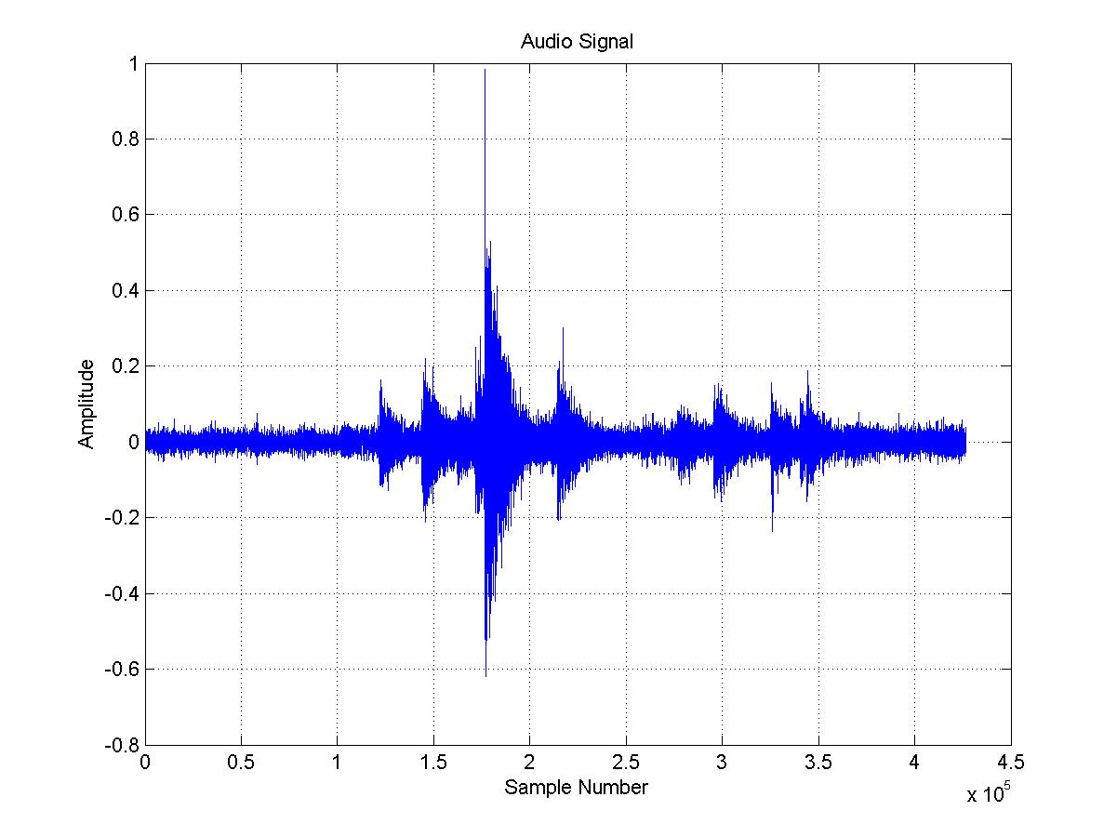

Fig.9. Audio signals corresponding to (a) a fall, which takes place at around sample number 1.8x10⁵ (left) and (b) talking (0 - 4.8x10⁵), bending (4.8x10⁵ – 5.8x10⁵), talking (5.8x10⁵ – 8.9x10⁵), walking (8.9x10⁵ – 10.1x10⁵), bending (10.1x10⁵ - 11x10⁵), and talking (11x10⁵ - 12 x10⁵) cases (right). Signals are sampled with44 KHz

In summary, the main contribution of this work is the use of both audio and video tracks to decide a fall in video. The audio information is essential to distinguish a falling person from a person simply sitting down or sitting on a floor. The method is computationally efficient and it can be implemented in real-time in a PC type computer. Similar HMM structures can be also used for automatic detection of accidents and stopped vehicles in highways which are all examples of important events occurring in video.
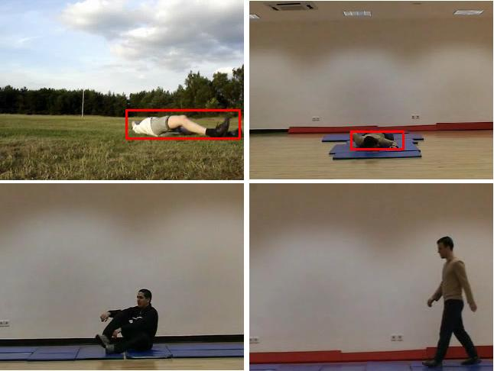

Fig. 10. Image frames from falling, sitting, and walking and talking video clips.

In [Nait2004] motion trajectories extracted from an omnidirectional video are used to determine falling persons. When a low cost standard camera is used instead of an omnidirectional camera it is hard to estimate moving object trajectories in a room. Our fall detection method can be also used together with [Nait 2004] to achieve a very robust system, if an omnidirectional camera is available. Another trajectory based human activity detection work is presented in [Cuntoor2005]. Neither [Nait2004] nor [Cuntoor 2005] used audio information to understand video events.

A more robust system can be achieved by combining the approach presented in this section and the trajectory based information described in [Nait2004].

5. Neural Networks and Support Vector Machines for Event Classification

We experimentally observed that the use of Neural Networks (NN) instead of HMMs neither improved nor degraded the performance of the image and video analysis algorithms.

We also plan to use Support Vector Machines (SVM) which are successfully used in many pattern recognition and classification problems. The HMMs, dynamic programming and NN structures that we use in the above systems were originally developed for speech recognition applications, in which the input is a time-varying signal, and a sequence of feature vectors are extracted to characterize an event. To the best of our knowledge, SVMs for time-varying inputs or events have not been developed. An E-team for such applications is being formed by Dr. Khalid Daoudi within MUSCLE. We plan to collaborate with Dr. Daoudi’s group and use their result in video event classification.

6. Three Dimensional (3-D) Texture Analysis and Detection in Video

In Deliverable Report 11-2 it is pointed out that detection and classification of 3-D textures in video have not been extensively studied. Examples of 3-D textures include fire, smoke, clouds, trees, sky, sea and ocean waves etc. In this report, we present partial solutions to fire and flame detection and tree and bush detection problems.

6.1 Fire Detection in Video

Conventional point smoke and fire detectors typically detect the presence of certain particles generated by smoke and fire by ionisation or photometry. An important weakness of point detectors is that they are distance limited and fail in open or large spaces. The strength of using video in fire detection is the ability to monitor large and open spaces. Current fire and flame detection algorithms are based on the use of color and motion information in video [Philips2002]. In this work, we not only detect fire and flame colored moving regions but also analyze the motion. It is well-known that turbulent flames flicker with a frequency of around 10 Hz [Fastcom2002]. Therefore, fire detection scheme was made more robust by detecting periodic high-frequency behavior in flame colored moving pixels compared to existing fire detection systems described in [Philips2002], [Chen2004], [Healey 2004]. However, this approach may also produce false alarms to police cars in tunnels. Our experiments indicate that flame flicker frequency is not constant and it varies in time. Variations of a flame pixel in video is plotted in Fig. 11. In fact, variations in flame pixels can be considered as random events. Therefore, a Markov model based modeling of flame flicker process produces more robust performance compared to frequency domain based methods.

Fig. 11: Temporal variation of a flame pixel and the corresponding wavelet coefficients (bottom plot).

Another important clue for fire detection is the boundary of moving objects in the video. If the contours of an object exhibit rapid time-varying behavior then this is an important sign of presence of flames in the scene. This time-varying behavior is directly observable in the variations of color channel values of the pixels under consideration. Hence, the model is built as consisting of states representing relative locations of the pixels in the color space. When trained with flame pixels off-line, such a model successfully mimics the spatio-temporal characteristics of flames. The same model is also trained with non-flame pixels in order to differentiate between real flames and other flame colored ordinary moving objects.

In addition, there is spatial color variation in flames (cf. Fig. 12). Flame pixels exhibit a similar spatial variation in their chrominance or luminosity values, as shown in Fig.12. The spatial variance of flames are much larger than that of an ordinary flame-colored moving object. The absolute sum of spatial wavelet coefficients of low-high, high-low and high-high subimages of the regions bounded by gray-scale rectangles excerpted from a child’s fire colored t-shirt and inside a fire, are shown in Fig.12 [Dedeoglu2005]. This feature of flame regions is also exploited by making use of the Markov models. This way of modeling the problem results in less number of false alarms when compared with other proposed methods utilizing only color and ordinary motion information as in [Philips2002].

.

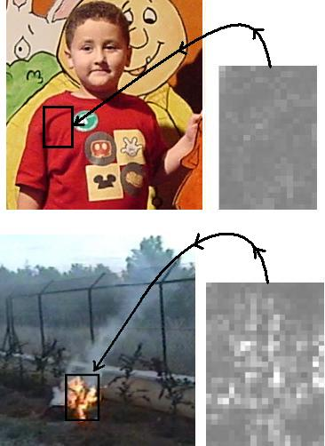

Fig.11. Comparison of spatial variations of fire-colored regions. Flame(bottom-left) have substantially higher spatial variation(bottom-right) compared to an ordinary fire-colored region.

In spatial color analysis step, pixels of flame coloured regions are horizontally and vertically scanned using the same Markov models in temporal analysis. If the fire-coloured model has a higher probability spatially as well, then an alarm is issued.

Our experimental studies indicate that Markovian modeling of the flames is not only more robust than the use of FFT to detect 10 Hz flame flicker but also computationally more efficient. Details of our experimental studies can be found in [Toreyin 2005,2], [Dedeoglu 2005].

The method can be used for fire detection in movies and video databases as well as real-time detection of fire. It can be incorporated with a surveillance system monitoring an indoor or an outdoor area of interest for early fire detection.

This method can take advantage of the audio track data as well. Typical fire sounds such as cracking in audio will be very important to reduce false alarms. The use of audio will be investigated in the next year.

6.2. Detection of Moving Tree Leaves

It is well known that tree leaves and branches in the wind, moving clouds, etc., is a main source of false alarms in outdoor video analysis. If one can initially identify bushes, trees and clouds in a video, then such regions can be excluded from the search space or proper care can be taken in such regions. This leads to robust moving object detection and identification systems in outdoor video. A method for detection of tree branches and leaves in video is developed. It is observed that the motion vectors of tree branches and leaves exhibit random motion. On the other hand regular motion of green colored objects has well-defined directions as shown in Figure 12. In our method, the wavelet transform of motion vectors are computed and objects are classified according to the wavelet coefficients of motion vectors. Color information is also used to reduce the search space in a given image frame of the video. Motion trajectories of moving objects are modeled as Markovian processes and Hidden Markov Models (HMMs) are used to classify the green colored objects in the final step of the algorithm.

Our detection algorithm consists of three main steps: (i) green colored moving region detection in video, (ii) estimation of the motion trajectories and computation of the wavelet domain signals representing motion trajectories, and iii) HMM based classification of the motion trajectories.

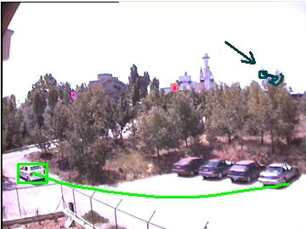

Fig. 12. The car has a directionally consistent trajectory whereas the leaves, marked by an arrow, randomly sway in the wind.

A random behavior with low temporal correlation is apparent for leaves and branches of a tree, in both the horizontal and vertical component of the temporal motion signal as shown in Figs. 13, respectively. On the other hand, an ordinary moving object with a well-defined direction does not exhibit such a random behavior. In this case there is high correlation between the samples of the motion feature signal. This difference in motion characteristics is also apparent in the wavelet domain.

We are in the process of preparing a paper on this research.

7. Multimedia Databases

To address the first grand challenge of the MUSCLE NoE, we initiated research on the following topics:

- Natural language interfaces for interaction with multimedia databases,
- Gesture-based interaction with multimedia databases, and
- Video text recognition.

In the following sections our research on multimedia databases and the partial solutions to the above problems are described:

7. I. Natural Language Interfaces for Interaction with Multimedia Databases

We developed a multimedia database system, called BilVideo, which provides an integrated support for queries on spatio-temporal, semantic and low-level features (color, shape, and texture) on video data [Donderler2005,Donderler2003]. A spatio-temporal query may contain any combination of directional, topological, object-appearance, 3D-relation, trajectory-projection and similarity-based object-trajectory conditions. BilVideo handles spatio-temporal queries using a knowledge-base, which consists of a fact-base and a comprehensive set of rules, while the queries on semantic and low-level features are handled by an object-relational database. The query processor interacts with both of the knowledge-base and object-relational database to respond to user queries that contain a combination of spatio-temporal, semantic, and low-level feature query conditions. Intermediate query results returned from these system components are integrated seamlessly by the query processor and sent to Web clients. Moreover, users can browse the video collection before giving complex and specific queries, and a text-based SQL-like query language is also available for users [Donderler2004]. However, these types of queries are very difficult to specify using a textual query language, such as SQL. To this end, query interfaces that are using natural language and gesture-based interaction are becoming very important.

BilVideo has a Web-based visual query interface and tools, Fact-Extractor, Video-Annotator, and Object Extractor. Fact-Extractor and Video-Annotator tools are used to populate the facts-base and feature database of the system to support spatio-temporal and semantic video queries, respectively. Fact-Extractor is used to extract spatio-temporal relations between video objects and store them in the knowledge-base as facts. These facts representing the extracted relations are used to query video data for spatio-temporal conditions. The tool also extracts object trajectories and 3D-relations between objects of interest. Video-Annotator is used to extract semantic data from video clips to be stored in the feature database to query video data for its semantic content. It provides some facilities for viewing, updating and deleting semantic data that has already been extracted from video clips and stored in the feature database. Object Extractor is used to extract salient objects from video keyframes. It also facilitates the fact-extraction process automating the minimum bounding rectangle (MBR) specification of salient objects.

BilVideo can handle multiple requests over the Internet through a graphical query interface developed as a Java applet [Saykol2001]. The interface is composed of query specification windows for different types of queries: spatial, trajectory, semantic, and low-level features. Since video has a time dimension, these two types of primitive queries can be combined with temporal predicates to query temporal contents of videos.

In addition to Web-based visual query interface, we also developed an interface that uses natural language interaction to input queries from the user. Application of natural language processing techniques, such as part-of-speech tagging, is necessary to identify parts of speech in a sentence [Wikipedia]. The algorithms, such as the Viterbi algorithm, Brill Tagger, and the Baum-Welch algorithm, could be used for this purpose. Our natural language processing interface uses MontyTagger [MontyTagger], which is based on Brill Tagger, for part of speech tagging. The interface processes the queries specified as sentences in spoken language, such as

"Retrieve all news video clip segments where James Kelly is to the right of his assistant."

and converts them to the SQL-like queries such as

select *
from video clip segments
where right(JamesKelly, assistant)

In future versions, we plan to be able to produce queries from speech only with the addition of speech recognition algorithms.

Appendix A.1 contains parts-of-speech tagging for example spatio-temporal (topological and directional) queries and A.2 contains example queries specified in natural language and their corresponding SQL-like queries.

7.2. Gesture-Based Interaction with Multimedia Databases

We are working on a hand based interaction system for BilVideo. Bilkent University researchers are collaborating with the researchers [Argyros2005] in Computational Vision and Robotics Laboratory, Institute of Computer Science (ICS), Foundation for Research and Technology-Hellas (FORTH). The hand tracker developed by FORTH researchers is described in detail in Appendix B. A researcher from Bilkent University, Tarkan Sevilmiş, visited ICS-FORTH in August 2005. Muscle partner Sztaki has also extensive experience on hand gesture recognition [Licsar 2004,2005]

User interactions on multimedia data are often limited to our current communication with computers based on keyboard and mouse. Neither being a natural way of expression for human beings, this causes a lot more problems when such a large instance of data is encountered. In a video database system, users must identify some physical attributes of the scene, or the objects in the scene to be able to get the videos they are searching for. These physical attributes mainly consist of sizes, relative or absolute positions, and the trajectories of the objects. Most humanly natural way to express these attributes is to use hand gestures. Gesture based interaction would also reduce both time to specify queries, since it’s much easier than using a keyboard or mouse, and the time required to learn the querying interface, since its much more natural. With appropriate visual feedback, users will be able to use the system with no or minimal prior training. Given all these benefits, we have decided to implement a gesture based query interface to BilVideo Multimedia Database System.

A variety of the interactions are necessary to be able to fully express the queries in a multimedia system. Furthermore, the interactions are dependent on the current context of the system. We can classify the querying of a video database system into 4 phases each with different contexts of interaction, as explained below.

The first phase is called specification phase. In this phase, user specifies the 2D and 3D positions of the objects and their trajectories. We think that the most natural gestures for these operations are grabbing of objects or bounding rectangles of objects and moving them. Bounding rectangles can be resized by stretching with using two hands.

The second phase is called definition phase, which is the stage where the user labels the objects in the scene with proper names, or defines them as variables. The user can also define semantic properties of the scene’s objects or the requested videos. Interaction in this phase mostly consists of list selection. List selection is a click operation of the mouse. With hands, this can be implemented as button pressing gesture or grabbing gesture.

The third phase is querying phase. After specification and definition phases are carried out to obtain queries. In the querying phase, these queries can further be joined using logical (and, or, not) or temporal (before, after, at the same time) conjunctions to obtain new queries. The user then needs to specify the query to be executed, and execute it to get the results. There are multiple options to describe a query joining operation. Most natural one seems to be to select the type of join, and then grab query parts, and bring them to each other.

The final phase is the result display phase. In this phase, results to the query are displayed. To display a result user should select the entry from the list. Selection can be done simple by button pressing action or, user may grab and bring the result to the media player to view it. Media player requires play and pause controls, possibly including rewind and fast forward. These actions can be bound to specific gestures.

With this guide we devised a step-by-step procedure to add natural hand based gesture interaction system for BilVideo, in collaboration with FORTH. The designed system is based on the given specifications, but it has been modified according to technical restrictions on hand tracker side. Currently we have completed the first step, which is to remove any non-pointer type of inputs to the current interface, so that the interface can be used with a single mouse, or a pointer controlled by hands. The aim is to test initial performance of the system with the FORTH’s current hand based pointer system. Next step will be to modify the interface so that it can handle two pointers at the same time, which will be getting pointer information from FORTH’s improved hand gesture recognition system via local socket connection.

The gesture based interaction scheme can be further improved allowing non-spatial queries, such as semantic queries to be constructed just by using hands. Semantic queries require objects and roles to be identified. Roles can be described by specific gestures by hands, or existing roles can be selected through a list. Using gesture based interaction for non-spatial queries will ease entering queries, as user will not be required to switch between gesture mode and mouse mode.

The hand gesture based interaction scheme can be even more natural in presence of realistic visual feedback, such as VR goggles, which will allow users to naturally know exactly what they are doing. Realistic visual feedback will also help users to realize the result of their actions, and will considerably reduce the time for training to use the system, as the users will be manipulating 3D virtual objects. This can especially be useful when the user is presented with the results of the query. Having resulting videos in a virtual 3D environment will allow user to quickly browse through the results and compare items, with simultaneous playback of any number of videos.

Besides, hand tracking and gesture recognition can be applied to the videos in the database to deduce semantic information regarding people. This process requires identification and classification of skin colored regions. After classification, the meaning of the gesture can be evaluated based on regions relative positions. In many domains this semantic information can be very useful. For example in surveillance, the hand positions can be tracked to find out actions of the people, and this system may be used to alert users of any suspicious activity. For news videos there are many important gestures such as hand shaking, hand waving, punching, etc. These gestures can be queried to find meetings, fights etc.

We are currently developing a tool to automatically extract object and their spatial relations from videos. Extracted information is used to construct a knowledgebase for the processed video to allow spatiotemporal queries to be answered. The tool currently can extract objects and their 2D positions, and builds the knowledge base with the help of this 2D location information. It is possible to extend the tool to have 3D location information and it can also track 3D positions, which will provide necessary location information to construct a complete knowledgebase containing spatiotemporal relations of the objects.

The tool can further be extended to not only detect, but to recognize the objects. This kind of recognition will both help in saliency measure, and also will greatly reduce the processing time of a video before it can be queried. First step in this task should be to identify previously appeared objects in a video, so the user would not need to name them again until a new video. As each object will be named once, the user will save a lot of time and effort, as many objects appear multiple times. Next step can be to have a database of objects, and compare detected objects with the entries in the database to see if it is a known object. Any unknown object can be added to the database whenever the user names them. This will help a lot in videos where most of the objects in the scene are well knows. For example the “anchorman” object will be appearing a lot in news videos. If it can be recognized automatically, user will be relieved of naming that object every time it appears.

8. Gaps in Know-how and Future Research Directions

In Report 11-2 the following topics are identified as future research topics:

- Current face and human body detection algorithms in video are not robust to variations in background, pose and posture.
- Human activity detection and understanding in video using both audio and video tracks of video have not been studied thoroughly.
- Instantaneous event detection in audio has not been extensively studied. Feature used in speech recognition are extracted from frames of sound data thus they are not suitable for detecting instantaneous events.
- Detection and classification of 3-D textures in video have not been studied. Examples of 3-D textures include fire, smoke, clouds, trees, sky, sea and ocean waves etc.
- Content Based Image Retrieval (CBIR) using both image content and the associated text may produce much better results compared to CBIR systems using only text or only image information.
- Multimedia databases with semi-automatic or automatic natural interaction features do not exist.
- Robust salient image and video features that can be used in CBIR and other related applications have to be developed.

In this report, we reviewed our current research work providing partial solutions to the some of the problems mentioned above.

In addition to the above topics,
- analysis of signals extracted from multi-sensor, multi-camera networks, and
- three dimensional signal analysis tools
are important research areas.

For example, it may be possible to extract the two-dimensional trajectory of a moving object from a multi-camera system and it is possible to reliably estimate the behaviour of the object based on two-dimensional trajectories. Registration of images obtained from a multi-camera system is an important problem. MUSCLE partner Sztaki carries out research in this field.

Recently, ENST and Bilkent University started working on three-dimensional adaptive wavelet transform for 3-D signal analysis.

References

[Argyros2005] A. A. Argyros M.I.A. Lourakis, “Tracking Skin-colored Objects in Real-time”, invited contribution to the “Cutting Edge Robotics Book”, in press.

[Argyros2005] A.A. Argyros, C. Bekris, S.C. Orphanoudakis, L.E. Kavraki, “Robot Homing by Exploiting Panoramic Vision”, Journal of Autonomous Robots, Springer, vol. 19, no. 1, pp. 7-25, July 2005.

[Barnes1998] N.M. Barnes, N.H. Edwards, D.A.D. Rose, P. Garner, “Lifestyle Monitoring: Technology for Supported Independence,” IEE Comp. and Control Eng. J. (1998) 169-174

[Bonner1997] S. Bonner: “Assisted Interactive Dwelling House,” Edinvar Housing Assoc. Smart Tech. Demonstrator and Evaluation Site, in Improving the Quality of Life for the European Citizen (TIDE), (1997) 396–400

[Bunke 2001] H. Bunke and T. Caelli (Eds.), HMMs Applications in ComputerVision, World Scientific, 2001.

[Chen2004] T. Chen, P. Wu, and Y. Chiou, “An early fire-detection method based on image processing,” in ICIP ’04, 2004, pp. 1707–1710.

[Collins 2000] R. Collins, A. Lipton, T. Kanade, H. Fujiyoshi, D. Duggins, Y. Tsin, D. Tolliver, N. Enomoto, and O. Hasegawa, “A System for Video Surveillance and Monitoring”, Tech. report CMU-RI-TR-00-12, Robotics Institute, Carnegie Mellon University, May, 2000.

[Collins 1999] R. T. Collins, A. J. Lipton, and T. Kanade, “A system for video surveillance and monitoring,” in 8th Int. Topical Meetingon Robotics and Remote Systems. 1999, American Nuclear Society.

[Cuntoor2005] N.P. Cuntoor, B. Yegnanarayana, R. Chellappa, “Interpretation of State Sequences in HMM for Activity Representation,” in Proc. of IEEE ICASSP’05, (2005) 709-712

[Dedeoglu2005] Y. Dedeoglu, B. U. Toreyin, U. Gudukbay, and A. E. Cetin, “Real-time fire and flame detection in video,” in ICASSP’05. 2005, pp. 669–672, IEEE. The journal paper version of this article will appear as: B. Ugur Töreyin, Yigithan Dedeoglu, Ugur Gudukbay, A. Enis Cetin, “Computer Vision Based Method for Real-time Fire and Flame Detection”, Pattern Recognition Letters, Elsevier (accepted for publication).
[Donderler 2005] M.E. Dönderler, E. Şaykol, U. Arslan, Ö. Ulusoy, U. Güdükbay, BilVideo: Design and Implementation of a Video Database Management System, Multimedia Tools and Applications, Vol. 27, pp. 79-104, September 2005.
[Donderler 2003] M.E. Dönderler, E. Şaykol, Ö. Ulusoy, U. Güdükbay, BilVideo: A Video Database Management System, IEEE Multimedia, Vol. 10, No. 1, pp. 66-70, January/March 2003.
[Donderler 2004] M.E. Dönderler, Ö. Ulusoy and U. Güdükbay, Rule-based spatio-temporal query processing for video databases, VLDB Journal, Vol. 13, No. 1, pp. 86--103, January 2004.
[Fastcom2002] Fastcom Technology SA, Method and Device for Detecting Fires Based on Image Analysis, Patent Coop. Treaty (PCT) Pubn.No: WO02/069292, Boulevard de Grancy 19A, CH-1006 Lausanne, Switzerland, 2002.

[Garcia 1999] C. Garcia and G. Tziritas. Face detection using quantized skin color regions merging and wavelet packet analysis. IEEE Trans. On Multimedia, volume MM-1, no 3, pages 264-277, Sept. 1999.

[Goldenberg 2005] Roman Goldenberg, Ron Kimmel, Ehud Rivlin, Michael Rudzsky,
Behavior classification by eigendecomposition of periodic motions Pattern Recognition 38 (2005) 1033 – 1043

[Havasi 2005] L. Havasi, Z. Szlávik, T. Szirányi: "Eigenwalks: walk detection and biometrics from symmetry patterns ", IEEE International Conference on Image Processing (ICIP), Genoa, Italy, September 11-14, 2005

[Healey2004] G. Healey, D. Slater, T. Lin, B. Drda, and A. D. Goedeke, “A system for real-time fire detection,” in CVPR ’93, 1993, pp. 15–17.

[Jabloun 1999] F. Jabloun, A.E. Cetin, E. Erzin, “Teager Energy Based Feature Parameters for Speech Recognition in Car Noise,” IEEE Signal Processing Letters (1999) 259-261

[Kim 1992] C.W. Kim, R. Ansari, A.E. Cetin, “A class of linear-phase regular biorthogonal wavelets,” in Proceedings of IEEE ICASSP’92, p.673-676, 1992.
[Licsar 2004] A. Licsár, T. Szirányi: “Hand Gesture Recognition in Camera-Projector System”, International Workshop on Human-Computer Interaction, Lecture Notes in Computer Science, Vol. LNCS 3058, pp.83-93, 2004
[Licsar 2005] A. Licsár, T. Szirányi: “User-adaptive hand gesture recognition system with interactive training”, Image and Vision Computing, in press, 2005
[Liu 2004] C. B. Liu and N. Ahuja, “Vision based fire detection,” in ICPR ’04, 2004, vol. 4.

[Nait2004] H. Nait-Charif, S. McKenna, “Activity Summarisation and Fall Detection in a Supportive Home Environment,” in Proc. of ICPR’04, (2004) 323-326

[McKenna2003] S.J. McKenna, F. Marquis-Faulkes, P. Gregor, A.F. Newell, “Scenario-based Drama as a Tool for Investigating User Requirements with Application to Home Monitoring for Elderly People,” in Proc. of HCI, (2003)
[Montytagger] MontyTagger v1.2, http://web.media.mit.edu/~hugo/montytagger/

[Philips2002] W. Phillips III, M. Shah, and N.V. Lobo, “Flame Recognition in Video,” Pattern Recognition Letters,Elsevier, vol. 23 (1-3), pp. 319-327, 2002
[Saykol2001] E. Şaykol, Web-based user interface for query specification in a video database system, M.S. thesis, Dept. of Computer Engineering, Bilkent University, Ankara, Turkey, Sept. 2001.
[Toreyin2005,1] B. Ugur Toreyin, Yigithan Dedeoglu, and A. Enis Cetin, `HMM Based Falling Person Detection Using Both Audio and Video,' accepted for publication in Proc. of IEEE International Workshop on Human-Computer Interaction.

[Toreyin2005,2] B. Ugur Toreyin, Yigithan Dedeoglu, and A. Enis Cetin, 'Flame Detection in Video Using Hidden Markov Models,' in Proc. of IEEE ICIP 2005.

[Tsai 1994] P.S. Tsai, M. Shah, K. Keiter, T. Kasparis, Cyclic motion detection for motion based recognition, Pattern Recognition, 27 (12) (1994) 1591–1603.
[Wikipedia] Wikipedia, Part-of-speech tagging, http://en.wikipedia.org/wiki/Part_of_speech_tagging

Appendix A. Example Queries in Natural Language
A.1 Understanding Queries after Tagging
  - Object Queries
    - appear
      - Example usage: “James Kelly appears with his assistant”, or “James Kelly and his assistant appear”
      - Tagged sentence
James/NNP Kelly/NNP appears/VBZ with/IN his/PRP$ assistant/NN
James/NNP Kelly/NNP and/CC his/PRP$ assistant/NN appear/VB
      - Possible order of tags
NN VB IN NN
NN CC NN VB
  - Spatial Queries - Topological Relations
    - disjoint
      - Example usage
Player is disjoint from ball.
Player and ball are disjoint.
      - Tagged sentence
Player/NNP is/VBZ disjoint/NN from/IN ball/NN ./.
Player/NNP and/CC ball/NN are/VBP disjoint/VBG ./.
      - Possible order of tags
NN VB NN IN NN
NN CC NN VB VB
    - touch
      - Example usage
Player touches the ball.
      - Tagged sentence
Player/NNP touches/VBZ the/DT ball/NN ./.
      - Possible order of tags
NN VB NN
    - inside
      - Example usage
The bird is inside the cage.
      - Tagged sentence
The/DT bird/NN is/VBZ inside/IN the/DT cage/NN ./.
      - Possible order of tags
NN VB IN NN
    - contains
      - Example usage
Mars may contain water.
      - Tagged sentence
Mars/NNP may/MD contain/VB water/NN ./.
      - Possible order of tags
NN VB NN
    - overlap
      - Example usage
Carpet overlaps the wall.
      - Tagged sentence
Carpet/NNP overlaps/VBZ the/DT wall/NN ./.
      - Possible order of tags
NN VB NN
    - covers
      - Example usage
Blanket covers the bed.
      - Tagged sentence
Blanket/NNP covers/VBZ the/DT bed/NN ./.
      - Possible order of tags
NN VB NN
    - coveredby
      - Example usage
Bed is covered by the blanket.
      - Tagged sentence
Bed/NN is/VBZ covered/VBN by/IN the/DT blanket/NN ./.
      - Possible order of tags
NN VB VB IN NN
    - equal
      - Example usage?
      - Tagged sentence?
      - Possible order of tags?
  - Spatial Queries - Directional Relations
    - north, south, east, west, northeast, northwest, southeast, southwest
      - Example usage
Atlanta-Galleria is north of Atlanta.
      - Tagged sentence
Atlanta/NNP -/: Galleria/NNP is/VBZ north/RB of/IN Atlanta/NNP ./.
      - Possible order of tags
NN VB RB IN NN
    - left, right
      - Example usage
Hall is on the left of the driveway.
      - Tagged sentence
Hall/NNP is/VBZ on/IN the/DT left/VBN of/IN the/DT driveway/NN ./.
      - Possible order of tags
NN VB IN VB IN NN
    - below, above
      - Example usage
Fish is below the sea.
      - Tagged sentence
Fish/NN is/VBZ below/IN the/DT sea/NN ./.
      - Possible order of tags
NN VB IN NN
  - Spatial Queries - 3D Relations
    - infrontof
      - Example usage
Alfredo was in front of his class.
      - Tagged sentence
Alfredo/NNP was/VBD in/IN front/NN of/IN his/PRP$ class/NN ./.
      - Possible order of tags
NN VB IN NN IN NN
    - strictlyinfrontof
      - Example usage
David placed strictly in front of the council.
      - Tagged sentence
David/NNP placed/VBD strictly/RB in/IN front/NN of/IN the/DT council/NN ./.
      - Possible order of tags
NN VB RB IN NN IN NN
    - touchfrombehind
      - Example usage
Technician touches the monitor from behind.
      - Tagged sentence
Technician/NNP touches/VBZ the/DT monitor/NN from/IN behind/IN ./.
      - Possible order of tags
NN VB NN IN IN
    - samelevel
      - Example usage
Target is same level as player.
Target has same level as player.
      - Tagged sentence
Target/NNP is/VBZ same/JJ level/NN as/IN player/NN ./.
Target/NNP has/VBZ same/JJ level/NN as/IN player/NN ./.
      - Possible order of tags
NN VB JJ NN IN NN
    - behind
      - Example usage
The ball is behind goalkeeper.
      - Tagged sentence
The/DT ball/NN is/VBZ behind/IN goalkeeper/NN ./.
      - Possible order of tags
NN VB IN NN
    - strictlybehind
      - Example usage
The burglar is strictly behind the wall.
      - Tagged sentence
The/DT burglar/NN is/VBZ strictly/RB behind/IN the/DT wall/NN ./.
      - Possible order of tags
NN VB RB IN NN
    - touchedfrombehind
      - Example usage
The monitor is touched from behind by the technician.
      - Tagged sentence
The/DT monitor/NN is/VBZ touched/VBN from/IN behind/IN by/IN the/DT technician/NN ./.
      - Possible order of tags
NN VB VB IN IN IN NN
  - Similarity-Based Object-Trajectory Queries
    - move
      - Example usage
James Kelly moves north
      - Tagged sentence
James/NNP Kelly/NNP moves/NNS west/RB
      - Possible order of tags
NN NN RB
Appendix A.2 Example Query Sentences and Their SQL Equivalents
- Object queries
James Kelly and his assistant appear
appear(JamesKelly) and appear(assistant)
James Kelly appears with his assistant.
appear(JamesKelly) and appear(assistant)
- Spatial Queries - Topological Relations
Player is disjoint from the ball.
disjoint(Player,ball)
The bird is inside the cage.
inside(bird,cage)
Mars may contain water.
contain(Mars,water)
Carpet overlaps the wall.
overlaps(Carpet,wall)
Blanket covers the bed.
covers(Blanket,bed)
Bed is covered by the blanket.
coveredby(Bed,blanket)
- Spatial Queries - Directional Relations
Galleria is northeast of Atlanta.
northeast(Galleria,Atlanta)
Hall is on the right of the driveway.
right(Hall,driveway)
Fish is below the sea.
below(Fish,sea)
- Spatial Queries - 3D Relations
Alfredo is in front of his class.
infrontof(Alfredo,class)
David Beckham JR placed strictly in front of the council.
strictlyinfrontof(DavidBeckhamJR,council)
Technician touches the monitor from behind.
touchfrombehind(Technician,monitor)
Target has same level as player.
samelevel(Target,player)
The ball is behind goolkeeper.
behind(ball,goolkeeper)
The burglar is strictly behind the wall.
strictlybehind(burglar,wall)
The monitor is touched from behind by the technician.
touchedfrombehind(monitor,technician)
- Similarity-Based Object-Trajectory Queries
James Kelly moves north
(tr(JamesKelly, [[north]]) sthreshold 0.75 tgap 1);
- SQL like sentences
Retrieve all news video clip segments where James Kelly is on the right of his assistant.
Select * from video clip segments where right(JamesKelly,assistant)
- Complex examples
Mars and Venus may contain water.
contain(Mars,water) and contain(Venus,water)
The bird is inside the cage and the house.
inside(bird,cage) and inside(bird,house)
Retrieve all news video clip segments where James Kelly is on the right of his assistant, and James Kelly has same level as his assistant.
Select * from video clip segments where right(JamesKelly,assistant) and samelevel(JamesKelly,assistant)

Appendix B: FORTH’s Hand Tracker
FORTH proposed a method for tracking multiple skin colored objects in images acquired by a possibly moving camera [B.1-6]. The proposed method encompasses a collection of techniques that enable the modeling and detection of skin-colored objects as well as their temporal association in image sequences. Skin-colored objects are detected with a Bayesian classifier which is bootstrapped with a small set of training data. Then, an on-line iterative training procedure is employed to refine the classifier using additional training images. On-line adaptation of skin-color probabilities is used to enable the classifier to cope with illumination changes. Tracking over time is realized through a novel technique which can handle multiple skin-colored objects. Such objects may move in complex trajectories and occlude each other in the field of view of a possibly moving camera. Moreover, the number of tracked objects may vary in time. A prototype implementation of the developed system operates on 320x240 live video in real time (30Hz) on a conventional Pentium 4 processor.
The proposed 2D tracker has formed a basic building block for tracking multiple skin colored regions in 3D. More specifically, we have developed a method which is able to report the 3D position of all skin-colored regions in the field of view of a potentially moving stereoscopic camera system. The prototype implementation of the 3D version of the tracker also operates at 30 fps.
On top of this functionality, the tracker is able to deliver 3D contours of all skin colored regions; this is performed at a rate of 22 fps.
One of the very important aspects of the proposed tracker is that it can be trained to any desired color distribution, which can be subsequently tracked efficiently and robustly with high tolerance in illumination changes.
Due to its robustness and efficiency, the proposed tracker(s) have already been used as important building blocks in a number of diverse applications. More specifically, the 2D tracker has been employed for:
- Tracking the hands of a person for human computer interaction. Simple gesture recognition techniques applied on top of the outcome of the skin-colored regions tracker has resulted in a system that permits to a human to control the mouse of a computer. These gesture recognition techniques are based on finger detection in skin-colored regions corresponding to human hands. Fingers are then detected based on multi-scale processing of blob-contours. Combined with the 3D tracking capabilities of the skin-color detector and tracker, finger detection can give very useful information on the 3D position of fingertips. The developed demonstrator has successfully been employed in real-world situations where a human controls the computer during MS PowerPoint presentations.
- Tracking color blobs in vision-based robot navigation experiments. The tracker has been trained in various (non-skin) color distributions to support angle-based robot navigation.
Moreover, the 3D tracker has been employed as a basic building block in the framework of a cognitive vision system developed within the EU-IST ActIPret project, whose goal is the automatic interpretation of the activities of people handling tools. A preliminary version of the developed tracker has been successfully presented in the ECCV’04 demonstrations session. More information and sample videos regarding the developed hand tracker can be found at the following URLS:
- http://www.ics.forth.gr/~argyros/research/colortracking.htm
- http://www.ics.forth.gr/~argyros/research/fingerdetection.htm

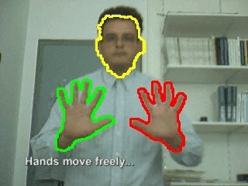 | 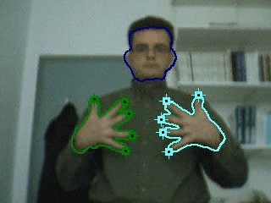
2D tracking of human face and hands | Finger detection on the tracked skin-colored regions

Related publications
- A.A. Argyros, M.I.A. Lourakis, “Tracking Skin-colored Objects in Real-time”, invited contribution to the “Cutting Edge Robotics” book, ISBN 3-86611-038-3, Advanced Robotic Systems International, 2005.
- A.A. Argyros, M.I.A. Lourakis, “Real time Tracking of Multiple Skin-Colored Objects with a Possibly Moving Camera”, in proceedings of the European Conference on Computer Vision (ECCV’04), Springer-Verlag, vol. 3, pp. 368-379, May 11-14, 2004, Prague, Chech Republic.
- A.A. Argyros, M.I.A. Lourakis, “Tracking Multiple Colored Blobs With a Moving Camera” in proceedings of the Computer Vision and Pattern Recognition Conference, (CVPR’05), vol. 2, no. 2, p. 1178, San Diego, USA, June 20-26, 2005.
- A.A. Argyros, M.I.A. Lourakis, “3D Tracking of Skin-Colored Regions by a Moving Stereoscopic Observer”, Applied Optics, Information Processing Journal, Special Issue on Target Detection, Vol. 43, No 2, pp. 366-378, January 2004.
- K. Sage, J. Howell, H. Buxton, A.A. Argyros, “Learning Temporal Structure for Task-based Control”, Image and Vision Computing Journal (IVC), special issue on Cognitive Systems, conditionally accepted, under revision.
- S.O. Orphanoudakis, A.A. Argyros, M. Vincze “Towards a Cognitive Vision Methodology: Understanding and Interpreting Activities of Experts”, ERCIM News, No 53, Special Issue on “Cognitive Systems, April 2003

