CS 319 Object-Oriented Software Engineering
Fall 2005 Final Exam
(Section 1 - Instructor: Dr. Kıvanç DİNÇER)
Q1 | 18
Q2 | 12
Q3 | 20
Q4 | 50
Total | 100 pts
December 28, 2005
- Time: 90 minutes.
- Show your work and reasoning clearly and write legibly, only within the space provided for each question.
- You may use scratch sheets, but they must be marked and submitted.
- Please stay seated if you finish during the last 10 minutes of the exam period.

Question 1: Fill in the blanks [18 pts]
Fill in the blanks below, with a word per blank, to form valid statements.
(a) User-centered design is the term used to describe approaches to software development that focus on the needs of users. (7P230)
(b) A UP project organizes the work and iterations across four major phases: inception, elaboration, and construction and transition. (2P033)
(c) Does the system allow the users to learn and to use the raw capabilities easily? This is usability . Documentation and on-line-help improves it. (5P057 /7P245)
(d) Use cases can be written in three different formats and levels of formality brief, casual and fully-dressed. (6P067)
(e) Requirements are capabilities and conditions to which the system – and more broadly, the project must conform. (5P054)
(f) Multiplicity (Cardinality) defines how many instances of a class A can be associated with one instance of a class B. (9P153)
(g) Three of the requirements artifacts in UP are UC Model , Supplementary Specifications, and Glossary, Vision, Business Rules. (5P058)
(h) The logical architecture is the large-scale organization of the software classes into packages (or namespaces), subsystems, and layers. (13P199)
(j) The generalization is the activity of identifying commonality among concepts and defining superclass (general concept) and subclass (specialized concept) relationships. (31P505)
(k) (4 blanks) (29P486) initial state, state, event, transition

Question 2: True – False [12pts]
Indicate whether you think the following are true or false. If you think an item is false, underline the incorrect part(s). Provide no explanations, and keep in mind that one incorrect answer cancels out a correct one.
(a) True | False Iterative and evolutionary development – contrasted with a evolutionary development lifecycle – assumes that development starts before all the requirements are defined in detail; feedback is used to clarify and improve the evolving specifications. (2P018)
(b) True | False The UP encourages a combination of client-driven, risk-driven, and architecture-centric iterative planning. (2P027)
(c) True | False In agile modeling the point of creating artifacts or models is not to document or diagram itself, but the thinking, analysis, and proactive readiness. (4P051)
(d) True | False The FURPS+ model, a useful mnemonic with the following meaning: functionality, usabibity, recoverability, performance, and supportability. “+” indicates other subfunctions. (5P057)
(e) True | False There are three kinds of external actors in relation to the system under development/discussion: primary actor, secondary actor, and supporting actor. (6P066)

(f) True | False Model-View Sparation Principle says do not put application logic in the UI object methods and connect UI objects directly to non-UI objects.
(g) True | False A synchronous message call does not wait for a response; it doesn’t block. They are used in multi-threaded environments so that new threads of execution can be created and initiated. (15P239)
(h) True | False The UML deployment diagram shows the large-scale organization of the software classes into packages, subsystems, and layers. (13P199)
(i) True | False Antipatterns are the patterns that are similar to the given pattern in the same context. (6P202)
(j) True | False In UP use-case realizations drive the design. That is, the team designs collaborating objects and subsystems in order to perform or realize the use cases. (6P095)

(k) True | False Efficiency of use is a measure of how fast an expert user can do his or her own work using the system. (7P245)

(l) True | False Affordance is the set of operations that the user can do at any given point in time. (15P224)

Question 3: OOSE [20 pts]
- What is a Data Dictionary? Why do you think it is a part of the UP requirements artifacts? What attributes does it contain? (7P115)

- The textbook’s author strongly recommends that developers should avoid the waterfall development approach. However there are cases in practice where the waterfall is the recommended/best approach to be followed. Can you think of any specific development context in which waterfall would be superior to the iterative and evolutionary approach? (2P023)

- What is agile modeling? Name three important practices and values of agile modeling? (2P030)

- Name five of the usability principles covered in the lectures and you applied in your project.

Question 4: OOA/D and UML [50pts]
Consider the following problem description for an Airline Reservation System:
TT Airlines runs regular flights between Ankara and 7 other cities in Turkey. There are several daily numbered flights on regular schedule. The reservation system keeps track of passengers who will be flying in specific seats on various flights., as well as people who will form the crew.
For the crew, the system needs to track what everyone does, and who supervises whom. There are three kinds of employees in the organization, pilots, hosts and ground personnel. Only the ground personnel uses the reservation system. But the potential passengers may do reservations using the system’s web interface.
There is also a frequent-flier program which shows flight points to frequent passengers and they may use their points during reservation.
TT Airlines personnel sometimes fly as passengers in scheduled flights. For their reservations, the system only requests their personnel id number. Their other info is already in the system. They are given points for each flight that they participate as a crew. Then during their reservation, they may use these points against their purchases. Besides, there is a regular 50% discount for airlines personnel and their families.
The system should be able to help to perform at least the following functions:
- Creating a new flight or modifying the attributes of a flight
- Searching for a particular flight
- Cancelling a flight on a specific day
- Making or cancelling a booking on a particular flight
- Reporting names of crew and passengers (marking TT personnel separately) on a particular flight and their payment type/discounts (cash, credit card, flyer points, crew points, etc.).
- (10 points) Draw the use case diagram for the above system.
A typical answer should look like the following:
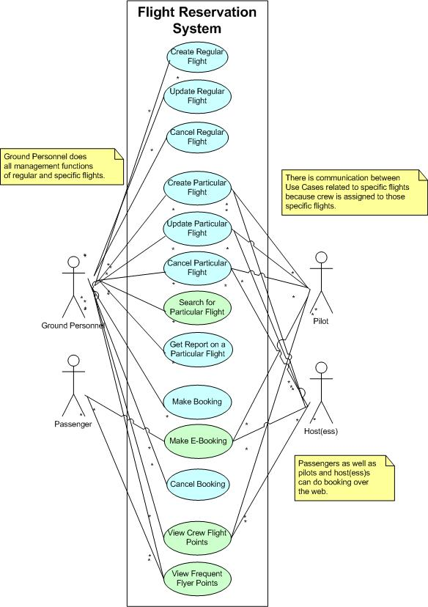
- (10 points) Draw a UML Activity Diagram that shows how the general business process flows.
- (10 points) Write the use case for `make a booking` use case including all sections of the use case.
- (10 points) Derive the design class diagram for the above system. You should make sure that you do not duplicate info kept about people using an appropriate generalization hierarchy in your class design. Use patterns when necessary to make your solution more concise.
A typical answer should look like the following:
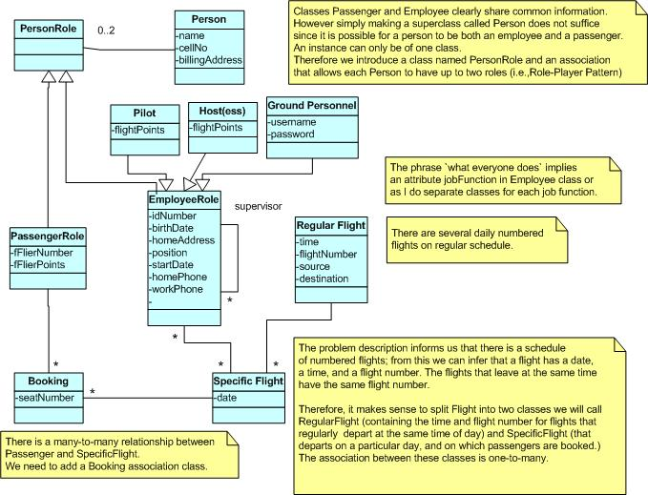
- (10 points) Draw the sequence diagram for `make a booking` use case. Show the UI objects, actors and other classes explicitly. Make sure that you also put on a explanation note for complex operations on the diagram.
Hint: Make sure that all your work is consistent with each other. You obey guidelines and principles given in the book. AND MAKE SURE THAT YOUR SOLUTION IS EASILY READABLE.
- GOOD LUCK -

