GXX / Name
Member1
Member2
Member3
Member4

dd/mm/2014

CS468 - Principles of User Interface Design
Spring 2014
PROJECT STAGE 2 | PROJECT STAGE 2
Name of your application | Name or very short decription of your application

Introduction
1 paragraph of the project description.

Persona & User Tasks
1- Create imaginary but realistic person descriptions namely persona for each user category.
Examples:
- Bob is a 20-year old male MIT junior studying Civil Engineering. He is a diligent student who goes to class and takes good notes, but he sometimes has trouble on his problem sets, which can be quite challenging. He sometimes works with one of his fraternity brothers who is also Course 1 and is in one of his classes together, but he has trouble finding other collaborators. He wants to be able to work with other people.

- Stacy is a 19-year old female MIT sophomore studying Computer Science. She skips a lot of classes and falls asleep in lecture when she does go. She is very bright and can typically get by reading the textbooks and reviewing lecture notes, but sometimes her knowledge is incomplete. She wants to be able to get a more accurate recap of lectures.

2- Identify all user categories and all tasks they perform.
Some user categories and performed tasks from UDesign are given as an example below:
1 - Future homeowners
- Account/Personal Profile
  - CRUD an account
  - Connect to Facebook (import profile)
    - Info. needs: user's email address and password
  - Share personal info./profile
    - Precondition: must be logged in
    - Info. needs: know/find people to share with
  - Set privacy rules
    - Precondition: must be logged in
- Design
  - CRUD designs
    - Draw/Move/Delete wall
    - Place/MOve/Delete furniture
    - Get cost estimate of the design
    - Input budget for the entire project/design or parts of it
    - Get help with certain things in the design process
    - Get feedback/warning about potential conflicts/problems in the design
  - "Project Planner": get a step-by-step schedule of how to execute the design
  - Compare designs on different attributes

2 - Designers
- Design
  - CRUD designs
  - Share designs, publish/post to Facebook
  - Save/Load designs
  - Browse designs
  - Search designs
    - Search by categories/keywords/tags
    - Filter search
    - Get recommendations/suggestions
  - Rate design
  - Add comments/annotate designs
- Professional
  - CRUD an online store/studio
  - Sell custom designs
  - Provide consultancy/design services
  - CRUD design solutions/components/assemblies (i.e., the "building blocks" of designs found in the library)
  - CRUD warnings/constraints (i.e., which components go together and which don't)
  - CRUD sample designs, showcased to users

Task Analysis
Make a detailed task analysis for 4 risky tasks with textual HTA descriptions PLUS make a simple task analysis for the remaining tasks. (Choose 4 risky tasks, the selected tasks should not be simple such as login/logout/sign in/sign out etc.)
Examples:
EXAMPLE for a detailed task (Should include Textual HTA Description)
TASK 1: Name of the Task
1 paragraph of the aim of the task that describes the actions people do.
HTA 1:
Don't draw the HTA diagram, only give textual HTA description such as the description on the slide 7 (http://cs.bilkent.edu.tr/~tcapin/courses/CS468/Slides/CS468-02.01-User&TaskAnalysis.pdf)
EXAMPLE for a simple task
TASK 1: Name of the Task
1 paragraph of the aim of the task that describes the actions people do. You don't need to give the textual HTA description.

Domain Analysis
Make a domain analysis and draw the domain analysis diagram. You can use any tools for drawing the diagram.
(You can get detailed information from:(http://cs.bilkent.edu.tr/~tcapin/courses/CS468/Slides/CS468-02.01-User&TaskAnalysis.pdf (Slide number: 85-89))

UDesign's domain analysis:

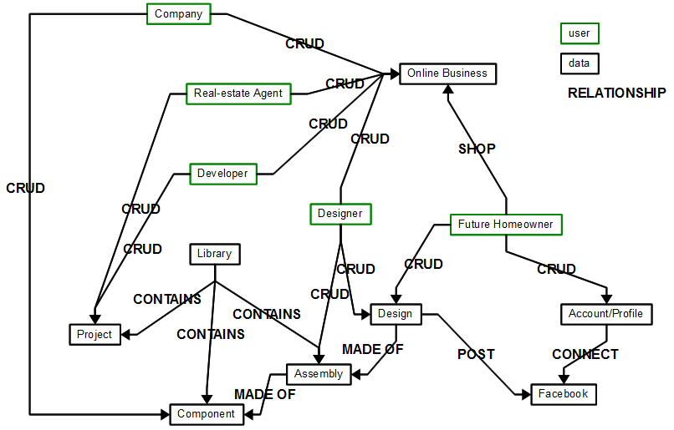

Usability Goals
Write 5 quantitative and 10 qualitative usability goals for your task. (1 sentence for each)
(You can read: http://cs.bilkent.edu.tr/~tcapin/courses/CS468/ReadingAssignments/01.02-Usability-Goal-Setting.pdf)
Type
Quantitative
Qualitative

Conclusion
…

Contributions
Contribution of each member (give percentages)

