CS468 - Principles of User Interface Design
PROJECT STAGE 3
Name or very short decription of your application

Group No / Name
Member1
Member2
Member3
Member4

v1.0: 03/03/2011 - v2.0: 09/03/2010

PART 1 : Individual Sketches
(50 pts)
This part of the report should be done individually by ALL team members. Everyone will be responsible for their sketches during the discussion hour in the class.
For each team member should design 1(at least) or more interface for each of the 4 high priority tasks. Sketches SHOULD be hand-drafts. DO NOT use any sketching tools.
EXAMPLE:
Design Choice 1 For Task Name (Designer: Member Name ):
E.g Header: Design Choice 1 For Taking a Virtual Tour (Designer: Bertan Gundogdu)
Add all design choices and the designer name (IMPORTANT- if you don't give the designer name, task name for a design, you WON'T get any points)
Some sketch examples:

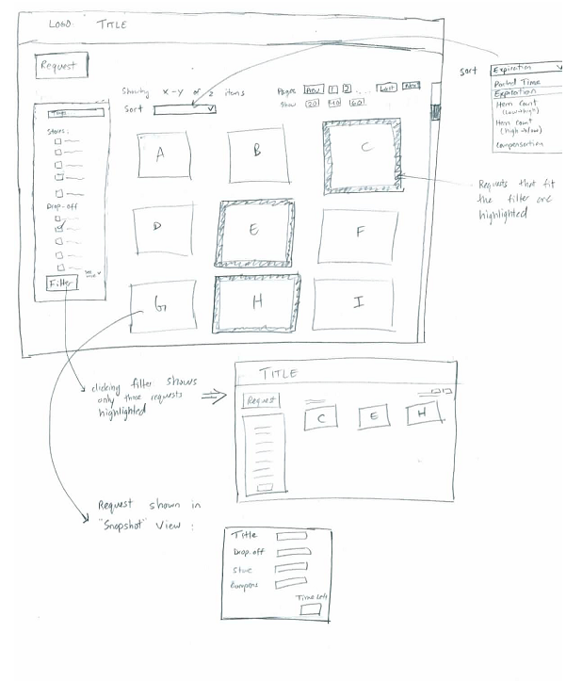

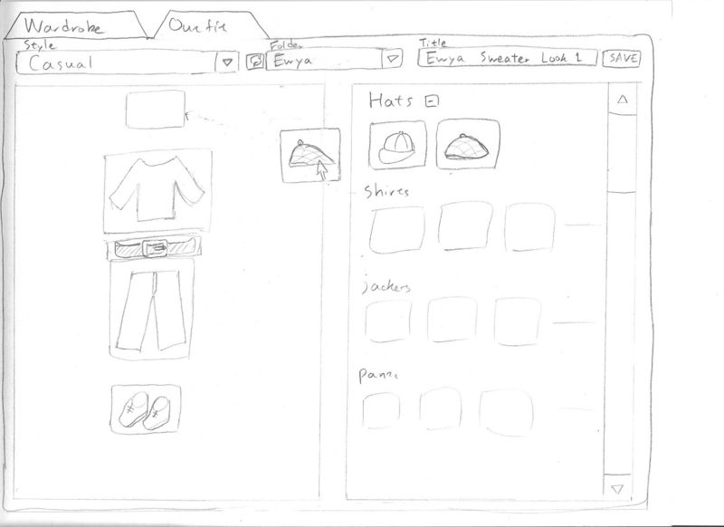

PART 2 : Selected Sketches & Storyboards & Metaphors
(50 pts)
Due to : This part of the report should be done by the TEAM.

2A: Final Sketch
(20 pts)
Explain why you have selected this sketch and not other sketches in detail. What are the problems of unselected sketches? Explain. Maybe you can update or merge your design choices in order to reach a final decision. Add your final sketch also.

EXAMPLE
You have to explain the following items for each design choice.
Design Choice 1 / X(Number of design choices):
Interface Description:
Learnability:
Visibility:
Efficiency:
Error Prevention:
Why you have selected this design or not?:
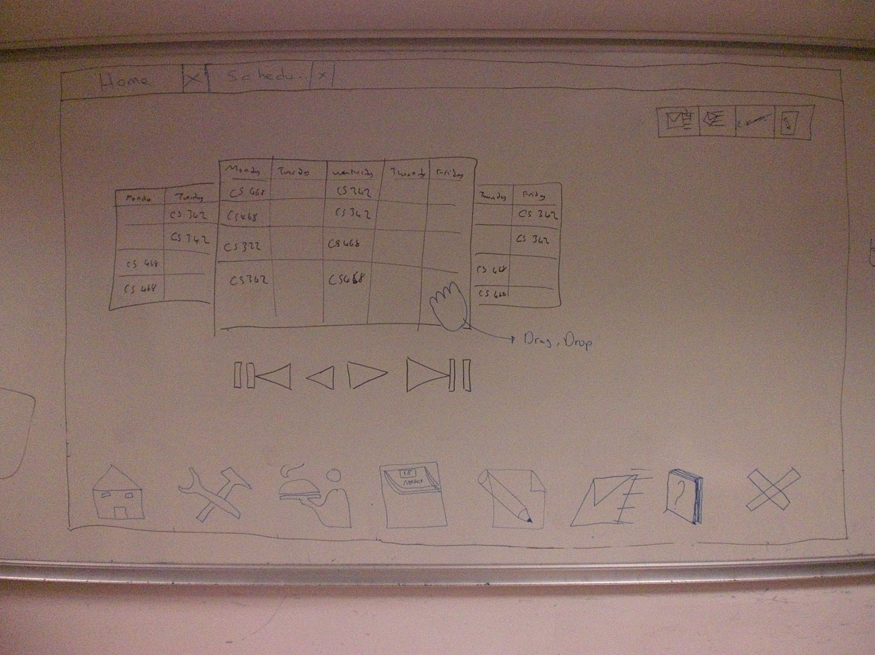
Final Sketch:
Add your final sketch. For example, this picture is from previous years. Team members decided the final sketch by drawing on the white board. You can add these kinds of sketches.

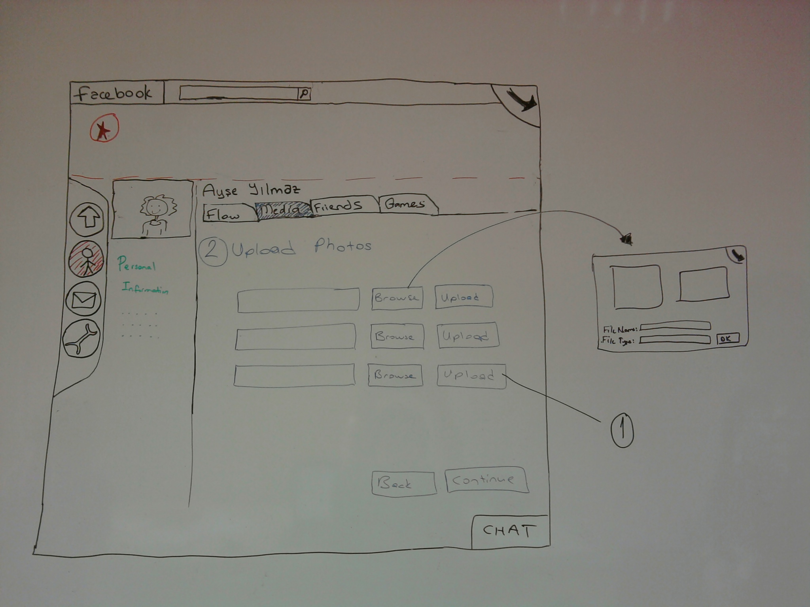

Example of a final sketch.

2B: Scenarios & Storyboards
(20 pts : 5 pts for each TASK)
For EACH selected high priority tasks from PS2, you need to write a scenario and draw the related storyboard. Note that, your storyboards' design should be the selected design from part 2A.

EXAMPLE
This example is from previous years. They designed a virtual tour for the Bilkent Library.
SCENARIO 1: Take a Virtual Tour
Aysegül, who is a student at Middle East Techical University, wonders Bilkent University’s Library. Without coming to Bilkent campus, she connects to the Internet and by entering the URL of Bilkent Library’s web page, she enters to Bilkent’s Library’s online system. In the home page, she selects virtual tour option. When she opens the application, library’s door welcomes her. She opens the door, then she walks around the halls and the floors of the library. She decides to take a look at the books located in the first floor. She steps into the first floor, and she turns the first left. She starts having a tour between the book shelves and then again, she turns to her left. When she finds a book that she is interested in at that corridor, she can take a look at the book by taking it from the shelf.

Then, draw storyboards clearly. Show user actions. Use the sketching tool called balsamiq in order to draw ONLY storyboards( http://www.balsamiq.com/ ). Be careful, the example below was not drawn by a tool, but you SHOULD use the sketching tool only for storyboards not individual sketches. For a storyboard which is done by a sketching tool, see (http://www.cs.bilkent.edu.tr/~yyigit/Group4_PS3.pdf)
STORYBOARD 1
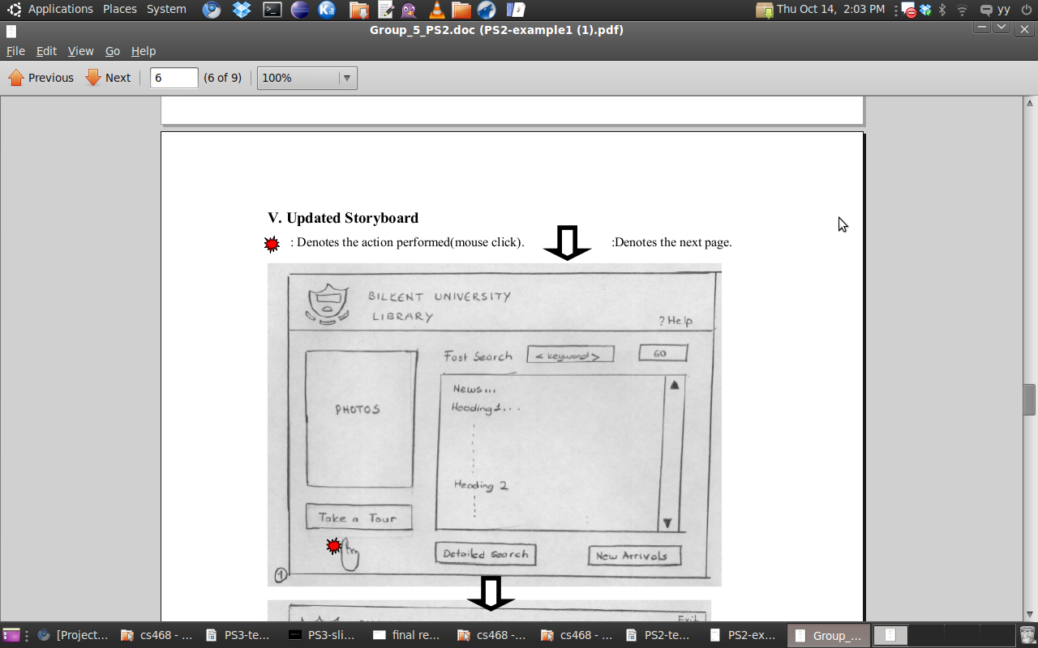

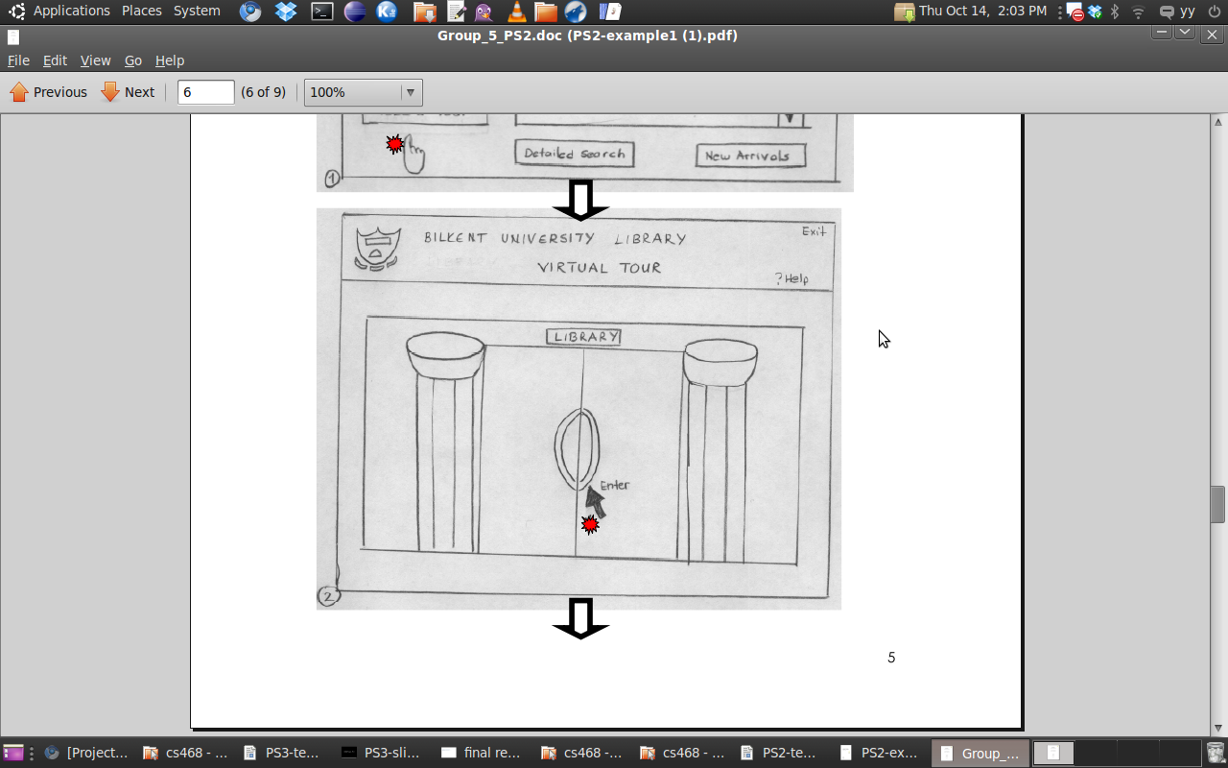

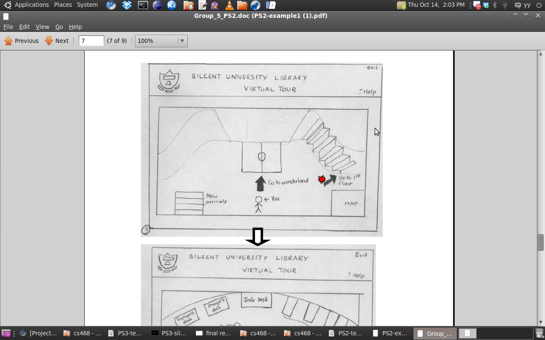

Etc….

2C: List of Metaphors
(10 pts)
Write down a list of GLOBAL and LOCAL metaphors that your system uses per task.

