1. Getting Started, Using Putty
Knuth machine is available for undergraduate students. You are free to write and compile your software on Knuth. To connect to a Linux machine from your Windows machine, you can use a client such as PuTTY. The putty window looks similar to this one:

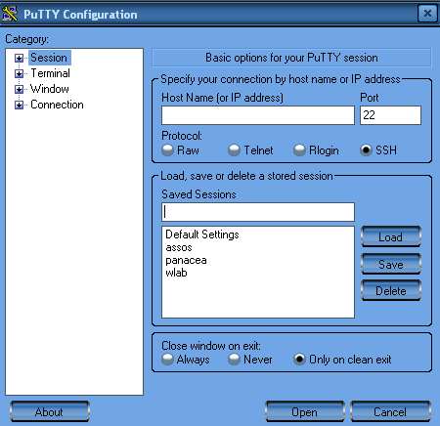

You will use the machine Knuth for your assignments, so fill in the information above:
Host Name: knuth.ug.bcc.bilkent.edu.tr

Write knuth in the text box below the title “Saved Sessions”, and then press “Save” button. You have now saved your session for the Knuth machine. Just double click on knuth and login with your own username/password.

2. Using FTP
You may want to implement your software with your own machine and IDE of choice, but compiling with the compiler installed on Knuth and running on Knuth is a strict requirement for your homework to be graded.

In order to upload your files to your Knuth account, you may use several free ftp clients, including SmartFTP, WinSCP, CuteFTP, etc…

You can also use Internet Explorer as an ftp client. Just replace your username (in the example “serdogan”) and enter your password when requested. You are free to upload your files like you are using Windows Explorer.

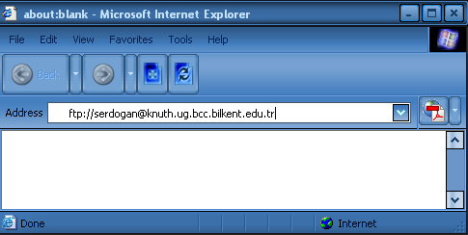

Bilkent network does only allow you to connect to ftp servers or linux machines from inside the campus network. If you are outside the campus, just make a vpn connection to Bilkent network. Details can be found at http://vpn.ug.bilkent.edu.tr/

3. Basic UNIX Commands
1) ls
ls (list) lists all files and directories in your current directory.
Sample usage: ls –al (list all the files including hidden ones and list their properties)

2) cd
cd (change directory) allows you to move into and out of directories, much like double-clicking on folders on your PC.
Sample usage: cd subdirectory (move into the folder subdirectory)
Sample usage: cd .. (move one folder above in the directory listing)

3) mkdir
mkdir (make directory) lets you create new directories (folders) in your current directory
Sample usage: mkdir new_directory_name

4) cp
cp (copy) command allows you to copy files as new files, or copy files and directories to new directories
Sample usage: cp index.html index2.html (copy index.html file as index2.html)

5) rm
rm (remove) is the UNIX command to delete files. It's short for "remove". Be very careful when deleting stuff with this command, as UNIX usually has no recycle bin - once you've deleted something, it's gone forever!
Sample usage: rm index.html (remove the file index.html)

6) more
The more command is a quick and easy way to view the contents of a text file on your server. Press the Enter key to scroll through one line at a time, or the Space bar to scroll one page at a time. To terminate the more command, press the key q.

7) man
man (manual) is the help system for UNIX servers.
Sample usage: man ls (show help file for ls command)

7) chmod, pwd, mv, rmdir,…
You may want to check these commands out on your favorite search engine or just use man command. Two files (linux-commands.pdf, linux-commands2.pdf) are available on the course web page.

4. Compiling & Running Software
Suppose you have a cpp file example.cpp. You may want to produce object file in Linux environment using

g++ -c example.cpp

-c option produces object files and you will have example.o file. Executable file is produced using

g++ -o executable example.o

-o option produces the executable file named as executable. Running your own software is as easy as

./executable

Simply you can compile .cpp files directly (without producing object files) and run using
g++ example.cpp
./a.out (default output file name)

or

g++ -o executable example.cpp
./executable

5. Links:
- http://www.elated.com/tutorials/management/unix/basic/
(Telnet and basic UNIX commands)
- http://www.elated.com/tutorials/management/unix/useful_commands/
(UNIX commands extended)
- http://www.math.montana.edu/help/software/unixtut/
(UNIX tutorial for beginners)
- http://www.cs.bilkent.edu.tr/~korpe/courses/cs342spring2005/internal/cstyle.pdf
(C programming style guidelines)
- http://sunsite.univie.ac.at/textbooks/emacs/emacs_toc.html
(GNU Emacs manual)
- http://www.tldp.org/HOWTO/Installation-HOWTO/
(The Linux Installation howto)
- http://cs.acadiau.ca/~jdiamond/comp2103/beginner-tutorials/LinuxTutorialGcc.html
(GCC tutorial)
- http://www.chiark.greenend.org.uk/~sgtatham/putty/
(Putty, telnet client for WindowsTM)

