A Framework for Complexity Management
in Graph Visualization

U. Dogrusoz and B. Genc
Computer Eng. Dept., Bilkent Univ., Ankara 06533, Turkey
Tom Sawyer Software, Oakland, CA 94612, USA

We present a comprehensive framework for development of complexity management techniques in graph visualization tools. The presented architecture:
- Is capable of managing multiple associated graphs
- Is based on dynamic interactive compound graphs.
- Provides ghosting, folding and hiding facilities for unwanted graph elements
- Is proven to be quite efficient
- Is implemented in a graph drawing tool (GET/Java of TSS) successfully

Original Graph
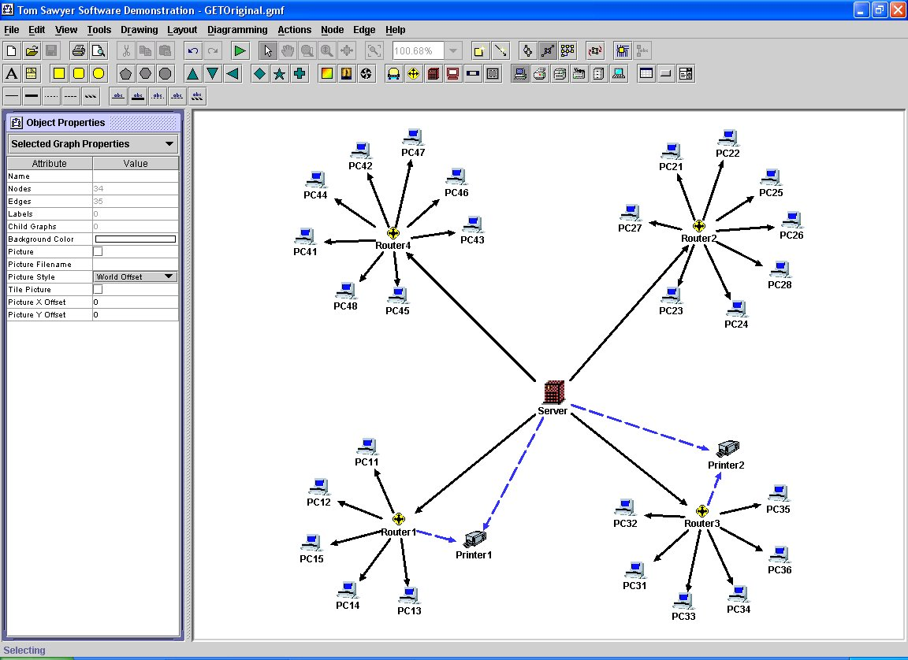
The original graph displays a network with 27 computers and 2 printers that are connected to each other over 4 routers and a server.

The printers are connected to two of the routers and also to the server. All PCs communicate through their routers and the server.

The figure on the right demonstrates the framework modeling the situation.

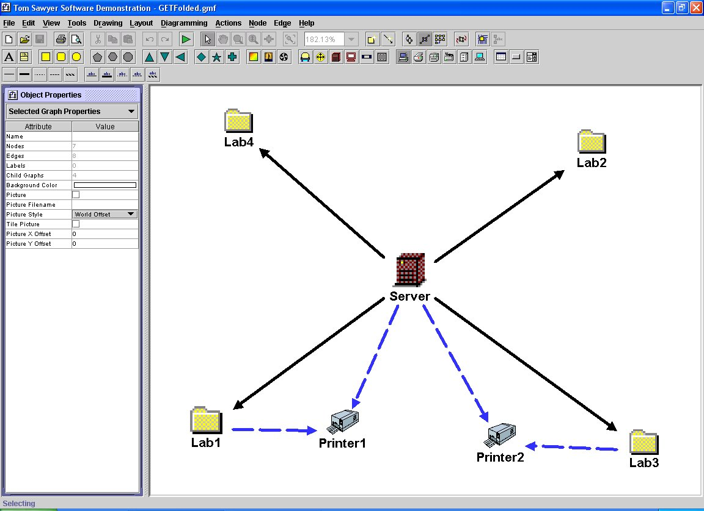
Folding / Grouping
A fold operation is applied to a group of graph members, and results in a new (folder) node and its new child graph with these members. At any time, an unfold operation may be applied on a folder node to reverse the effects of the fold operation.
The figure shows how the framework handles the situation when all PCs are folded with their routers. Note that upon folding the PCs and the routers, the edges connecting them to the server are replaced with meta edges.

Expanding / Collapsing
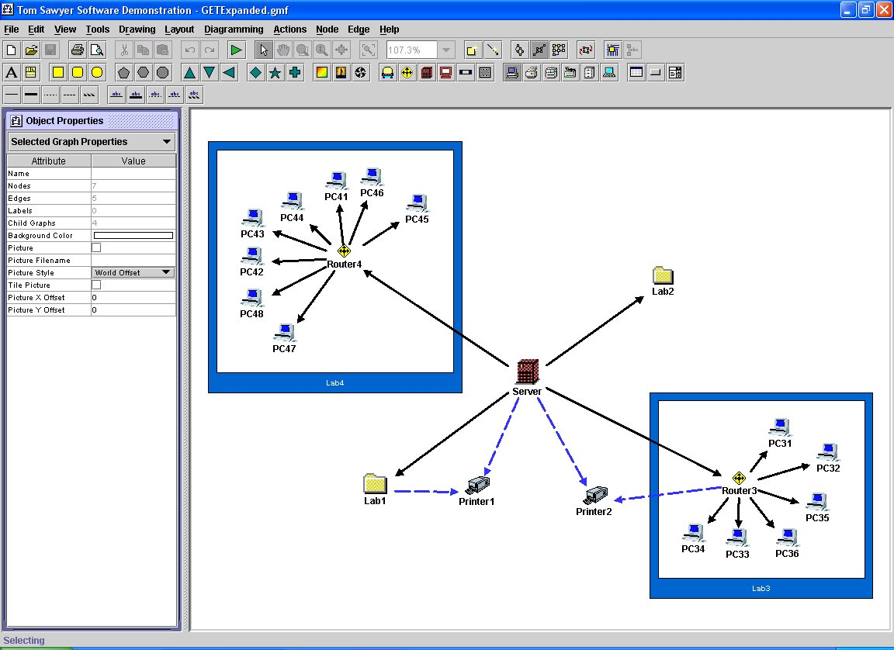
Most applications require multiple levels of abstraction, where the user would like to visualize the information with varying levels of abstraction for different parts of the drawing.

The collapse operation allows us to cancel a nesting relation between a node and a graph, thus avoiding the drawing of the graph inside the node. The expand operation is defined as the reverse operation creating a nesting relation between a node and a graph. The figure shows what happens if we expand two of the folder nodes denoting the PCs and their specific router.
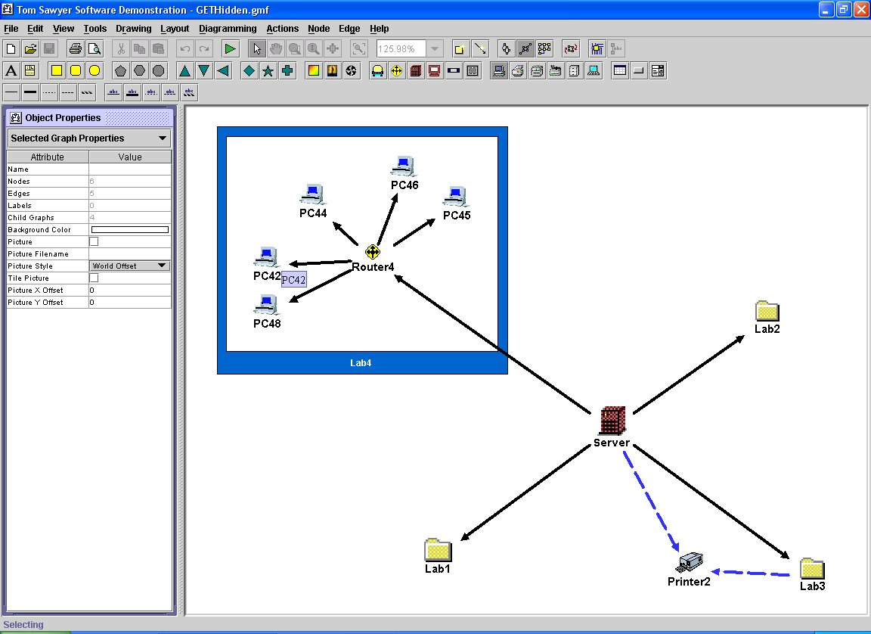
Hiding
A graph member is said to be invisible when it is not rendered on the display yet it is part of the graph topology. Hiding, on the other hand, is used to avoid any means of user interaction on a set of graph members, and temporarily removes graph contents from the graph topology as well. Any set of graph members may later be unhidden.
In the figure, one of the folders has been expanded to reveal the details. Printer1, PC41, PC43 and PC47 are assumed to be broken and we move them out of our topology by hiding their representing nodes.
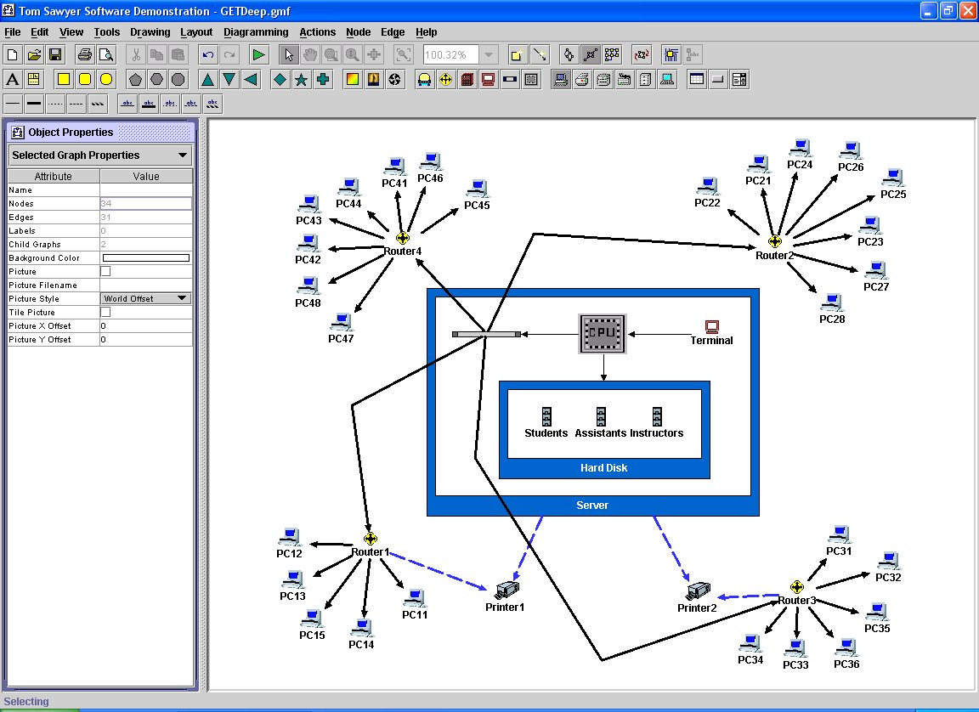
Deep Nesting
At any time, the need for inputting more details into the graph members may arise. This is handled in our framework by simply converting normal nodes to expanded folders and editing them as required.

In the figure, the details of the server have been added to the graph. In order to do this, first the node representing the server has been converted to a folder node by assigning a child graph to it, then it is expanded and the details have been entered as new graph elements. Edges are reconnected as needed.



Bilkent University
Department of Computer Engineering
Bilkent, Ankara Turkey

http://www.cs.bilkent.edu.tr
http://www.bilkent.edu.tr


Tom Sawyer Software
1625 Clay Street Sixth Floor
Oakland, CA 94612 U.S.A.

http://www.tomsawyer.com

