CS351 – QUIZ 3

Q: Form a B+ tree of degree 1 (both for the index nodes and sequence set nodes) by inserting the following keys in the given order: 4,12,6,1,3,15,5,9,7,14,16,10,11

Solution:

Insert 4, 12, 6:
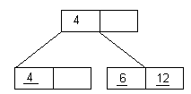

Insert 1:
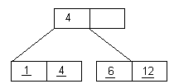

Insert 3: (first node becomes 1, 3, 4; as 3 is the middle one it goes up near 4)

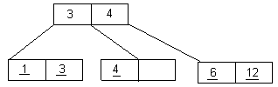

Insert 15: (the third node becomes 6, 12, 15; as 12 is the middle one it goes up near 3 and 4, now among the three 4 is the middle, so the node splits and 4 goes up)
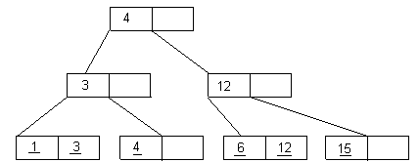

Insert 5: (third node becomes 5, 6, 12. As 6 is the middle one it goes up near 12)
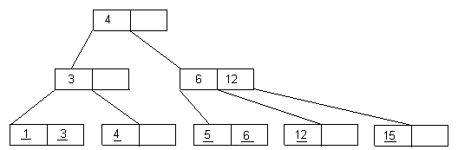

Insert 9:
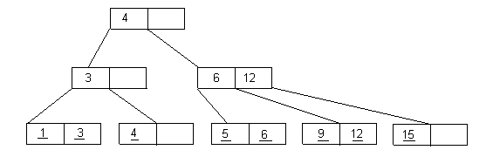

Insert 7:
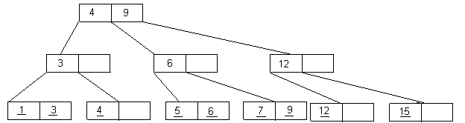

Insert 14:
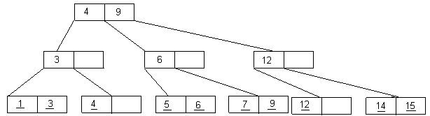

Insert 16:
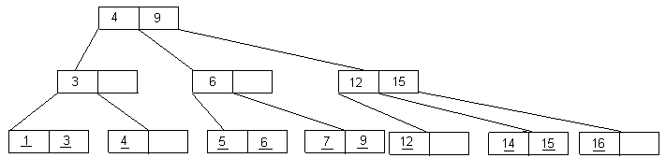

Insert 10:

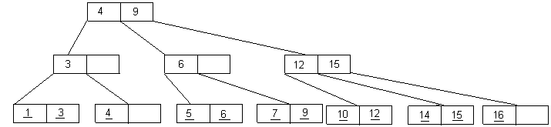

Insert 11:
